

Task Title: Courier Routes

OALCF Cover Sheet – Practitioner Copy

Learner Name: __________________________________________
Date Started: ___________________________________________
Date Completed: _________________________________________

Goal Path: | Employment | Apprenticeship
Secondary School | Post Secondary | Independence
Successful Completion: Yes No

Task Description: The learner will use Google Maps to create a courier route, calculate total distance, and determine where to stop for gas and how to most efficiently add an unexpected stop.
Main Competency/Task Group/Level Indicator:
- Understand and Use Numbers/Use measures/C3.2
- Use Digital Technology/D.3
Materials Required:
- Pen/pencil and paper and/or digital device
- Computer
- Calculator or digital device with calculator function (optional)

Learner Information
Delivery drivers and couriers may be responsible for planning their routes and submitting total mileage at the end of each day.

Open Google Maps on the computer.
Then scan the “Library Courier Destinations” below.

Library Courier Destinations

Bruce County Library Headquarters (1243 MacKenzie Road, Port Elgin, Ontario. N0H 2C6)
Bruce County Port Elgin Branch (708 Goderich Street, Port Elgin, Ontario. NOH 2C3)
Bruce County Tiverton Branch (50 King Street, Kincardine, Ontario. N0G 2T0)
Bruce County Kincardine Branch (728 Queen Street, Kincardine, Ontario. N2Z 2Y2)
Bruce County Ripley Branch (23 Jessie Street, Ripley, Ontario. N0G 2R0)
Bruce County Walkerton Branch (253 Durham Street East, Walkerton, Ontario. N0G 2V0)
Bruce County Tobermory Branch (22 Bay Street, Tobermory, Ontario. N0H 2R0)
Bruce County Wiarton Branch (578 Brown Street, Wiarton, Ontario. N0H 2T0)
Bruce County Paisley Branch (391 Queen Street North, Paisley, Ontario. N0G 2N0)

Work Sheet
Task 1: The courier’s route on Mondays is
- Library headquarters to Tiverton branch
- Tiverton branch to Kincardine branch
- Kincardine branch to Walkerton branch
- Walkerton branch to Port Elgin branch
- Port Elgin branch to library headquarters
Add each destination into Google Maps. Calculate the total distance driven on Monday.
Answer:

______________________________________________________
Task 2: The driver starts the day with enough gas to drive about 100km. They prefer to stop for gas in a town where they will already be stopping. List two (2) towns where they could get gas to avoid running out of gas between destinations.
Answer:

______________________________________________________
Task 3: The courier is asked to make an additional stop at the Paisley branch. Look at the route for the day. When could the courier stop in Paisley to avoid too much extra driving?
Answer:

______________________________________________________

Answers
Task 1: The courier’s route on Mondays is
- Library headquarters to Tiverton branch
- Tiverton branch to Kincardine branch
- Kincardine branch to Walkerton branch
- Walkerton branch to Port Elgin branch
- Port Elgin branch to library headquarters
Add each destination into Google Maps. Calculate the total distance driven on Monday.
Answer:
Library headquarters to Tiverton branch: 26.6km
Tiverton branch to Kincardine branch: 14.5km
Kincardine branch to Walkerton branch: 44.8km
Walkerton branch to Port Elgin branch: 46.5km
Port Elgin branch to library headquarters:2.3km

Total: 134.7km

Task 2: The driver starts the day with enough gas to drive about 100km. They prefer to stop for gas in a town where they will already be stopping. List two (2) towns where they could get gas to avoid running out of gas between destinations.
Answer: Any two of:
- Walkerton (85.9km to this point in the route) is the last destination where they could stop to avoid running out of gas between destinations
- They could also stop earlier – Tiverton
- They could also stop earlier – Kincardine
- They could fill up at the library headquarters before leaving on their route
Task 3: The courier is asked to make an additional stop at the Paisley branch. Look at the route for the day. When could the courier stop in Paisley to avoid too much extra driving?
Answer: After Walkerton and before Port Elgin. Paisley is on the way from Walkerton to Port Elgin (highway 3). Any other departure from the route would add time and distance to the scheduled route.
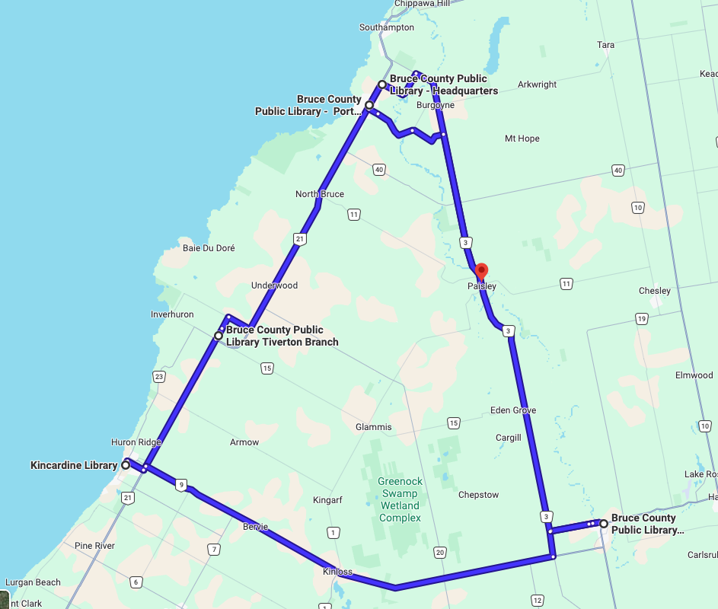

Performance Descriptors
Levels | Performance Descriptors | Needs Work | Completes task with support from practitioner | Completes task independently
C3.2 | calculates using numbers expressed as whole numbers, fractions, decimals, percentages and integers
 | uses strategies to check accuracy (e.g. estimating, using a calculator, repeating a calculation, using the reverse operation)
D.3 | experiments and problem solves to achieve the desired results
 | manages unfamiliar elements (e.g. vocabulary, context, topic) to complete tasks
 | makes inferences to interpret icons and text
 | performs advanced searches (e.g. refines search terms, uses advanced search features, cross-refers between websites)

This task: Was successfully completed Needs to be tried again

Learner Comments:

Instructor (print): Learner (print):
__________________ _________________

