

Task Title: Construction Industry Outlook

OALCF Cover Sheet – Practitioner Copy

Learner Name: __________________________________________
Date Started: ___________________________________________
Date Completed: _________________________________________

Goal Path: | Employment | Apprenticeship
Secondary School | Post Secondary | Independence
Successful Completion: Yes No

Task Description: The learner will interpret graphs about construction outlooks in Ontario, and answer questions.
Main Competency/Task Group/Level Indicator:
- Understand and Use Numbers/Manage data/C4.2
Materials Required:
- Pen/pencil and paper and/or digital device
NOTE: a colour printout of the graphs is recommended for anyone completing this taskset on paper rather than digitally.

Learner Information
Understanding trends and anticipated changes in employment can help when researching a career.

Scan “Distribution of Construction Employment in 2024, Ontario”, “Population and Age Distribution, Ontario”, and “Residential Construction Growth Outlook, Greater Toronto Area”.

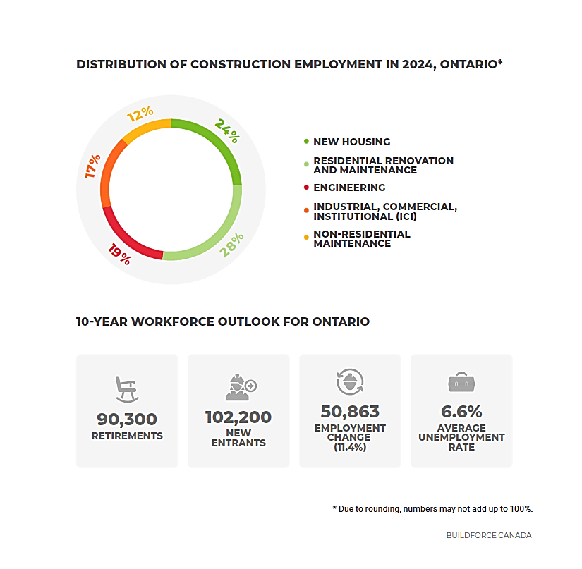

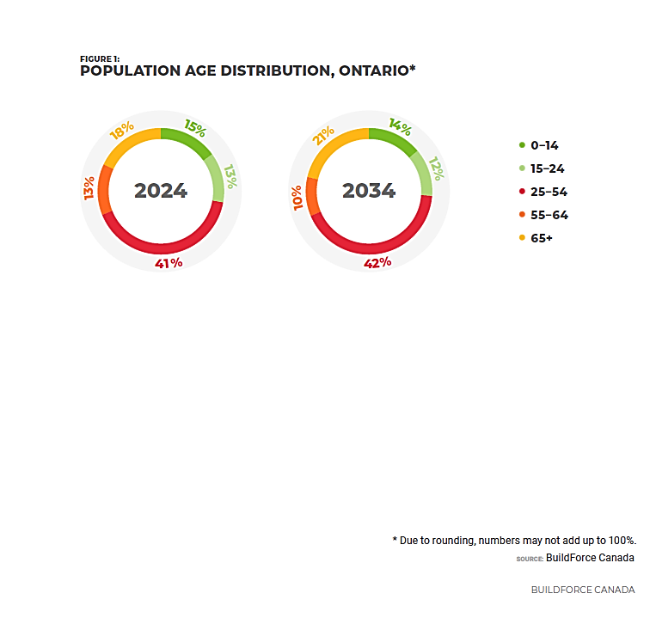

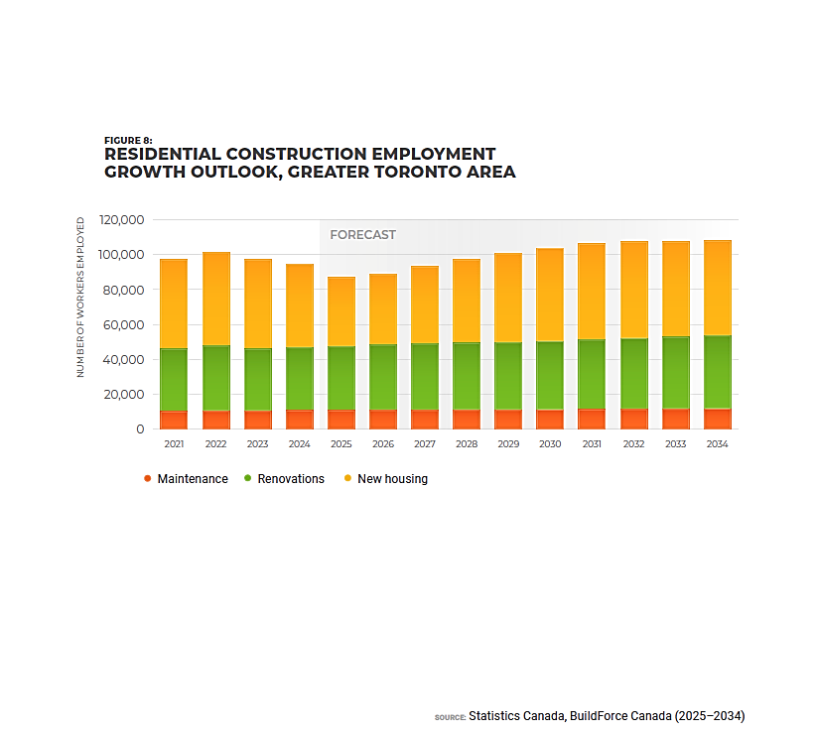

Work Sheet
Task 1: Use the “Distribution of Construction Employment in 2024, Ontario” graph. What percentage of the construction workforce was employed in new housing in 2024?
Answer:

______________________________________________________
Task 2: Use the “Population and Age Distribution, Ontario” graph. Which age groups are expected to increase their share of total construction workers between 2024 and 2034?
Answer:

______________________________________________________
Task 3: Use the “Residential Construction Growth Outlook, Greater Toronto Area” graph. Is the number of workers employed in residential construction expected to increase or decrease between 2026 and 2030?
Answer:

______________________________________________________

Answers
Task 1: Use the “Distribution of Construction Employment in 2024, Ontario” graph. What percentage of the construction workforce was employed in new housing in 2024?
Answer: 24%

Task 2: Use the “Population and Age Distribution, Ontario” graph. Which age groups are expected to increase their share of total construction workers between 2024 and 2034?
Answer: 25-54 (increase of 1%); 65+ (increase of 3%).

Task 3: Use the “Residential Construction Growth Outlook, Greater Toronto Area” graph. Is the number of workers employed in residential construction expected to increase or decrease between 2026 and 2030?
Answer: Increase

Performance Descriptors
Levels | Performance Descriptors | Needs Work | Completes task with support from practitioner | Completes task independently
C4.2 | interprets rates (e.g. crime rates) and ratios (e.g. shots-on-net goals)
 | recognizes patterns and begins to identify trends in data (e.g. population, crime, demographic, inventory, injury)

This task: Was successfully completed Needs to be tried again

Learner Comments:

Instructor (print): Learner (print):
__________________ _________________

