

Task Title: Calculate Time to Fill Pool Using Different

Hoses

OALCF Cover Sheet – Practitioner Copy

Learner Name: __________________________________________
Date Started: ___________________________________________
Date Completed: _________________________________________

Goal Path: | Employment | Apprenticeship
Secondary School | Post Secondary | Independence
Successful Completion: Yes No

Task Description: The learner will calculate the volume of, and cost to fill a round pool, then calculate how much time it will take to fill when using different sized hoses.
Main Competency/Task Group/Level Indicator:
- Understand and Use Numbers/Manage money/C1.2
- Understand and Use Numbers/Manage time/C2.2
- Understand and Use Numbers/Use measures/C3.2
Materials Required:
- Pen/pencil and paper and/or digital device
- Calculator or digital device with calculator function

Learner Information
Many people set up backyard pools in the summer. Calculating the amount of time and cost to fill a pool is important when budgeting for this expense.

Scan the volume formula for round objects and the dimensions of the round pool.

Formula
Volume of circular or round objects = ∏r² x height
∏ = 3.14
r = radius (1/2 of the diameter of the circle)

Round Pool

Diameter: 26 feet
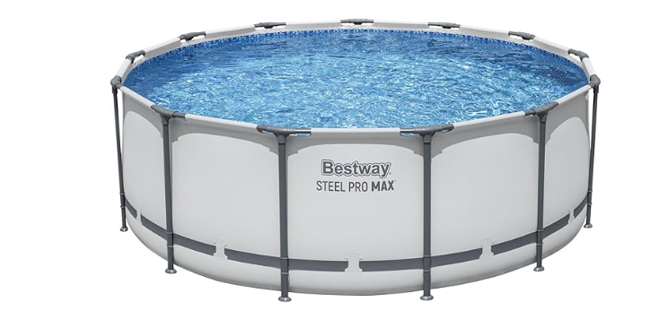
Depth: 4 feet

Work Sheet
Task 1: Calculate the amount of water needed to fill the pool to 1/4 foot (3 inches) from the top. Round to the second decimal place.
Answer:

______________________________________________________
Task 2: The flow rate of water from the garden hose is 2.2 cubic feet of water per minute. Calculate the number of hours and minutes it will take to fill the pool. Round up to the nearest full minute.
Answer:

______________________________________________________
Task 3: The cost of water is $0.06 per cubic foot. Calculate the cost to fill the pool.
Answer:

______________________________________________________
Task 4: The pool owner is considering purchasing a hose with a larger flow rate of 3.0 cubic feet per minute. Calculate the number of hours and minutes it will take to fill the pool using this hose. Round up to the nearest full minute.
Answer:

______________________________________________________
Task 5: How much faster can they fill the pool using the new hose? Round up to the nearest full minute.
Answer:

______________________________________________________

Answers
Note to Practitioners: Tasks 2-6 depend on correct volume calculation in Task 1. Use the volume the learner has calculated in Task 1 when determining the correct calculations for subsequent tasks.

Task 1: Calculate the amount of water needed to fill the pool to 1/4 foot (3 inches) from the top. Round to the second decimal place.
Answer:
Radius = diameter/2
Radius = 26/2 = 13 feet

Height = 4 feet – 1/4 feet = 3.75 feet
Volume = ∏r² x height
Volume = (3.14)(13²) x 3.75
Volume = (3.14)(169) x 3.75
Volume = 530.66 x 3.75
Volume = 1,989.98 feet³

Task 2: The flow rate of water from the garden hose is 2.2 cubic feet of water per minute. Calculate the number of hours and minutes it will take to fill the pool. Round up to the nearest full minute.
Answer:
1,989.98/2.2 = 904.54 minutes = 15.08 hours = 15 hours and .08 of an hour (4.8 minutes)
15 hours and 5 minutes (rounded from 4.8)

Task 3: The cost of water is $0.06 per cubic foot. Calculate the cost to fill the pool.
Answer: 1,989.98 x 0.06 = $119.40 (rounded from $119.3988)
Task 4: The pool owner is considering purchasing a hose with a larger flow rate of 3.0 cubic feet per minute. Calculate the number of hours and minutes it will take to fill the pool using this hose. Round up to the nearest full minute.
Answer:
1,989.98/3.0 = 663.33 minutes = 11.06 hours = 11 hours and 4 minutes (rounded from 3.6 minutes)

Task 5: How much faster can they fill the pool using the new hose? Round up to the nearest full minute.
Answer: 15.08 – 11.06 = 4.02 hours = 4 hours and 2 minutes (1.2 minutes) faster with the new hose

Performance Descriptors
Levels | Performance Descriptors | Needs Work | Completes task with support from practitioner | Completes task independently
C1.2 | calculates using numbers expressed as whole numbers, fractions, decimals, percentages, and integers
 | interprets and applies rates
 | represents costs and rates using monetary symbols, decimals, and percentages
C2.2 | calculates using numbers expressed as whole numbers, fractions, decimals, and percentages
 | converts between units of time
 | interprets, represents and converts time using whole numbers, decimals, percentages, ratios and simple, common fractions (e.g. 1/2, 1/4)
 | selects appropriate steps to reach solutions
 | uses strategies to check accuracy (e.g. estimating, using a calculator, repeating a calculation, using the reverse operation)
C3.2 | interprets and represents area and volume using symbols and abbreviations (e.g. m3)
 | understands and uses formulas for finding the perimeter, area, and volume of simple, common shapes
 | chooses and performs required operation(s); may make inferences to identify required operation(s)
 | selects appropriate steps to solutions
 | interprets, represents and converts measures using whole numbers, decimals, percentages, ratios and simple, common fractions (e.g. 1/2, 1/4)
 | uses strategies to check accuracy (e.g. estimating, using a calculator, repeating a calculation, using the reverse operation)
This task: Was successfully completed Needs to be tried again

Learner Comments:

Instructor (print): Learner (print):
__________________ _________________

