

Task Title: Understanding Hierarchy of Controls

OALCF Cover Sheet – Practitioner Copy

Learner Name: __________________________________________
Date Started: ___________________________________________
Date Completed: _________________________________________

Goal Path: | Employment | Apprenticeship
Secondary School | Post Secondary | Independence
Successful Completion: Yes No

Task Description: The learner will review the Hierarchy of Controls for minimizing hazards, and answer questions about how different controls are used in the workplace.
Main Competency/Task Group/Level Indicator:
- Find and Use Information/Read continuous text/A1.3
Materials Required:
- Pen/pencil and paper and/or digital device

Learner Information
The hierarchy of controls is used in workplaces to eliminate or reduce workplace hazards. This ranking system is used to keep people safe in the workplace.
Read “Hierarchy of Controls”.

Hierarchy of Controls

The hierarchy of controls is a step-by-step approach to eliminating or reducing workplace hazards. It ranks controls from the most effective level of protection to the least effective level of protection. Continue this process until you reach the bottom of the pyramid and have identified as many controls as needed to adequately protect the worker from the hazard.

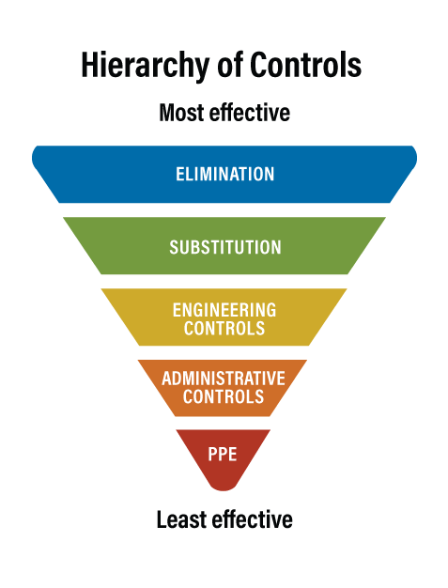

Elimination

Elimination is the process of removing the hazard from the workplace. It is the most effective way to control a risk because the hazard is no longer present.

Examples of elimination control methods include:

Purchasing equipment that is not noisy

Using a reach pole, where feasible, for window washing to eliminate working from heights

Removing and properly disposing of products that are stored in the workplace and are no longer being used

Avoiding driving during extreme winter weather conditions

Substitution

Substitution is the act of replacing something with another thing. In this case, a hazard is replaced with a less hazardous one. Care must be taken to make sure that the new hazard is actually lower, and that one hazard is not being replaced with another that is just as harmful or more harmful.

Examples of substitution controls include:

Replacing solvent-based paints with a water-based alternative

Using a larger granule form of a product instead of a fine powder to reduce dust generation

Using electric motors rather than diesel ones to eliminate diesel exhaust emissions

Engineering Controls

Engineering controls control the hazard at the source, before it comes in contact with the worker.

Engineering controls can be built into the design of a plant, equipment, or process to minimize the hazard. Engineering controls are a very reliable way to control worker exposures as long as the controls are designed, used, and maintained properly. Examples of engineering controls are:

Isolation – separating workers from the hazard by distance or the use of barriers

Enclosures – placing the material or process in a closed system (e.g., enclosed machines, booths, etc.)

Guarding and shielding – using guards around moving parts of machinery

Ventilation – using local exhaust or general dilution ventilation to remove or reduce airborne products

Mechanical lifting devices– using mechanical methods to lift or move objects instead of manual lifting

Guardrails – using guardrails to prevent a fall

Administrative Controls

Administrative controls involve developing procedures to ensure the work is conducted in a way that minimizes the hazard. Examples include developing or changing policies, implementing or improving training and education, and developing or enhancing work practices and procedures.

Administrative controls are ranked lower than elimination, substitution, and engineering controls because these methods do not necessarily remove or reduce the hazard from the workplace. For example, administrative controls limit workers' exposures by scheduling shorter work times in contaminant areas or by implementing other "rules". These control measures have many limitations because the hazard itself is not actually removed or reduced. Administrative controls should be used in combination with other control measures where possible.

Methods of administrative control include:

Using job-rotation schedules or a work-rest schedule that limits the amount of time an individual worker is exposed to a substance.

Implementing a preventative maintenance program to keep equipment in proper working order.

Scheduling maintenance and other high-exposure operations for times when few workers are present (such as evenings and weekends).

Restricting access to a work area.

Restricting the task to only those competent or qualified to perform the work.

Using signs to warn workers of a hazard.

PPE

Personal protective equipment (PPE) refers to anything workers wear to help protect them from workplace hazards.

PPE limits exposure to the harmful effects of a hazard but only if the PPE is worn and used correctly. Examples of PPE include:

Respiratory protection

Skin protection (e.g., coveralls, aprons, full body suits)

Gloves

Eye protection (e.g., face shield, goggles)

Foot protection

Hearing protective devices (e.g., ear plugs, ear muffs)

The choice of what type of PPE is required must be based on the specific hazard found at the workplace.

[Sourced from Canadian Centre for Occupational Health and Safety: https://www.ccohs.ca/oshanswers/hsprograms/hazard/hierarchy_controls.html]

Work Sheet
For each task, identify which control is used and explain how it is being used in one or two sentences.

Task 1: A toxic cleaning solvent is replaced with a bio-degradable, non-toxic cleaning product.
Answer:

______________________________________________________
Task 2: A soundproof room is built to accommodate a very loud piece of machinery on a manufacturing floor.
Answer:

______________________________________________________
Task 3: A robotic system replaces a heavy lifting task that was previously done by a worker.
Answer:

______________________________________________________

Task 4: On the door of a laboratory, signs are posted identifying biohazards and other toxic materials in the room.
Answer:

______________________________________________________
Task 5: A machinist must wear steel-toed boots, noise-cancelling headphones, safety glasses, and cut-resistant gloves.
Answer:

______________________________________________________

Answers
For each task, identify which control is used and explain how the control is being used.

Task 1: A toxic cleaning solvent is replaced with a bio-degradable, non-toxic cleaning product.
Answer: Substitution: A potentially hazardous cleaning product has been replaced with one that is not hazardous.

Task 2: A soundproof room is built to accommodate a very loud piece of machinery on a manufacturing floor.
Answer: Engineering Controls: This reduces the noise exposure to people in the area. Only those using the specific machine will be close to the noise.

Task 3: A robotic system replaces a heavy lifting task that was previously done by a worker.
Answer: Elimination: The risk to a worker has been eliminated since a person is no longer undertaking this task.

Task 4: On the door of a laboratory, signs are posted identifying biohazards and other toxic materials in the room.
Answer: Administrative control: The sign raises awareness and identifies hazards to anyone entering the room.

Task 5: A machinist must wear steel-toed boots, noise-cancelling headphones, safety glasses, and cut-resistant gloves.
Answer: PPE. These are all examples of protective equipment someone must wear to keep themselves safe in this job.
Performance Descriptors
Levels | Performance Descriptors | Needs Work | Completes task with support from practitioner | Completes task independently
A1.3 | integrates several pieces of information from texts
 | manages unfamiliar elements (e.g. vocabulary, context, topic) to complete tasks
 | identifies the purpose and relevance of texts
 | infers meaning which is not explicit in texts
 | uses organizational features, such as headings, to locate information
 | follows the main events of descriptive, narrative, informational and persuasive texts
 | obtains information from detailed reading

This task: Was successfully completed Needs to be tried again

Learner Comments:

Instructor (print): Learner (print):
__________________ _________________

