

Task Title: School Allergy Policy

OALCF Cover Sheet – Practitioner Copy

Learner Name: __________________________________________
Date Started: ___________________________________________
Date Completed: _________________________________________

Goal Path: | Employment | Apprenticeship
Secondary School | Post Secondary | Independence
Successful Completion: Yes No

Task Description: The learner will read a school anaphylaxis policy, answer written questions, and explain the policy to another person (instructor).
Main Competency/Task Group/Level Indicator:
- Find and Use Information/A1.2
- Communicate Ideas and Information/Interact with others/B1.2
Materials Required:
- Pen/pencil and paper and/or digital device
- Conversation partner (instructor)

Notes for Instructors/Practitioners
Task 4 is a role-playing exercise in which the learner will be a school staff member and you will be a parent. Ask at least two follow-up questions when the learner explains the school’s allergy policy. Examples of follow-up questions may include:
- Why can’t my child eat her muffin if she isn’t sharing it?
- Why can’t my child eat her muffin when no one in her class has any allergies?
- Why can’t she bring her muffin today? She brought the same muffin to school last week and no one said anything.
- My child doesn’t have any allergies. Why do I need to limit what she eats for breakfast because of other children?

Learner Information
Anyone working or volunteering in a school has a responsibility to keep children safe. Many children have life-threatening allergies. Schools typically have very detailed guidelines to minimize exposure to potential allergens so everyone can be safe at school. Educational assistants, early childhood educators, teachers, and other school staff must understand and be able to explain these policies when needed.

Read the “Anaphylaxis Policy”.

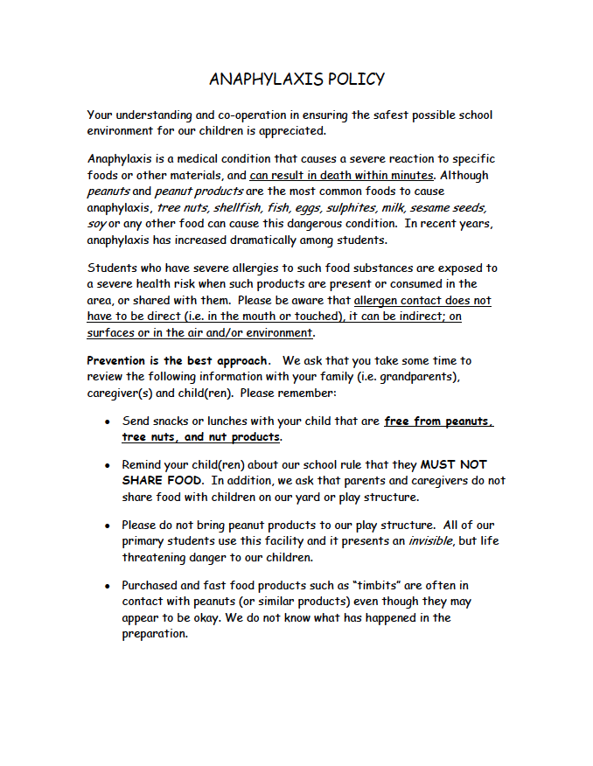

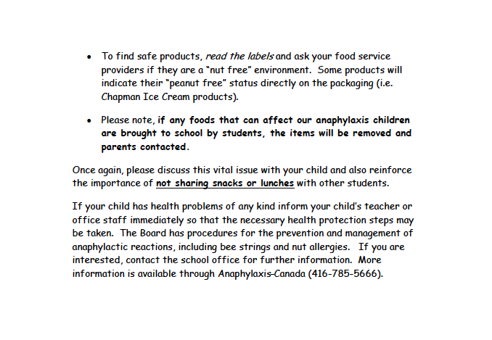

Work Sheet
Task 1: What is the most common food that causes anaphylaxis reactions?
Answer:

______________________________________________________
Task 2: List three (3) examples of indirect allergen contact that may occur.
Answer:

______________________________________________________
Task 3: What action should a parent take if their child has a health condition?
Answer:

______________________________________________________
Task 4: You are a staff member at an elementary school. You are supervising the playground during morning drop off. A parent drops off their child with a muffin in a bag from a fast food restaurant. Explain to your instructor (the parent) why you are concerned about this food. Discuss any action that should be taken.
Answer: No written response required here.

Task completed: Yes:
______________________________________________________

Answers
Task 1: What is the most common food that causes anaphylaxis reactions?
Answer: Peanuts and peanut products
Task 2: List three (3) examples of indirect allergen contact that may occur.
Answer:
- On surfaces (e.g. desks, playground equipment)
- In the air and/or
- In the environment
Task 3: What action should a parent take if their child has a health condition?
Answer: Inform the child’s teacher or office staff immediately so that necessary health protection steps may be taken.
Task 4: You are a staff member at an elementary school. You are supervising the playground during morning drop off. A parent drops off their child with a muffin in a bag from a fast food restaurant. Explain to your instructor (the parent) why you are concerned about this food. Discuss any action that should be taken.
Answers will vary. The learner should identify several of the following
- Fast food products are often in contact with peanuts or other allergens even if they seem to be fine
- We don’t know what has happened during preparation of these foods
- To keep children with allergies safe, we ask that fast food not be brough to the school or play yard
- Anaphylaxis is a serious condition that can result in death within minutes
- Children may be allergic to food if it is consumed, but another child bringing food and touching surfaces (play structure), for example, can cause an allergic reaction in some children even if they have not ingested or touched the food directly
- It is everyone’s responsibility to maintain an allergy-free environment at school so we can keep everyone safe
- Please take the muffin home with you; the learner may also have a creative solution such as asking the parent to have their child eat the muffin their car, then wash their hands before entering the school

Performance Descriptors
Levels | Performance Descriptors | Needs Work | Completes task with support from practitioner | Completes task independently
A1.2 | scans text to locate information
 | locates multiple pieces of information in simple texts
 | follows the main events of descriptive, narrative and informational texts
 | obtains information from detailed reading
B1.2 | shows an awareness of factors that affect interactions, such as differences in opinions and ideas, and social, linguistic or cultural differences
 | demonstrates some ability to use tone appropriately
 | uses strategies to maintain communication, such as encouraging responses form others and asking questions
 | speaks or signs clearly in a focused and organized way
 | rephrases to confirm or increase understanding
 | uses and interprets non-verbal cues (e.g. body language, facial expressions, gestures)
This task: Was successfully completed Needs to be tried again

Learner Comments:

Instructor (print): Learner (print):
__________________ _________________

