

Task Title: Red Seal Exam Information

OALCF Cover Sheet – Practitioner Copy

Learner Name: __________________________________________
Date Started: ___________________________________________
Date Completed: _________________________________________

Goal Path: | Employment | Apprenticeship
Secondary School | Post Secondary | Independence
Successful Completion: Yes No

Task Description: The learner will read information from Skilled Trades Ontario (STO) about Red Seal exam preparation to answer questions.
Main Competency/Task Group/Level Indicator:
- Find and Use Information/Read continuous text/A1.2
Materials Required:
- Pen/pencil and paper and/or digital device

Learner Information
In Ontario, Skilled Trades Ontario (STO) administers red seal exams for eligible trades. Understanding the expectations for exam candidates and what needs to be done in advance are part of being prepared.

Read “Skilled Trades Ontario: Fact Sheets for Exam Candidates”

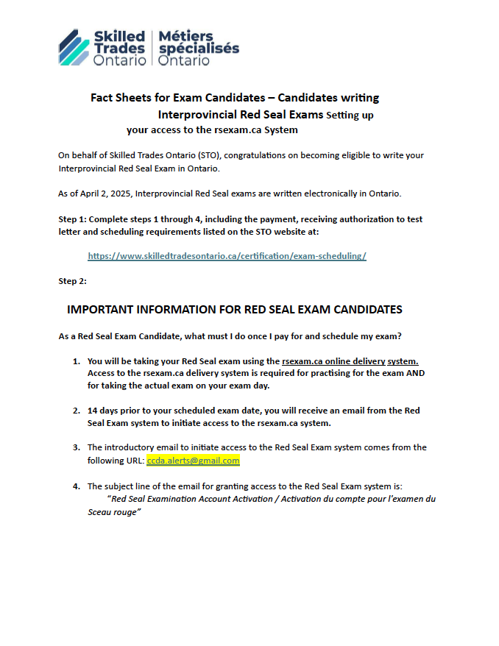

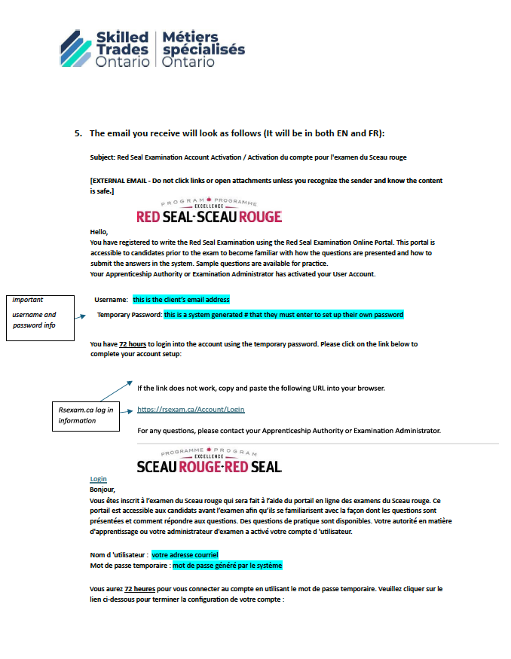

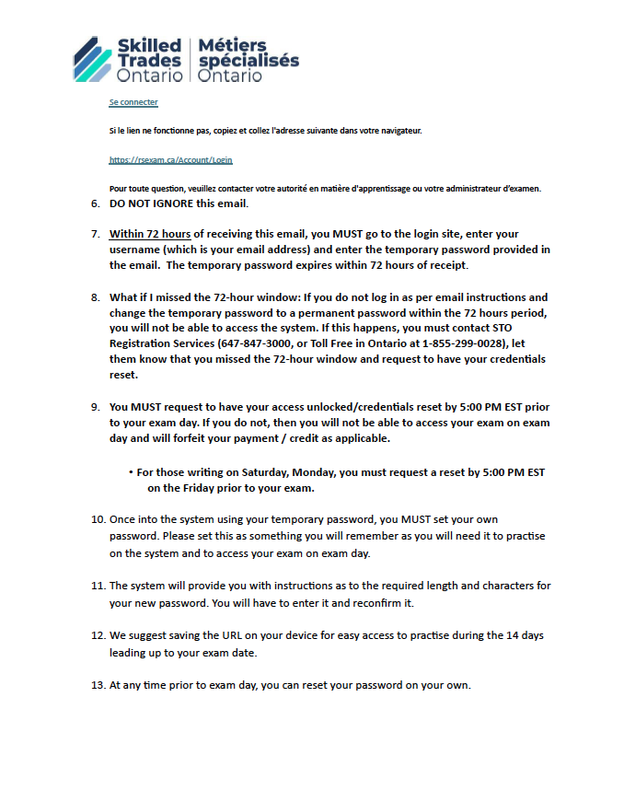

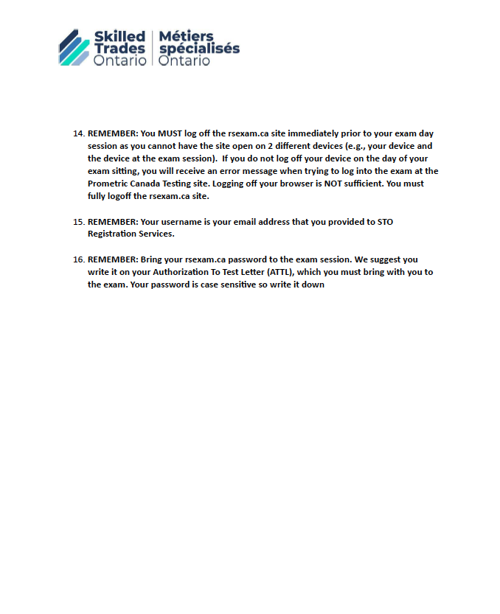

Work Sheet
Task 1: When should a Red Seal candidate expect to receive an email about accessing the online exam portal?
Answer:

______________________________________________________
Task 2: What is the username a candidate will use to access the Red Seal Examination Online portal?
Answer:

______________________________________________________
Task 3: How long is the temporary login password active before expiring?
Answer:

______________________________________________________
Task 4: If the temporary login password expires before the candidate creates a permanent login password, what should they do?
Answer:

______________________________________________________

Answers
Task 1: When should a Red Seal candidate expect to receive an email about accessing the online exam portal?
Answer: 14 days prior to the scheduled exam date

Task 2: What is the username a candidate will use to access the Red Seal Examination Online portal?
Answer: Their (the candidate’s) email address

Task 3: How long is the temporary login password active before expiring?
Answer: 72 hours

Task 4: If the temporary login password expires before the candidate creates a permanent login password, what should they do?
Answer: Contact STO registration services at 647-847-3000 or 1-855-299-0028 (toll free). This must be done by 5pm on the day prior to exam day.

Performance Descriptors
Levels | Performance Descriptors | Needs Work | Completes task with support from practitioner | Completes task independently
A1.2 | scans text to locate information
 | locates multiple pieces of information in simple texts
 | makes connections between sentences and between paragraphs in a single text
 | reads more complex texts to locate a single piece of information
 | follows the main events of descriptive, narrative and informational texts
 | obtains information from detailed reading
This task: Was successfully completed Needs to be tried again

Learner Comments:

Instructor (print): Learner (print):
__________________ _________________

