

Task Title: Random Acts of Kindness Day

OALCF Cover Sheet – Practitioner Copy

Learner Name: __________________________________________
Date Started: ___________________________________________
Date Completed: _________________________________________

Goal Path: | Employment | Apprenticeship
Secondary School | Post Secondary | Independence
Successful Completion: Yes No

Task Description: The learner will read a short blog post about Random Acts of Kindness Day and draft their own messages of thanks and appreciation.
Main Competency/Task Group/Level Indicator:
- Find and Use Information/Read continuous text/A1.2
- Communicate Ideas and Information/Write continuous text/B2.1
- Communicate Ideas and Information/Express oneself creatively/B4
Materials Required:
- Pen/pencil and paper and/or digital device
- Computer

Learner Information
Community events rely on people to promote awareness where they live. Learning more about different events can help you participate in your community.
Scan the card templates and read “How You Can Participate in Random Acts of Kindness Day”:
https://www.canadahelps.org/en/giving-life/how-you-can-participate-in-random-acts-of-kindness-day-with-canadahelps/



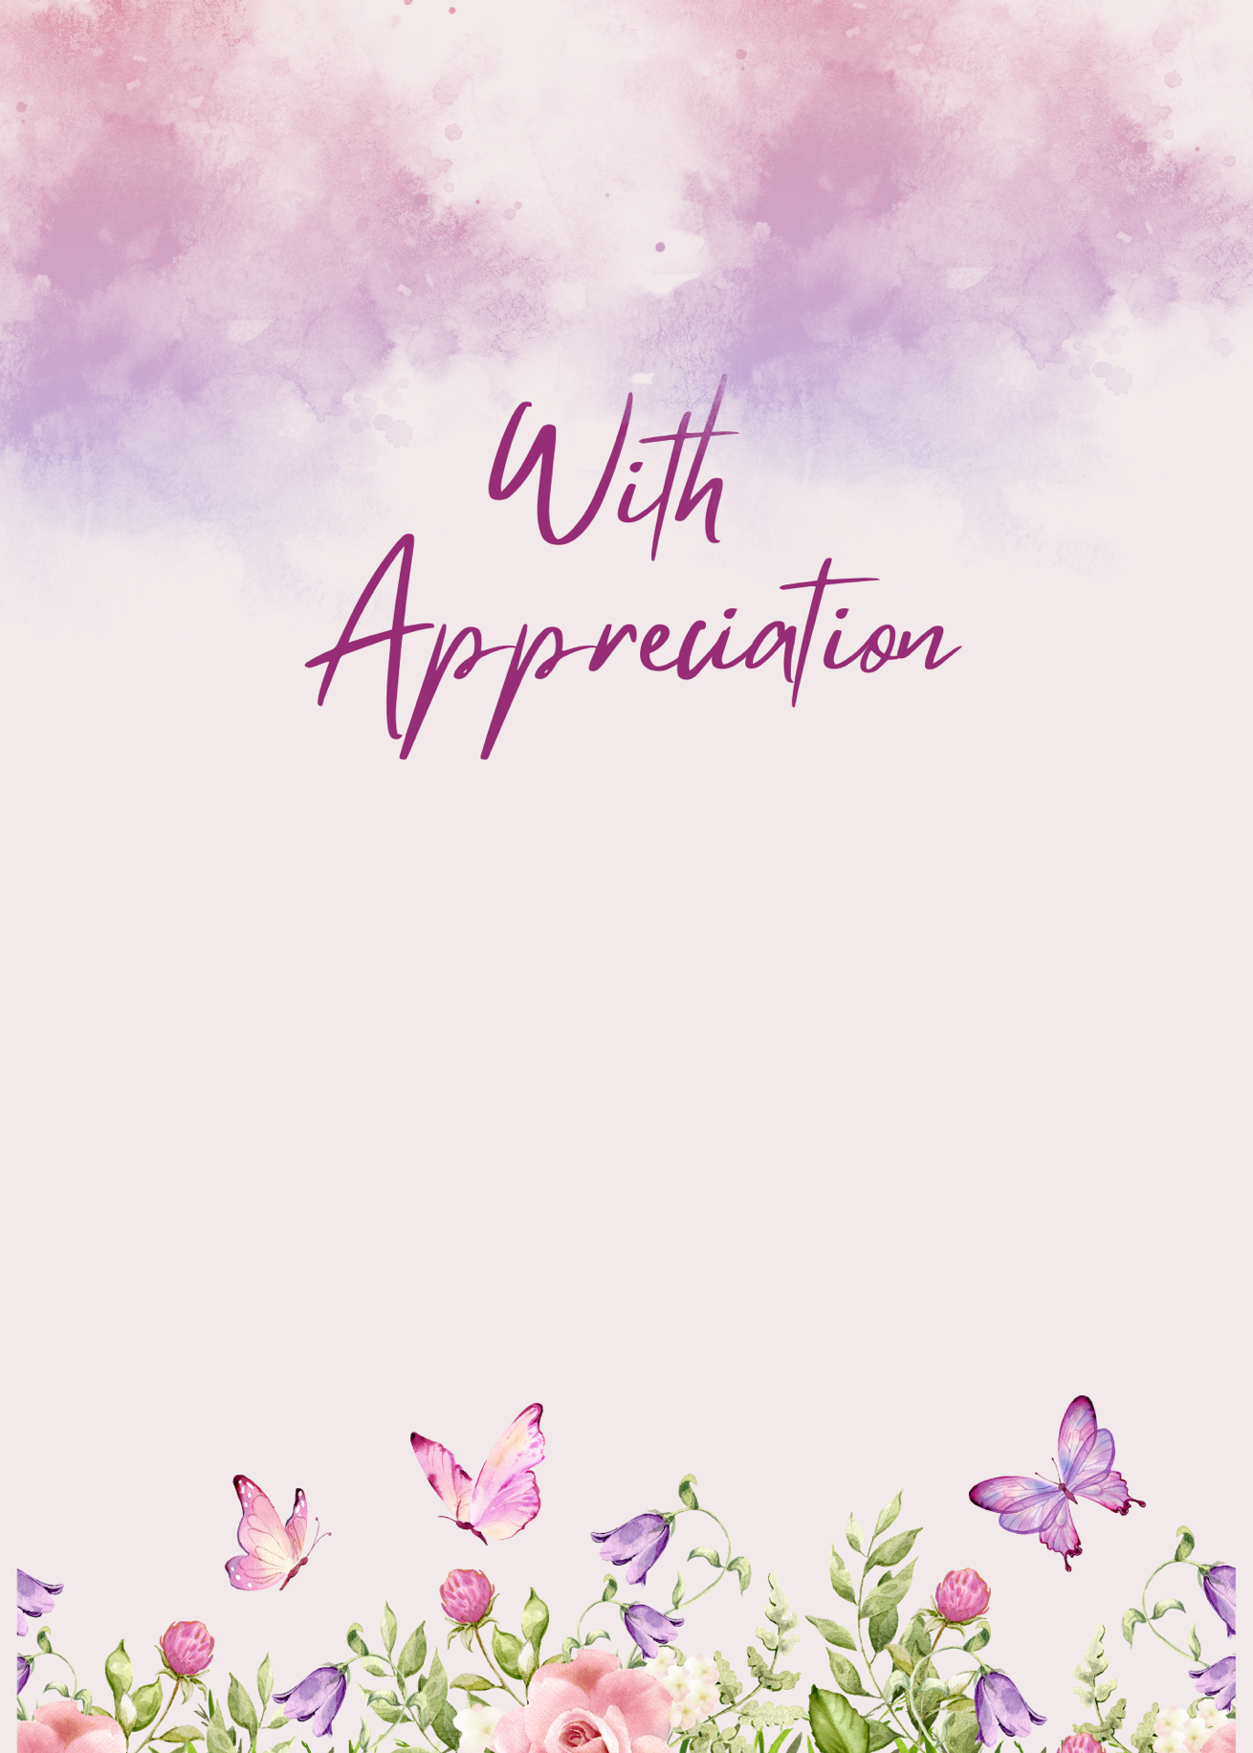

Work Sheet
Task 1: List three (3) acts of kindness someone could participate in without leaving their home.
Answer:

______________________________________________________
Task 2: Write a message of at least three (3) sentences to thank or appreciate a friend or family member.
Answer:

______________________________________________________
Task 3: Write a message of at least three (3) sentences to thank or appreciate a neighbour or acquaintance.
Answer:

______________________________________________________

Task 4: Write each message into one of the card templates provided, or into a card you’ve designed yourself. In each card, include the name of the person you are appreciating.
Answer: No written response required here.

Task completed: Yes:

Answers

Task 1: List three (3) acts of kindness someone could participate in without leaving their home.
Answer: Any three of
- support a fundraiser
- reach out to a loved one
- give the gift of giving
- send an e-card
- set up a monthly donation
- become a virtual volunteer

Task 2: Write a message of at least three (3) sentences to thank or appreciate a friend or family member.
Task 3: Write a message of at least three (3) sentences to thank or appreciate a neighbour or acquaintance.
Answers will vary. Following the article’s example, the learner could let the person know they’ve been thinking about them, ask how they’re doing, share a story, or recall a shared memory.

Task 4: Write each message into one of the card templates provided, or into a card you’ve designed yourself. In each card, include the name of the person you are appreciating.
Answers will vary.

Performance Descriptors
Levels | Performance Descriptors | Needs Work | Completes task with support from practitioner | Completes task independently
A1.2 | scans text to locate information
 | locates multiple pieces of information in simple texts
 | makes low-level inferences
 | follows the main events of descriptive, narrative, and informational texts
 | obtains information from detailed reading
B2.1 | writes simple texts to request, remind or inform
 | conveys simple ideas and factual information
 | uses sentence structure, upper and lower case and basic punctuation
 | uses highly familiar vocabulary
B4 | express oneself creatively, such as by writing journal entries, telling a story and creating art

This task: Was successfully completed Needs to be tried again

Learner Comments:

Instructor (print): Learner (print):
__________________ _________________

