

Task Title: Understanding an Apprenticeship Logbook

OALCF Cover Sheet – Practitioner Copy

Learner Name: __________________________________________
Date Started: ___________________________________________
Date Completed: _________________________________________

Goal Path: | Employment | Apprenticeship
Secondary School | Post Secondary | Independence
Successful Completion: Yes No

Task Description: The learner will review sections of the Apprenticeship Training Standard Logbook for Automotive Service Technicians and answer questions.
Main Competency/Task Group/Level Indicator:
- Find and Use Information/Read continuous text/A1.2
- Find and Use Information/Interpret documents/A2.2
Materials Required:
- Pen/pencil and paper and/or digital device
- Computer

Notes for Instructors/Practitioners
This task uses the Automotive Service Technician Apprenticeship Training Standard Logbook. It can be modified to reflect a different trade that is of interest to the learner. All tasks, except Task 5, will work for any trade. Tasks 5 references a specific page in the Automotive Service Technician logbook that lists specific skills required for this trade. This could easily be switched out for a sample page from a different trade logbook.

A complete list of Ontario trades is found on the STO website:
https://www.skilledtradesontario.ca/about-trades/trades-information/
Select “View Details” to open a trade-specific webpage. Select “Apprenticeship Training Standard (PDF)” to access a Training Standard Logbook for that trade.

Learner Information
Completing an apprenticeship in Ontario includes keeping a record of each skill an apprentice has mastered under supervision. This is one step that is completed when working towards achieving certification in a trade.

Read the selection from the Apprenticeship Training Standard Logbook for Automotive Service Technicians.
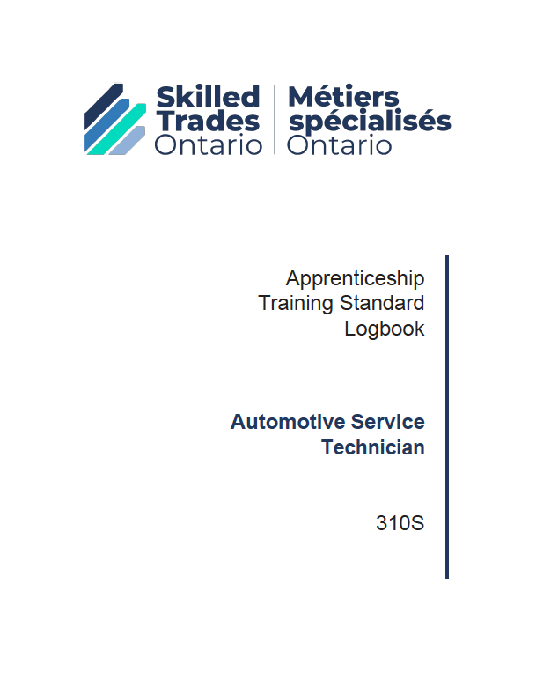

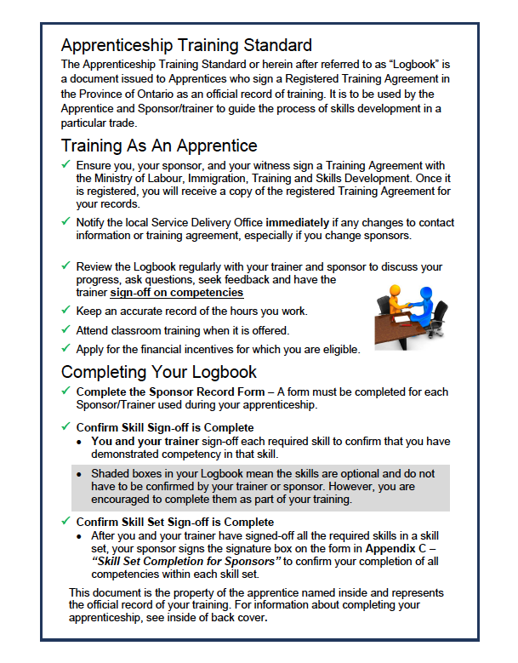

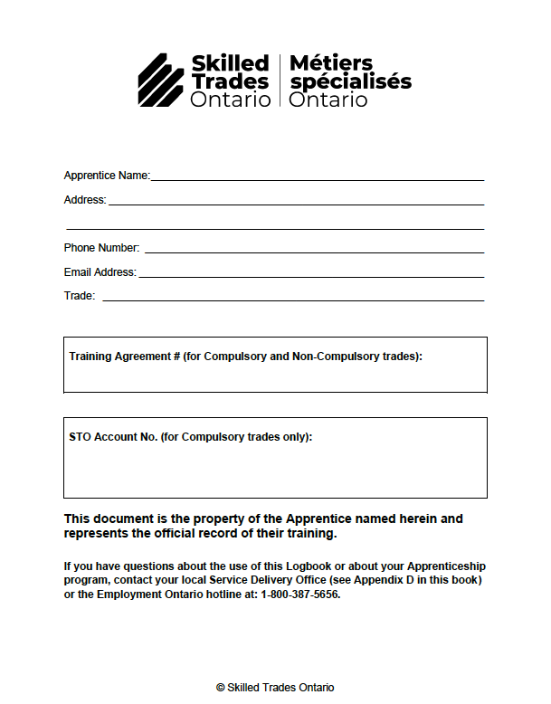

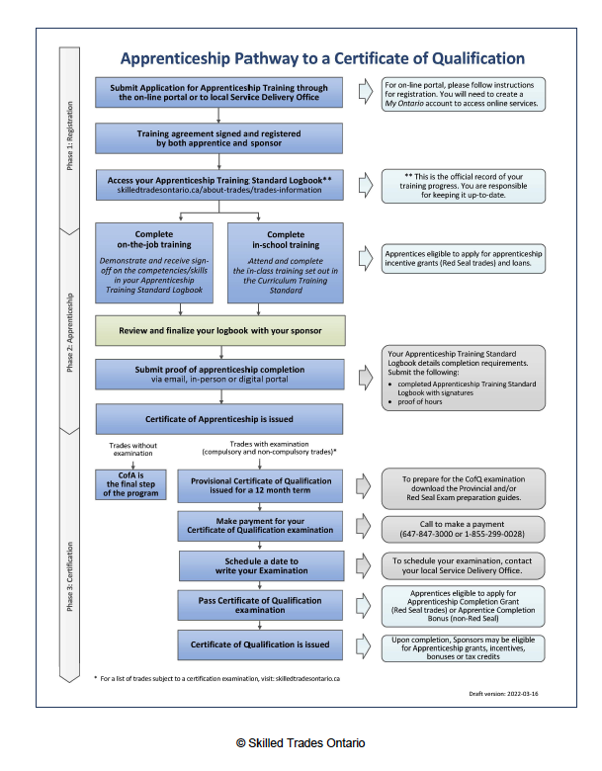

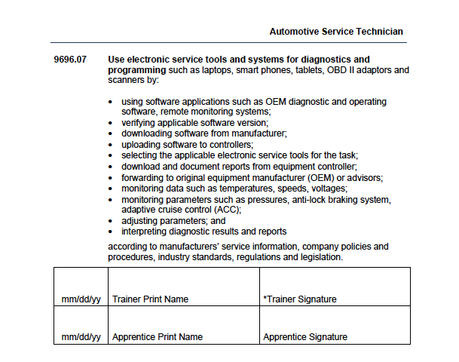

Source: https://www.skilledtradesontario.ca/wp-content/uploads/1970/01/Automotive-Service-Technician-310S-TS-EN-January-15th-2024-FINAL.pdf (pp. 1-4; p. 33)

Work Sheet
Task 1: List the individuals and organizations that must sign a Training Agreement.
Answer:

______________________________________________________
Task 2: List the three (3) requirements of completing your logbook.
Answer:

______________________________________________________
Task 3: What does it mean if there is a shaded box in the logbook?
Answer:

______________________________________________________
Task 4: An apprentice has completed both on-the-job and in-school training. List the next two (2) steps before a certificate of apprenticeship is issued.
Answer:

______________________________________________________
Task 5: On the page listing skill 9696.07, circle where the apprentice would sign.

Answer: No written response required here.

Task completed: Yes:

Answers
Task 1: List the individuals and organizations that must sign a Training Agreement.
Answer: You (the apprentice), your sponsor, your witness.

Task 2: List the three (3) requirements of completing your logbook.
Answer:
- Complete the Sponsor Record Form
- Confirm Skill Sign-off is Complete
- Confirm Skill Set Sign-Off is Complete

Task 3: What does it mean if there is a shaded box in the logbook?
Answer: Shaded boxes in your logbook mean the skills are optional and do not have to be confirmed by your training or sponsor. However, you are encouraged to complete them as part of your training.

Task 4: An apprentice has completed both on-the-job and in-school training. List the next two (2) steps before a certificate of apprenticeship is issued.
Answer:
- Review and finalize your logbook with your sponsor
- Submit proof of apprenticeship completion

Task 5: On the page listing skill 9696.07, circle where the apprentice would sign.

Answer:

Performance Descriptors
Levels | Performance Descriptors | Needs Work | Completes task with support from practitioner | Completes task independently
A1.2 | scans text to locate information
 | locates multiple pieces of information in simple texts
 | reads more complex texts to locate a single piece of information
 | follows the main events of descriptive, narrative and informational texts
 | obtains information from detailed reading
A2.2 | extracts information from tables and forms
 | uses layout to locate information
 | makes connections between parts of documents

This task: Was successfully completed Needs to be tried again

Learner Comments:

Instructor (print): Learner (print):
__________________ _________________

