
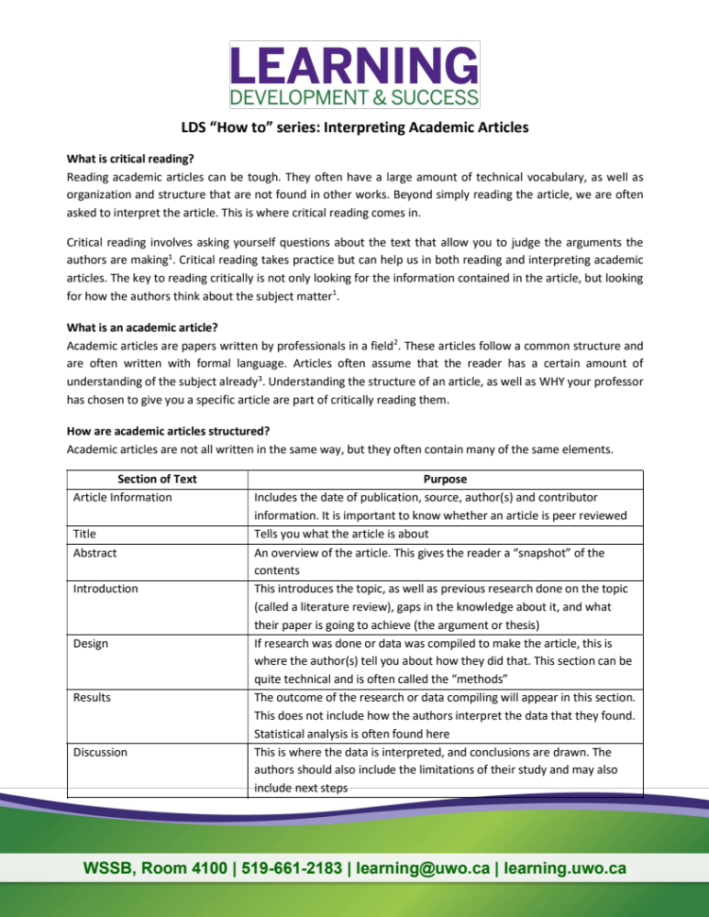

Task Title: Reading Strategies for Academic Articles

OALCF Cover Sheet – Practitioner Copy

Learner Name: __________________________________________
Date Started: ___________________________________________
Date Completed: _________________________________________

Goal Path: | Employment | Apprenticeship
Secondary School | Post Secondary | Independence
Successful Completion: Yes No

Task Description: The learner will read about strategies for understanding academic articles, then apply these strategies when reading a new article.
Main Competency/Task Group/Level Indicator:
- Find and Use Information/Read continuous text/A1.3
- Communicate Ideas and Information/Write continuous text/B2.3
Materials Required:
- Pen/pencil and paper and/or digital device
- Computer

Learner Information
Academic articles can be challenging compared to what students are used to reading in high school. Building strategies for learning how to read academic articles can help post-secondary students become more successful when transitioning to more complex material.

Read “Interpreting Academic Articles” from Western University’s Learning Development & Success department.

After reading “Interpreting Academic Articles”, read the academic article “The Impact of Artificial Intelligence (AI) on Students’ Academic Development”: https://www.mdpi.com/2227-7102/15/3/343



Interpreting Academic Articles

What is Critical Reading?
Reading academic articles can be tough. They often have a large amount of technical vocabulary, as well as organization and structure that are not found in other works. Beyond simply reading the article, we are often asked to interpret the article. This is where critical reading comes in.
Critical reading involves asking yourself questions about the text that allow you to judge the arguments the authors are making. Critical reading takes practice but can help us in both reading and interpreting academic articles. The key to reading critically is not only looking for the information contained in the article, but looking for how the authors think about the subject matter.

What is an Academic Article?
Academic articles are papers written by professionals in a field. These articles follow a common structure and are often written with formal language. Articles often assume that the reader has a certain amount of understanding of the subject already. Understanding the structure of an article, as well as WHY your professor has chosen to give you a specific article are part of critically reading them.

How are Academic Articles Structured?
Academic articles are not all written in the same way, but they often contain many of the same elements.

Section of Text | Purpose
Article Information | Includes the date of publication, source, author(s) and contributor information. It is important to know whether an article is peer reviewed.
Title | Tells you what the article is about
Abstract | An overview of the article. This gives the reader a “snapshot” of the contents.
Introduction | This introduces the topic, as well as previous research done on the topic (called a literature review), gaps in the knowledge about it, and what their paper is going to achieve (the argument or thesis).
Design | If research was done or data was compiled to make the article, this is where the author(s) tell you about how they did that. This section can be quite technical and is often called the “methods”.
Results | The outcome of the research or data compiling will appear in this section. This does not include how the authors interpret the data that they found. Statistical analysis is often found here.
Discussion | This is where the data is interpreted, and conclusions are drawn. The authors should also include the limitations of their study and may also include next steps.
References | The authors list articles, textbooks, and other sources that they have cited or used information from to make their own article.

Approaching Academic Articles
Critically reading an academic article takes time and practice. Often, they need to be looked at a few times to fully grasp the purpose of the article, methods, and overarching concepts.
Before diving in, it can be useful to skim the article. Look for sections that contain the main point of the article and find any words that you don’t understand. This can help prepare you for a more critical look at the contents.

Steps for Critically Reading an Academic Article
Now that we know what the components of a research article are for, how do we critically read an article?
Find the purpose (thesis) of the article | - What questions does the author ask?  - What arguments does the author make?  - Why are the authors writing this article?
Find the context of the article | - Is there a debate happening about the subject?  - Why does the paper matter?  - Who is this article written for?  - Is the article peer reviewed by other experts?
Assess the argument | - Is the argument biased?  - How strong is the argument?
Assess the evidence | - What evidence does the paper contain (peer reviewed articles, anecdotes, ethics, etc.)?  - How does the evidence fit into the context of the article?  - Do the results reflect what they are supposed to measure?
Evaluate the components | - Does the evidence adequately address the argument?  - Are there flaws in the methodology?  - Are there flaws in the evaluation of the data?  - What questions are left unanswered?

After reading the article and asking yourself the above questions, you can come to conclusions about the article and the arguments that the author(s) have made. Be sure to make note of questions that you have and ask questions if you are unsure about something! Remember - reading academic articles takes practice, so give yourself time to process the contents and read it multiple times if necessary.

Sourced from: https://learning.uwo.ca/selfhelp/skill_building_handouts/

Work Sheet
Task 1: List two (2) ways critical reading of academic texts is different from reading other types of texts.
Answer:

______________________________________________________
Task 2: How does the results section differ from the discussion section in an academic article?
Answer:

______________________________________________________

Task 3: Identify the purpose (thesis) of the article “The Impact of Artificial Intelligence (AI) on Students’ Academic Development”. Answer the questions from “Steps for Critically Reading an Academic Article” in your response.
Answer:

______________________________________________________
Task 4: Explain the context of the article “The Impact of Artificial Intelligence (AI) on Students’ Academic Development”. Answer the questions from “Steps for Critically Reading an Academic Article” in your response.
Answer:

______________________________________________________
Task 5: Explain the evidence cited in the article “The Impact of Artificial Intelligence (AI) on Students’ Academic Development”. Answer the questions from “Steps for Critically Reading an Academic Article” in your response.
Answer:

______________________________________________________

Answers

Task 1: List two (2) ways critical reading of academic texts is different from reading other types of texts.
Answer: Any two of
- Critical reading is the interpretation of an academic article, beyond simply reading and understanding what is written
- Critical reading involves asking questions about the text that allow you to judge the arguments the author is making
- Critical reading involves looking at the information contained in the article, as well as how the authors think about their subject matter

Task 2: How does the results section differ from the discussion section in an academic article?
Answer: The results section includes
- Outcome of the research or compilation of data
- Statistical analysis is often found here
- Note: Authors’ interpretation of their data is not typically found here.
The discussion section includes
- Data interpretation
- Conclusions
- Any study limitations
- Any next steps

Task 3: Identify the purpose (thesis) of the article “The Impact of Artificial Intelligence (AI) on Students’ Academic Development”. Answer the questions from “Steps for Critically Reading an Academic Article” in your response.
Answer:
Answers will vary. As with any critical analysis, readers may interpret the article in slightly different ways. Here is an example of how the critical analysis questions about identifying the thesis can be applied to the AI article.
Find the purpose (thesis) of the article:
- What questions does the author ask? The author is asking whether or not the role of AI in education is positively addressing the needs of learners or if the negative impacts outweigh the positive benefits.
- What arguments does the author make? The authors argue that AI does have significant benefits (e.g. personalized learning, increased student engagement) but also presents challenges (e.g. over-reliance on technology and decrease in critical reasoning). Given both positives and negatives to this technology, they argue for continued research into how AI can be incorporated into learning with essential considerations such as training, clear protocols for AI use, and guidelines protecting privacy.
- Why are the authors writing this article? “This study investigates the concerns and challenges associated with the integration of AI in education”. The authors are primarily concerned with how AI integration is affecting learning processes. They approach this question by surveying students and analyzing their self-reflections about how they are using this tool.

Task 4: Explain the context of the article “The Impact of Artificial Intelligence (AI) on Students’ Academic Development”. Answer the questions from “Steps for Critically Reading an Academic Article” in your response.
Answers will vary. As with any critical analysis, readers may interpret the article in slightly different ways. Below is an example of how the critical analysis questions about context can be applied to the AI article.
Find the context of the article:
- Is there a debate happening about the subject? With most students reporting that they use AI in their learning, the authors believe there is ongoing debate about the pros and cons of using this tool.
- Why does the paper matter? The authors suggest that research on this topic matters because AI has been quickly incorporated into post-secondary learning without enough consideration for whether student learning is benefiting from AI use.
- Who is this article written for? The target audience of this article is educators (primarily post-secondary) and anyone interested in how AI is affecting student learning.
- Is the article peer reviewed by other experts? The article is peer reviewed: The journal, Education Sciences, is peer reviewed and information is available by clicking in the journal title. However, a learner may not notice this on the website and should not be penalized for leaving this question blank if they cannot find this information.

Task 5: Explain the evidence cited in the article “The Impact of Artificial Intelligence (AI) on Students’ Academic Development”. Answer the questions from “Steps for Critically Reading an Academic Article” in your response.
Answers will vary. As with any critical analysis, readers may interpret the article in slightly different ways. Below is an example of how the critical analysis questions about evidence can be applied to the AI article.
Assess the evidence:
- What evidence does the paper contain (peer reviewed articles, anecdotes, ethics, etc.)? Evidence is primarily drawn from self-administered questionnaires that were distributed online and contain a mix of quantitative and qualitative data. Questionnaires were sent to second year students in engineering programs with a high integration of AI as a learning tool. The authors reference several related research papers in this article.
- How does the evidence fit into the context of the article? The primary evidence in this article is the conclusions drawn from student surveys about their AI use. This directly responds to the research questions the authors are asking.
- Do the results reflect what they are supposed to measure? Yes. The study questions, and analysis/interpretation thereof, reflect the authors’ desire to inquire further into how and why students are using AI, and what their experiences have been. A mix of closed and open-ended questions has allowed them to analyze student experiences and respond to the variables they are trying to measure in their study (e.g. analyzing written responses to determine positive/negative/neutral impacts of AI on collaboration and teamwork, for example).

Performance Descriptors
Levels | Performance Descriptors | Needs Work | Completes task with support from practitioner | Completes task independently
A1.3 | integrates several pieces of information from texts
 | manages unfamiliar elements (e.g. vocabulary, content, topic) to complete tasks
 | identifies the purpose and relevance of text
 | skims to get the gist of longer texts
 | begins to recognize bias and points of view in texts
 | infers meaning which is not explicit in texts
 | uses organizational features, such as headings, to locate information
 | follows the main events of descriptive, narrative, informational and persuasive texts
B2.3 | writes texts to present information, summarize, express opinions, present arguments, convey ideas, or persuade
 | selects and uses vocabulary, tone, and structure appropriate to the task
B2.3 cont’d | organizes and sequences writing to communicate effectively
 | uses a variety of vocabulary, structures, and approaches to convey main ideas with supporting details

This task: Was successfully completed Needs to be tried again

Learner Comments:

Instructor (print): Learner (print):
__________________ _________________

