

Task Title: Locating Local Weather Information

OALCF Cover Sheet – Practitioner Copy

Learner Name: __________________________________________
Date Started: ___________________________________________
Date Completed: _________________________________________

Goal Path: | Employment | Apprenticeship
Secondary School | Post Secondary | Independence
Successful Completion: Yes No

Task Description: The learner will use a website to find information about local weather.
Main Competency/Task Group/Level Indicator:
- Find and Use Information/Interpret documents/A2.1
- Use Digital Technology/D.2
Materials Required:
- Pen/pencil and paper and/or digital device
- Computer

Learner Information
There are many reasons people want to know the weather today or a few days from now. People often look up the weather to choose clothing, prepare in advance of a storm, or plan travel.

Go to the Weather Network page:
https://www.theweathernetwork.com/en

Instructions:
In the “Enter location” box, type the name of your town or city. Click the correct entry from the drop-down menu.
Make sure you choose your location in Ontario.
If your location does not appear, try typing the name of a larger city close by.

Work Sheet
Task 1: What is today’s temperature?
Answer:

______________________________________________________
Task 2: What is the wind speed today?
Answer:

______________________________________________________
Task 3: What time is sunset today?
Answer:

______________________________________________________
Task 4: Click on “all 14 days” to see the weather for the next 14 days. List two (2) changes that are expected in the weather over the next 14 days.
Answer:

______________________________________________________
Answers
Task 1: What is today’s temperature?
Answers will vary.
Task 2: What is the wind speed today?
Answer will vary.
Task 3: What time is sunset today?
Answers will vary.
Task 4: Click on “all 14 days” to see the weather for the next 14 days. List two (2) changes that are expected in the weather over the next 14 days.
Answers will vary. The learner may notice an increase or decrease in temperature, increase in snow, changes in wind or humidity, etc.

Note for Practitioners: A screenshot of how weather information is displayed (as of December 2025) is below.

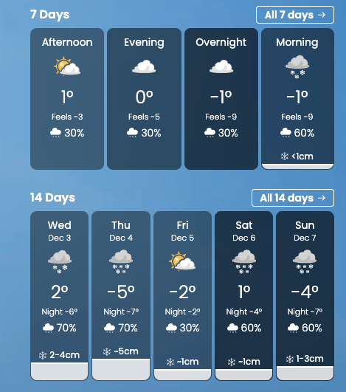
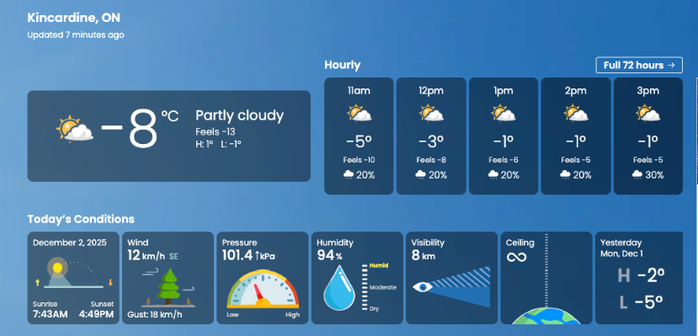

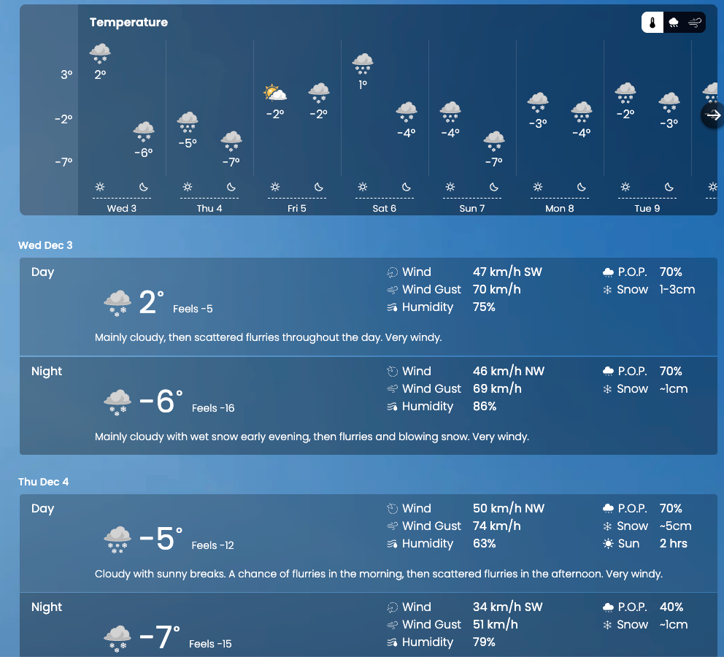
14-day outlook:

Performance Descriptors
Levels | Performance Descriptors | Needs Work | Completes task with support from practitioner | Completes task independently
A2.1 | scans to locate specific details
 | interprets brief text and common symbols
D.2 | selects and follows appropriate steps to complete tasks
 | locates and recognizes functions and commands
 | makes low-level inferences to interpret icons and text
 | begins to identify sources and evaluate information
 | performs simple searches using keywords (e.g. internet, software help menu)

This task: Was successfully completed Needs to be tried again

Learner Comments:

Instructor (print): Learner (print):
__________________ _________________

