

Task Title: Completing an Apprenticeship Logbook

OALCF Cover Sheet – Practitioner Copy

Learner Name: __________________________________________
Date Started: ___________________________________________
Date Completed: _________________________________________

Goal Path: | Employment | Apprenticeship
Secondary School | Post Secondary | Independence
Successful Completion: Yes No

Task Description: The learner will enter skill completion information into an apprentice logbook for Agriculture Equipment Technician.
Main Competency/Task Group/Level Indicator:
- Find and Use Information/Read continuous text/A1.2
- Communicate Ideas and Information/Complete and create documents/B3.2a
- Understand and Use Numbers/Manage time/C2.1
Materials Required:
- Pen/pencil and paper and/or digital device

Notes for Instructors/Practitioners
While this task uses the Agriculture Equipment Technician Apprenticeship Training Standard Logbook, it can be modified to reflect a trade that is of interest to the learner. All task questions could be switched out for a sample page from a different trade logbook.

A complete list of Ontario trades is found on the STO website:
https://www.skilledtradesontario.ca/about-trades/trades-information/
Select “View Details” to open a trade-specific webpage.
Select “Apprenticeship Training Standard (PDF)” to access a Training Standard Logbook for that trade.

Learner Information
Completing an apprenticeship in Ontario includes keeping a record of each skill an apprentice has mastered under supervision. Properly entering information into the logbook is an important skill for apprentices so they can accurately track progress towards completion.

Read the excerpt from the Apprenticeship Training Standard Logbook for Agricultural Equipment Technician.

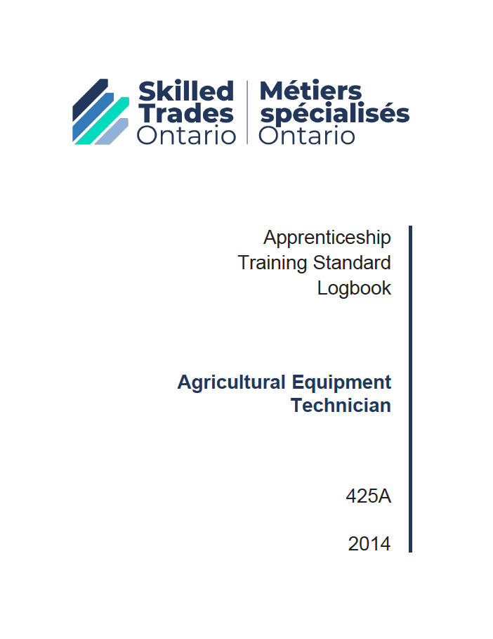

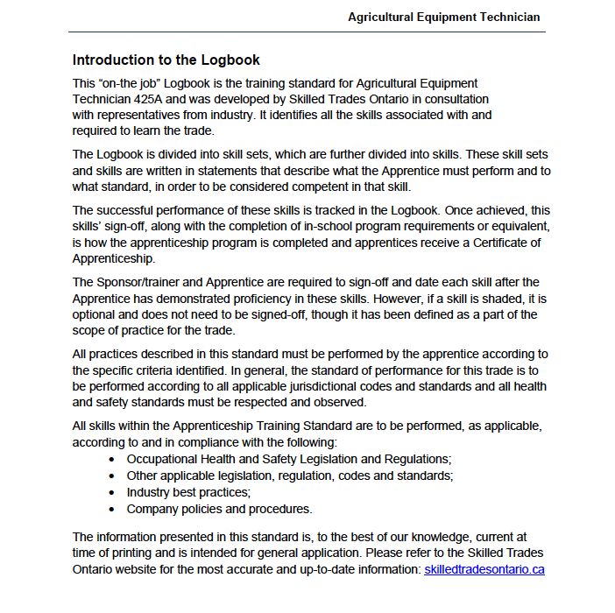

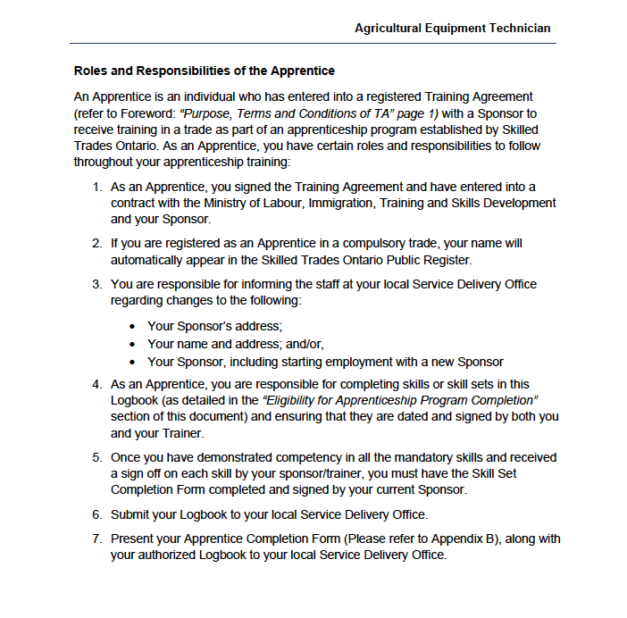

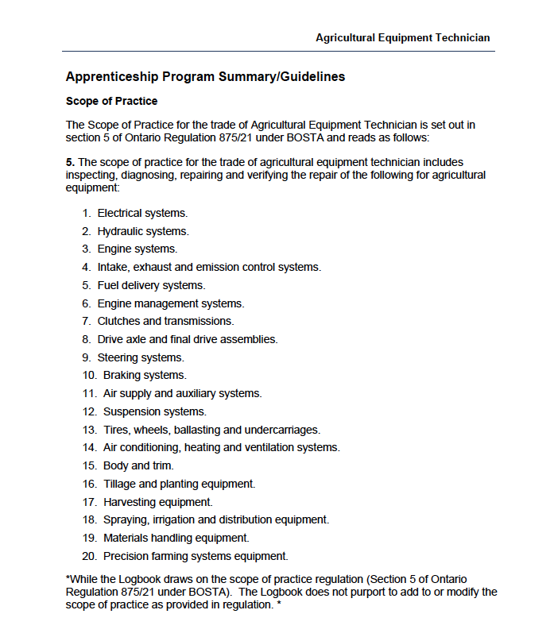

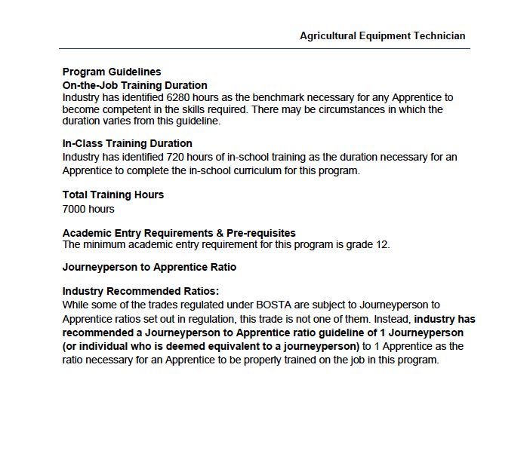

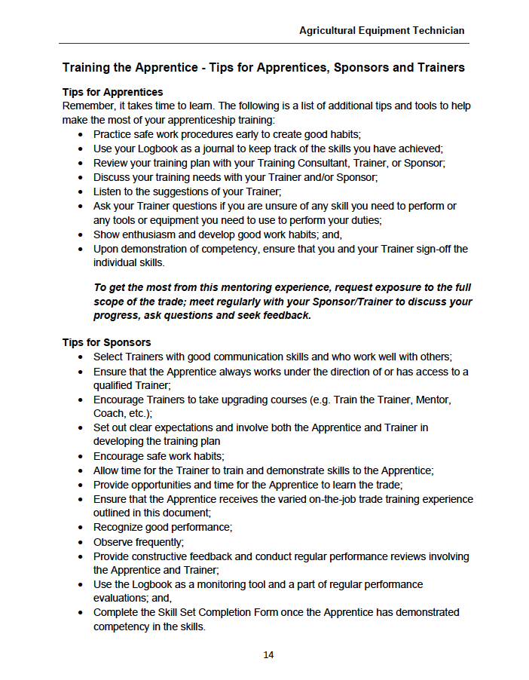

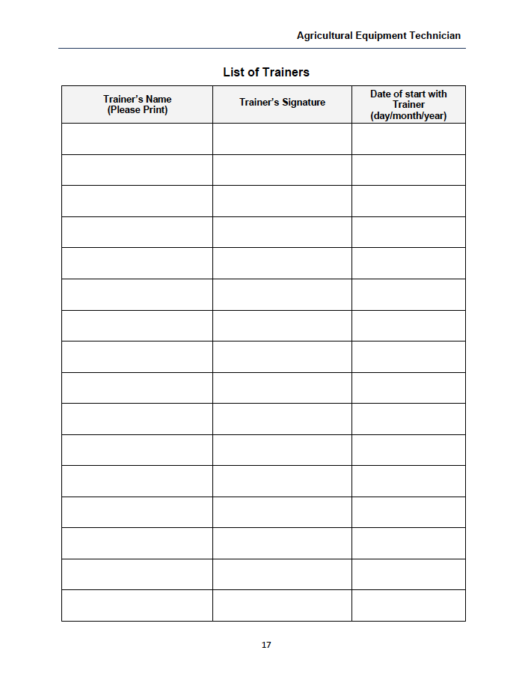

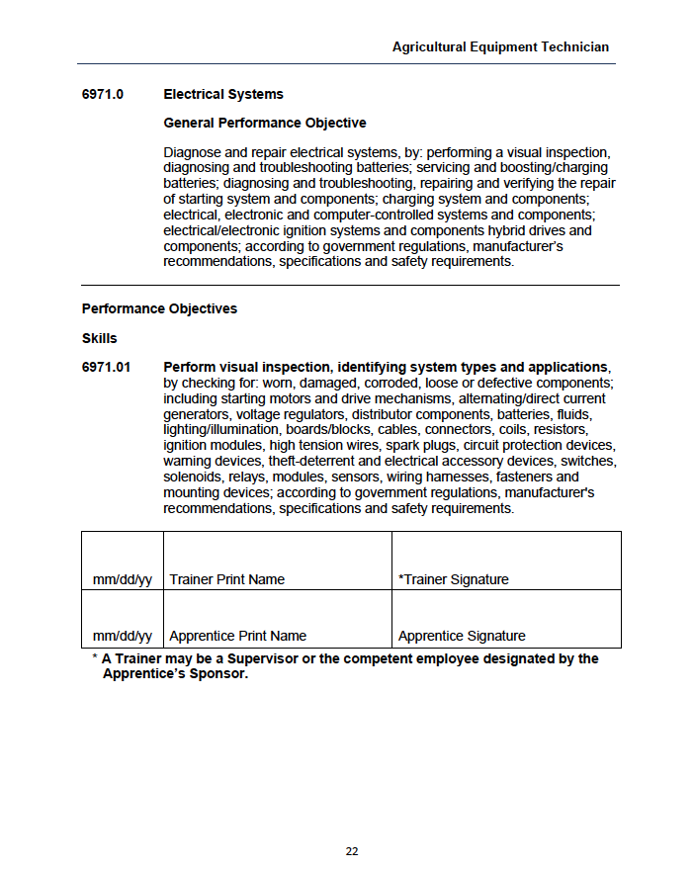

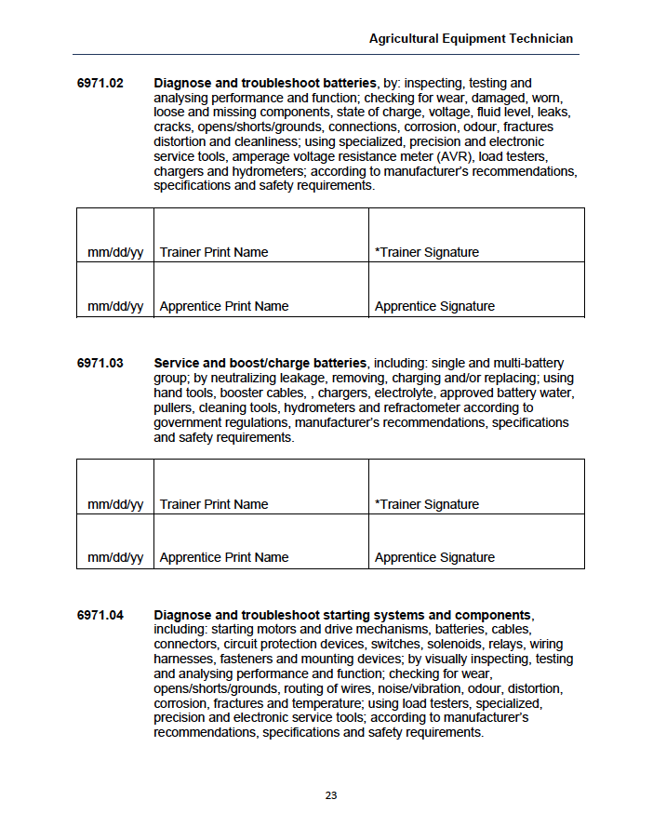

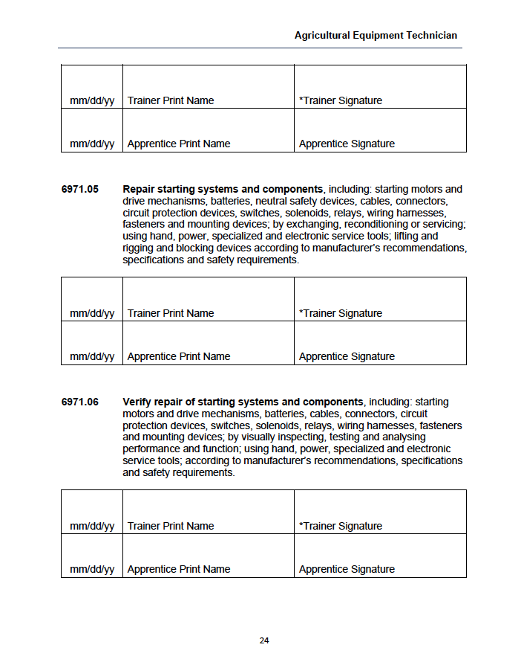

Source: https://www.skilledtradesontario.ca/wp-content/uploads/1970/01/Agricultural-Equipment-Technician-425A-EN-TS-V100-2014.pdf [Excerpts: pp.1, 10, 12, 17, 18, 21, 24, 29-31]

Work Sheet
Task 1: Under “List of Trainers”, enter your instructor’s name and June 1, 2026 as the first entry. If completing this task in person, ask your instructor to sign if needed.
Answer: No written response required here.

Task completed: Yes:

Task 2: An apprentice completed skill 6971.01 on June 1, 2026. Enter this information into the log. Use your name as the apprentice and your instructor’s name as the trainer. Sign the log if needed. If completing this task in person, ask your instructor to sign if needed.
Answer: No written response required here.

Task completed: Yes:

Task 3: An apprentice completed skill 6971.05 on May 2, 2027. Enter this information into the log. Use your name as the apprentice and your instructor’s name as the trainer. Sign the log if needed. If completing this task in person, ask your instructor to sign if needed.
Answer: No written response required here.

Task completed: Yes:

Answers
Task 1: Under “List of Trainers”, enter your instructor’s name and June 1, 2026 as the first entry. If completing this task in person, ask your instructor to sign if needed.
Answer: Learner should have filled in the List of Trainers form found on page 9 of the Learner Copy of this document.

Instructor Name Instructor Signature 1/June/2026
Task 2: An apprentice completed skill 6971.01 on June 1, 2026. Enter this information into the log. Use your name as the apprentice and your instructor’s name as the trainer. Sign the log if needed. If completing this task in person, ask your instructor to sign if needed.

Answer: Learner should have filled in the chart found at the bottom of page 10 of the Learner Copy of this document.

06/01/2026 Instructor Name Instructor Signature
06/01/2026 Learner Name Learner Signature

Task 3: An apprentice completed skill 6971.05 on May 2, 2027. Enter this information into the log. Use your name as the apprentice and your instructor’s name as the trainer. Sign the log if needed. If completing this task in person, ask your instructor to sign if needed.
Answer: Learner should have filled in the chart found in the middle of page 12 of the Learner Copy of this document.

05/02/2027 Instructor Name Instructor Signature
05/02/2027 Learner Name Learner Signature

Performance Descriptors
Levels | Performance Descriptors | Needs Work | Completes task with support from practitioner | Completes task independently
A1.2 | scans text to locate information
 | locates multiple pieces of information in simple texts
B3.2a | uses layout to determine where to make entries
 | follows instructions on documents
C2.1 | understands and uses common date formats

This task: Was successfully completed Needs to be tried again

Learner Comments:

Instructor (print): Learner (print):
__________________ _________________

