

Task Title: Campus Buildings and Directions

OALCF Cover Sheet – Practitioner Copy

Learner Name: __________________________________________
Date Started: ___________________________________________
Date Completed: _________________________________________

Goal Path: | Employment | Apprenticeship
Secondary School | Post Secondary | Independence
Successful Completion: Yes No

Task Description: The learner will find locations and give directions using a university campus map.
Main Competency/Task Group/Level Indicator:
- Find and Use Information/Interpret documents/A2.2
- Communicate Ideas and Information/Interact with others/B1.1
Materials Required:
- Pen/pencil/highlighter and paper

Learner Information
Most colleges and universities have multiple buildings. It can be difficult to navigate around a new campus. Using a campus map can help students locate buildings where classes and other services are found.

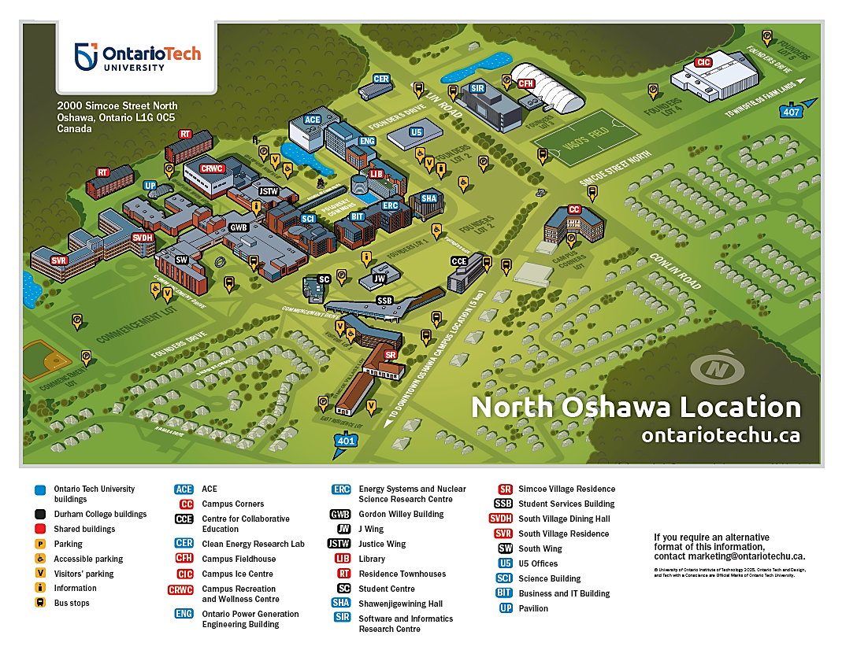
Scan the Ontario Tech University’s North Oshawa campus map.

Work Sheet
Task 1: Circle the science building on the map.
Answer: No written response required here.

Task completed: Yes:
______________________________________________________
Task 2: Circle the library on the map.
Answer: No written response required here.

Task completed: Yes:
______________________________________________________
Task 3: Circle the ACE building on the map.
Answer: No written response required here.

Task completed: Yes:
______________________________________________________
Task 4: A student has a class in the science building, then a study session in the library. After the study session, they have a class in the ACE building. Give your instructor directions for a walking route the student could take. Describe buildings and landmarks they would pass.
Answer: No written response required here.

Task completed: Yes:

______________________________________________________

Answers
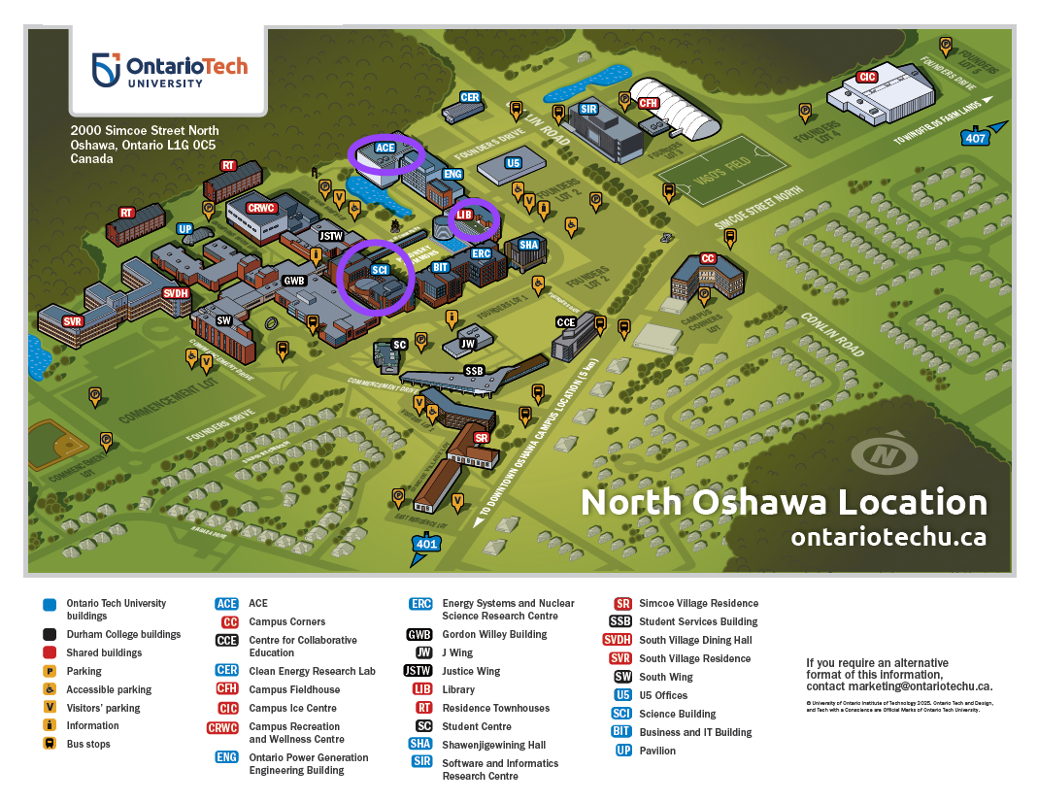

Task 3

Task 2

Task 1

Task 4: A student has a class in the science building, then a study session in the library. After the study session, they have a class in the ACE building. Give your instructor directions for a walking route the student could take. Describe buildings and landmarks they would pass.
Answer will vary. An example is as follows:
After leaving the science building, walk on Founders Drive towards the Business and IT building. On your left, you will pass the Business and IT building, the Energy Systems and Nuclear Science Research Centre, and Shawenjigewining Hall. Shawenjigewining Hall is on the corner; turn left here. The next building on your left will be the library. When you leave the library, continue up the road in the opposite direction from Shawenjigewining Hall. You will pass the Ontario Power Generation Engineering Building on your left. The next building on your left will be the ACE building.

Performance Descriptors
Levels | Performance Descriptors | Needs Work | Completes task with support from practitioner | Completes task independently
A2.2 | locates information in simple graphs and maps
 | uses layout to locate information
 | makes connections between parts of documents
B1.1 | chooses appropriate language in exchanges with clearly defined purposes
 | participates in short, simple exchanges
 | gives short, straightforward instructions or directions
 | speaks or signs clearly in a focused and organized way

This task: Was successfully completed Needs to be tried again

Learner Comments:

Instructor (print): Learner (print):
__________________ _________________

