

Task Title: Calculate Water Volume and Cost to Fill Pools

OALCF Cover Sheet – Practitioner Copy

Learner Name: __________________________________________
Date Started: ___________________________________________
Date Completed: _________________________________________

Goal Path: | Employment | Apprenticeship
Secondary School | Post Secondary | Independence
Successful Completion: Yes No

Task Description: The learner will calculate the volume and cost of water needed to fill backyard pools with different dimensions.
Main Competency/Task Group/Level Indicator:
- Understand and Use Numbers/Manage money/C1.2
- Understand and Use Numbers/Use measures/C3.3
Materials Required:
- Pen/pencil and paper and/or digital device
- Calculator or digital device with calculator function

Learner Information
Many people decide to set up an above-ground pool during the summer months. When setting up a pool, it is important to determine how much water will be needed to fill it. If you live in an area where you are charged for water, it is important to estimate the cost of filling the pool before you begin.
Scan the Volume Formulas and the specifications for the round and rectangular pools.

Volume Formulas

Volume of square or rectangular objects = length x width x height

Volume of circular or round objects = ∏r² x height
∏ = 3.14
r = radius (1/2 of the diameter of the circle)

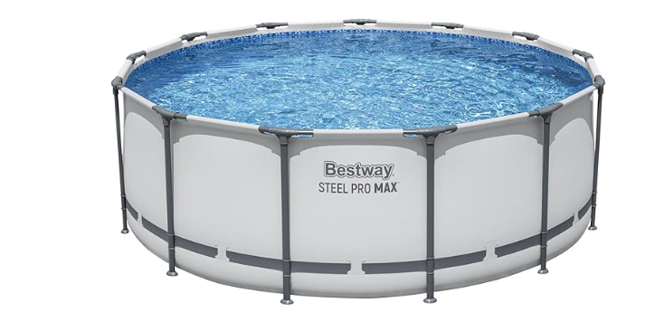

Round Pool: 30 feet circumference, 20 feet diameter, 3 feet deep

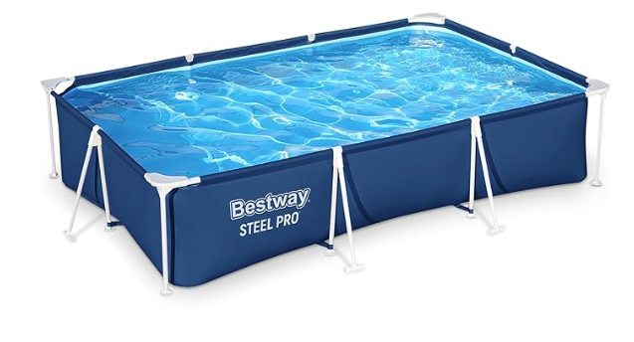

Rectangular Pool: 30 feet long, 6 feet wide, 2 feet deep

Work Sheet
Task 1: Calculate the total volume of water needed to fill the round pool to 1/2 foot (6 inches) from the top.
Answer:

______________________________________________________
Task 2: If the cost of water is $0.04 per cubic foot, how much will it cost to fill the round pool?
Answer:

______________________________________________________
Task 3: Calculate the total volume of water needed to fill the rectangular pool to 1/2 foot (6 inches) from the top.
Answer:

______________________________________________________
Task 4: If the cost of water is $0.04 per cubic foot, how much will it cost to fill the rectangular pool?
Answer:

______________________________________________________
Task 5: Both pools cost the same amount to purchase. Once the customer pays for water to fill the pool, which pool would be the cheaper option and by how much?
Answer:

______________________________________________________

Answers
Task 1: Calculate the total volume of water needed to fill the round pool 1/2 foot (6 inches) from the top.
Answer:
Radius = Diameter/2
Radius = 20/2 = 10 feet

Volume = ∏r² x height
Volume = (3.14)(10²) x (3-0.5)
Volume = (3.14)(100) x (2.5)
Volume = 314 x 2.5
Volume = 785 feet³

Task 2: If the cost of water is $0.04 per cubic foot, how much will it cost to fill the round pool?
Answer: 785 x 0.04 = $31.40
Task 3: Calculate the total volume of water needed to fill the rectangular pool 1/2 foot (6 inches) from the top.
Answer:
Volume = length x width x height
Volume = 30 x 6 x (2-0.5)
Volume = 30 x 6 x 1.5
Volume = 270 feet³

Task 4: If the cost of water is $0.04 per cubic foot, how much will it cost to fill the rectangular pool?
Answer: 270 x 0.04 = $10.80
Task 5: Both pools cost the same amount to purchase. Once the customer pays for water to fill the pool, which pool would be the cheaper option and by how much?
Answer: The rectangular pool is the cheaper option by $20.60 ($31.40 - $10.80).

Performance Descriptors
Levels | Performance Descriptors | Needs Work | Completes task with support from practitioner | Completes task independently
C1.2 | calculates using numbers expressed as whole numbers, fractions, decimals, percentages and integers
 | interprets and applies rates (e.g. $/kg, $/1)
 | chooses and performs required operation(s); may make inferences to identify required operation(s)
 | selects appropriate steps to reach solutions
 | represents costs and rates using monetary symbols, decimals and percentages
 | uses strategies to check accuracy (e.g. estimating, using a calculator, repeating a calculation, using the reverse operation)
C3.3 | calculates using numbers expressed as whole numbers, fractions, decimals, percentages and integers
 | calculates the radius, diameter and circumference of circles
C3.3 cont. | understands and uses formulas for finding the perimeter, area and volume of non-rectangular, composite shapes
 | chooses and performs required operations; makes inferences to identify required operations
 | uses strategies to check accuracy (e.g. estimating, using a calculator, repeating a calculation, using the reverse operation)

This task: Was successfully completed Needs to be tried again
Learner Comments:

Instructor (print): Learner (print):
__________________ _________________

