

Task Title: Calculating Petty Cash

OALCF Cover Sheet – Practitioner Copy

Learner Name: __________________________________________
Date Started: ___________________________________________
Date Completed: _________________________________________

Goal Path: | Employment | Apprenticeship
Secondary School | Post Secondary | Independence
Successful Completion: Yes No

Task Description: The learner will enter petty cash amounts into a table and calculate the monthly closing balance.
Main Competency/Task Group/Level Indicator:
- Communicate Ideas and Information/Complete and create documents/B3.2a
- Understand and Use Numbers/Manage money/C1.1
Materials Required:
- Pen/pencil and paper and/or digital device
- Calculator or digital device with calculator function (optional)

Learner Information
Administrative and clerical assistants are often responsible for office petty cash. Petty cash is money that can be used by employees for small, incidental purchases such as coffee supplies, stamps, or parking costs. Petty cash amounts are typically tracked and reconciled at the end of each month.

Scan “March 2026 Petty Cash Log” and “March 2026 Petty Cash Receipts”.

March 2026 Petty Cash Log
Date | Amount | Employee Name | Description of Purchase | Petty Cash Balance

Opening Balance March 1, 2026: $300
Closing Balance March 31, 2026:

March 2026 Petty Cash Receipts

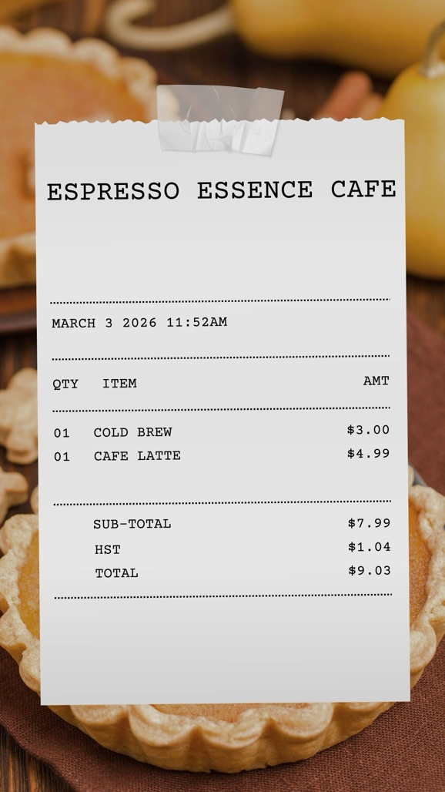
Receipt #1
Note on back of receipt:
- Fatima S.
- Coffee purchase with client before
meeting on March 3

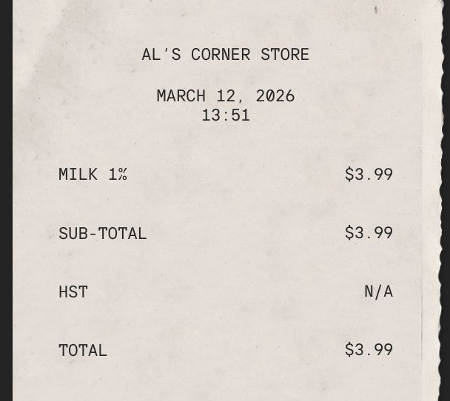
Receipt #2
Note on back of receipt:
- Joel G.
- Milk for staff break room

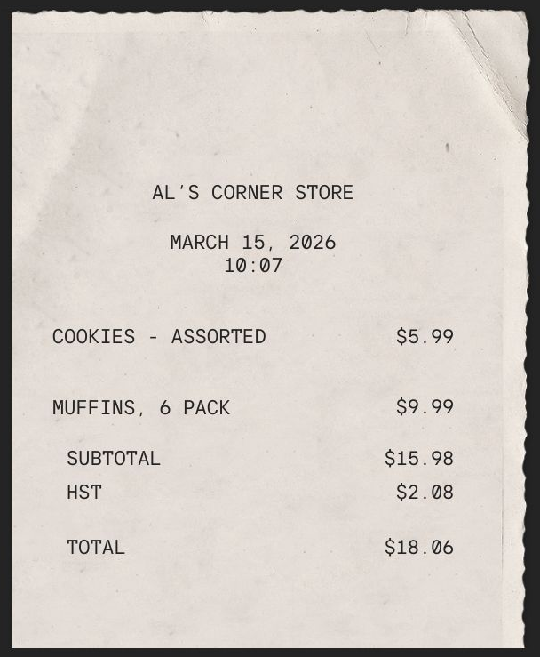
Receipt #3
Note on back of receipt:
- Joel G.
- Snacks for monthly staff
meeting

Receipt #4
March 20, 2026
I paid for parking downtown when I was meeting a client.
Total was $4.00 for the day. I paid with coins.

Thanks,
Joel!

Work Sheet
Task 1: Enter the petty cash receipts into the March 2026 Petty Cash Log and calculate the petty cash closing balance for March.
Answer: No written response required here.

Task completed: Yes:
______________________________________________________
Task 2: Calculate the total amount reimbursed to
- Fatima

Answer:

b) Joel
Answer:

______________________________________________________

Answers

Task 1: Enter the petty cash receipts into the March 2026 Petty Cash Log and calculate the petty cash closing balance for March.
Answer:
March 2026 Petty Cash Log
Date | Amount | Employee Name | Description of Purchase | Petty Cash Balance
March 3 2026 | $9.03 | Fatima S. | Coffee with client | $290.97
March 12, 2026 | $3.99 | Joel G. | Milk for break room | $286.98
March 15, 2026 | $18.06 | Joel G. | Snacks for staff meeting | $268.92
March 20, 2026 | $4.00 | Joel G. | Parking for client meeting | $264.92

Opening Balance March 1, 2026: $300
Closing Balance March 31, 2026: $264.92

Task 2: Calculate the total amount reimbursed to
a) Fatima
Answer: $9.03
b) Joel
Answer: $3.99 + $18.06 + $4.00 = $26.05

Performance Descriptors
Levels | Performance Descriptors | Needs Work | Completes task with support from practitioner | Completes task independently
B3.2a | uses layout to determine where to make entries
 | follows instructions on documents
C1.1 | adds, subtracts, multiplies and divides whole numbers and decimals
 | identifies and performs required operation
 | follows apparent steps to reach solutions
 | interprets and represents costs using monetary symbols and decimals
 | uses strategies to check accuracy (e.g. estimating, using a calculator, repeating a calculation, using the reverse operation)

This task: Was successfully completed Needs to be tried again

Learner Comments:

Instructor (print): Learner (print):
__________________ _________________

