

Task Title: Write an Email to a College

OALCF Cover Sheet – Practitioner Copy

Learner Name:___________________________________________
Date Started:____________________________________________
Date Completed: _________________________________________
Successful Completion: Yes No

Goal Path: | Employment | Apprenticeship
Secondary School | Post Secondary | Independence

Task Description: The learner will write an email requesting information about a College tuition payment plan.

Main Competency/Task Group/Level Indicator
- Find and Use Information/Read continuous text/A1.2
- Communicate Ideas and Information/Write continuous text/B2.2
- Use Digital Technology/D.2

Materials Required:
- Computer with access to email program
Learner Information
When applying to colleges or universities, people may need more information than is posted on the website. Prospective students may send emails to ask questions. For example, students may need to contact admissions, financial aid, or program offices before submitting an application.

Read “George Brown College Payment Plan” (2 pages) and “George Brown College Payment Plan: Frequently Asked Questions” (2 pages).

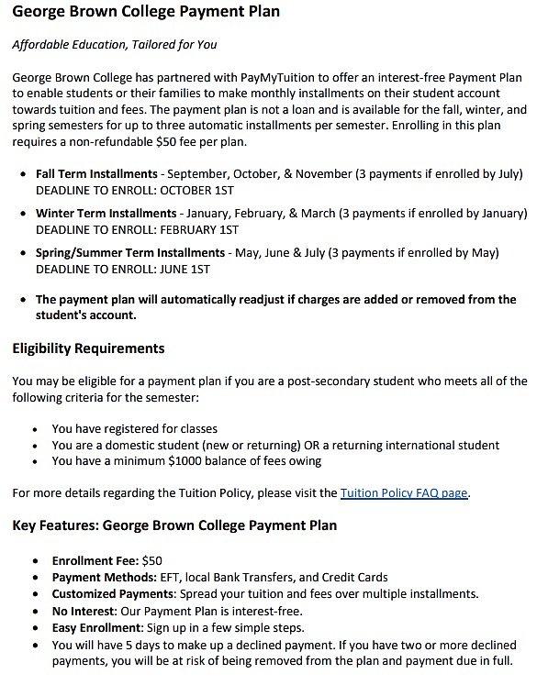
…Continued on next page.
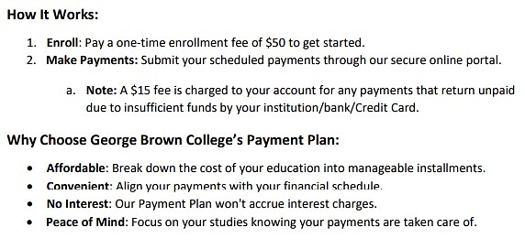

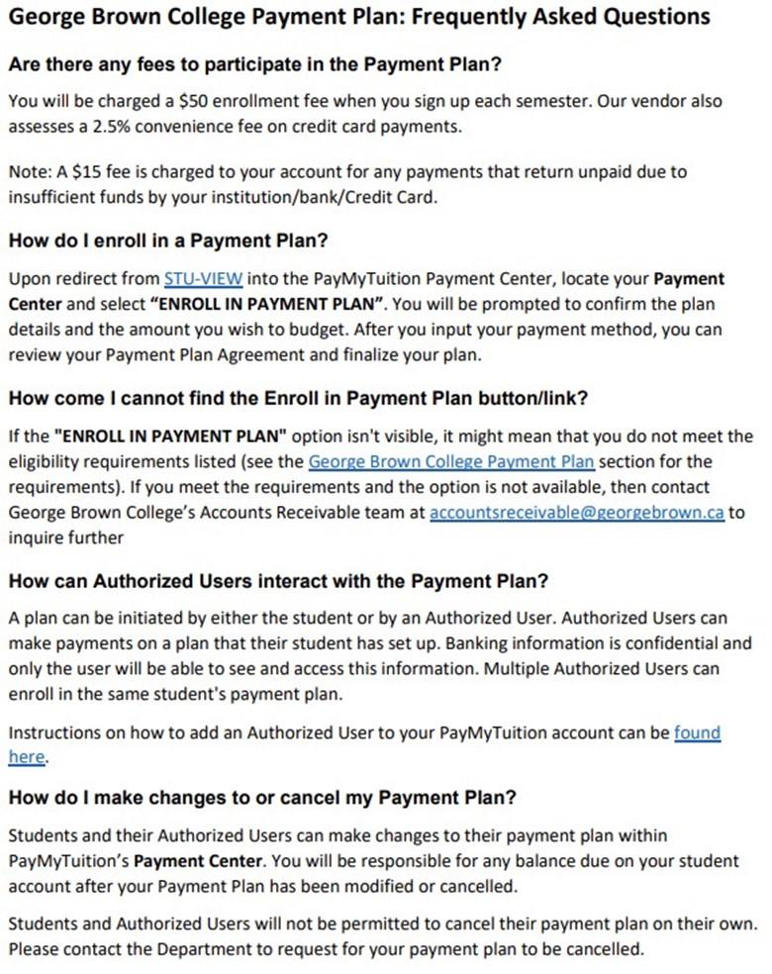

…Continued on next page.
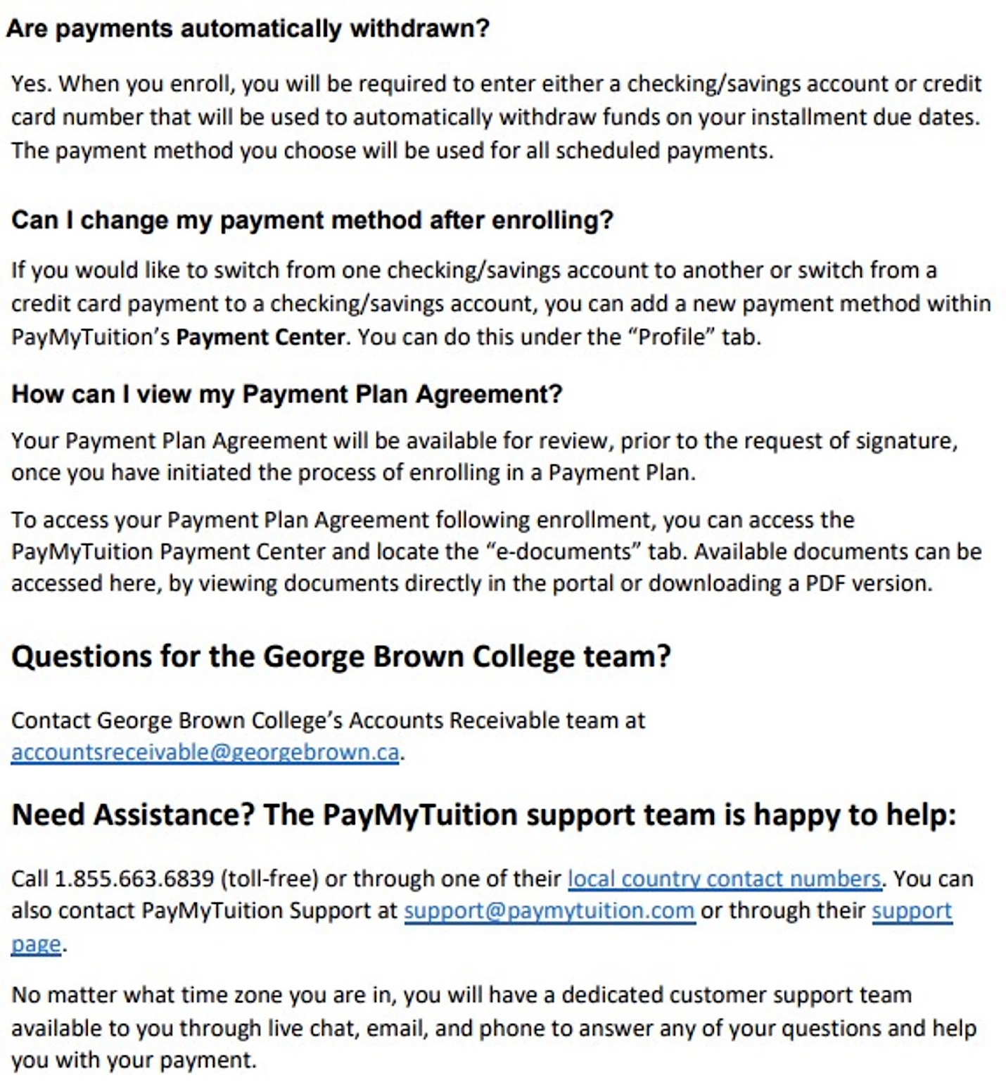

Work Sheet
Task 1: Open an email program on the computer. Compose a professional email message to the financial aid office at George Brown College. In your email, include at least three questions you have about the Tuition Payment Plan.
Email the final copy to your instructor.

Answer: No written response required here.

Task completed: Yes:

Answers
Answers will vary.

Performance Descriptors
Levels | Performance Descriptors | Needs Work | Completes task with support from practitioner | Completes task independently
A1.2 | locates multiple pieces of information in simple texts
 | makes connections between sentences and between paragraphs in a single text
 | follows the main events of descriptive, narrative and informational texts
 | obtains information from detailed reading
 | begins to identify sources and evaluate information
B2.2 | conveys intended meaning on familiar topics for a limited range of purposes and audiences
 | uses a limited range of vocabulary and punctuation appropriate to the task
 | begins to organize writing to communicate effectively
D.2 | selects and follows appropriate steps to complete tasks
 | locates and recognizes functions and commands
 | makes low-level inferences to interpret icons and text

This task: Was successfully completed Needs to be tried again

Learner Comments:

Instructor (print): Learner (print):

___________________ _____________________

