

Task Title: Ontario’s Insurable Deposits Coverage A

OALCF Cover Sheet – Practitioner Copy

Learner Name:___________________________________________
Date Started (m/d/yyyy):__________________________________
Date Completed (m/d/yyyy): _______________________________
Successful Completion: Yes No

Goal Path: | Employment | Apprenticeship
Secondary School | Post Secondary | Independence

Task Description: The learner will read a brochure to gain understanding of the deposit insurance program functions of the Financial Services Regulatory Authority of Ontario (FSRA).

Main Competency/Task Group/Level Indicator:
- Find and Use Information/Interpret documents/A2.2

Materials Required:
- Pencil/pen and/or digital device

Learner Information
Ontario’s Financial Services Regulatory Authority (FSRA)’s deposit insurance program protects insurable deposits held with Ontario credit unions and caisses populaires. Deposit insurance is part of a comprehensive depositor protection program that ensures the safety and soundness of credit unions and caisses populaires. FSRA now handles the deposit insurance functions previously performed by the Deposit Insurance Corporation of Ontario (DICO).
Scan the “FSRA Deposit Insurance Reserve Fund (DIRF)” advertising brochure.

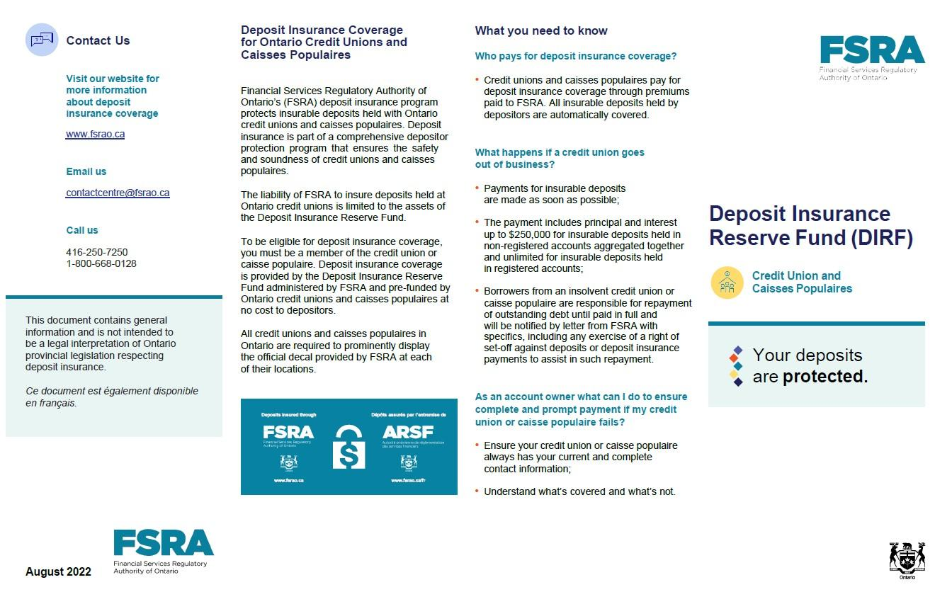
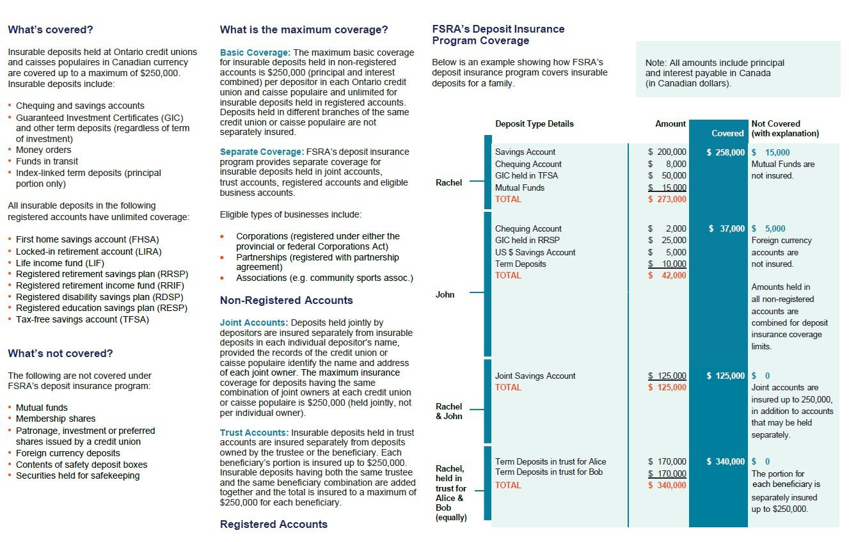

Work Sheet

Task 1: What must you be to be considered eligible for deposit insurance coverage?
Answer:

______________________________________________________
Task 2: List 3 insurable deposits covered by FSRA’s Deposit Insurance Program.
Answer:

_____________________________________________________
Task 3: List 3 deposits that are not insured.
Answer:

______________________________________________________
Task 4: How much is the maximum basic protection for eligible deposits?
Answer:
______________________________________________________
Task 5: How much is the maximum basic protection for a registered savings plan?
Answer:

______________________________________________________

Answers

Task 1: What must you be to be considered eligible for deposit insurance coverage?
Answer: A member of the credit union or caisse populaire

Task 2: List 3 insurable deposits covered by FSRA’s Deposit Insurance Program.
Answer: Any 3 of
- Chequing and saving accounts
- Guaranteed Investment Certificates (GIC) and other term deposits (regardless of term of investment)
- Money orders
- Funds in transit
- Index-linked term deposits (principal portion only)

Task 3: List 3 deposits that are not insured.
Answer: Any 3 of
- Mutual funds
- Membership shares
- Patronage, investment or preferred shares issued by a credit union
- Foreign currency deposits
- Contents of safety deposit boxes
- Securities held for safekeeping
Task 4: How much is the maximum basic protection for eligible deposits?
Answer: $250,000

Task 5: How much is the maximum basic protection for a registered savings plan?
Answer: There is no maximum. All insurable deposits in registered accounts are all fully insured.

Performance Descriptors
Levels | Performance Descriptors | Needs Work | Completes task with support from practitioner | Completes task independently
A2.2 | Performs limited searches using one or two search criteria
 | Extracts information from tables and forms
 | Uses layout to locate information
 | Makes connections between parts of documents
 | Makes low-level inferences
 | Begins to identify sources and evaluate information

This task: Was successfully completed Needs to be tried again

Learner Comments:

Instructor (print): Learner Signature:
_______________________ _______________________

