

Task Title: Skilled Trades Earnings Infographics

OALCF Cover Sheet – Practitioner Copy

Learner Name: __________________________________________
Date Started: ___________________________________________
Date Completed: _________________________________________

Goal Path: | Employment | Apprenticeship
Secondary School | Post Secondary | Independence
Successful Completion: Yes No

Task Description: The learner will find information about salary differences between men and women in skilled trades, and perform a calculation.
Main Competency/Task Group/Level Indicator:
- Find and Use Information/Interpret documents/A2.2
- Understand and Use Numbers/Manage money/C1.1
Materials Required:
- Pen/pencil and paper and/or digital device

Learner Information
When researching a career, it is important to learn about the expected salary you will earn. In some careers, there is a significant difference between average earnings for men and women.

Scan the infographic sections from “How Much do they Make?”

How Much do they Make?
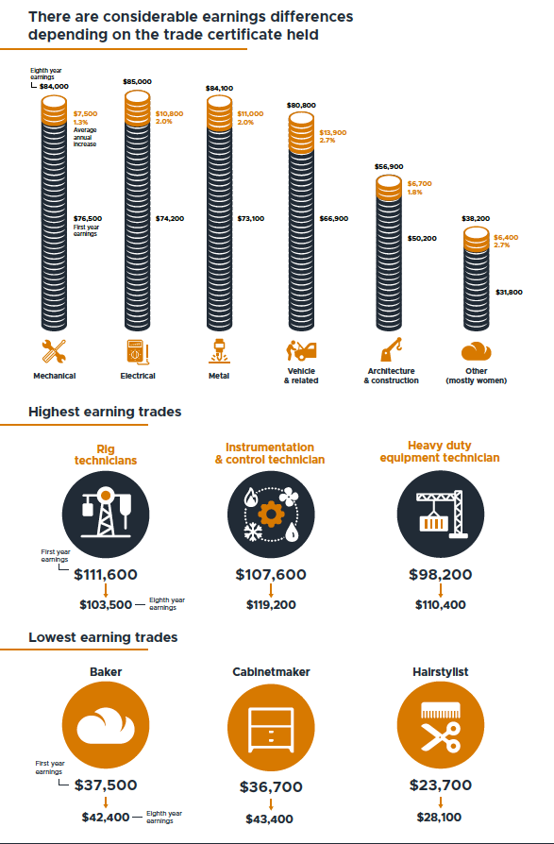

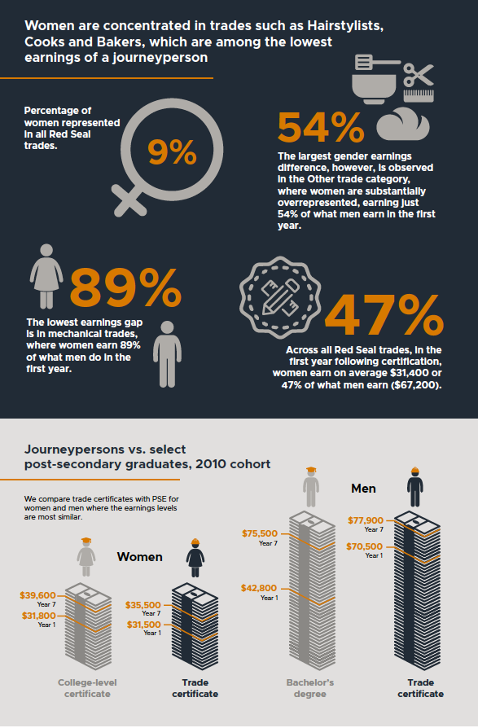

Work Sheet
Task 1: List the lowest-earning trades.
Answer:

______________________________________________________
Task 2: What percentage of Red Seal trades are held by women?
Answer:

______________________________________________________
Task 3: Across all Red Seal trades, how much do women earn on average in their first year after certification compared to men?
Answer:

______________________________________________________
Task 4: Calculate how much more men earn than women, based on average earnings at year 7 for people with a trade certificate.
Answer:

______________________________________________________

Answers
Task 1: List the lowest-earning trades.
Answer: Baker, cabinetmaker, hairstylist.

Task 2: What percentage of Red Seal trades are held by women?
Answer: 9%

Task 3: Across all Red Seal trades, how much do women earn on average in their first year after certification compared to men?
Answer: On average, women earn $31,400; men earn $67,200 (on average, women earn 47% of what men earn)

Task 4: Calculate how much more men earn than women, based on average earnings at year 7 for people with a trade certificate.
Answer: $77,900 - $35,500 = $42,400

Performance Descriptors
Levels | Performance Descriptors | Needs Work | Completes task with support from practitioner | Completes task independently
A2.2 | performs limited searches using one or two search criteria
 | extracts information from tables and forms
 | locates information in simple graphs and maps
 | uses layout to locate information
 | makes connections between parts of documents
 | makes low-level inferences
 | begins to identify sources and evaluate information
C1.1 | adds, subtracts, multiplies and divides whole numbers and decimals
 | recognizes values in number and word format
 | identifies and performs required operation
 | follows apparent steps to reach solutions
 | interprets and represents costs using monetary symbols and decimals
 | uses strategies to check accuracy (e.g. estimating, using a calculator, repeating a calculation, using the reverse operation)

This task: Was successfully completed Needs to be tried again
Learner Comments:

Instructor (print): Learner (print):
__________________ _________________

