

Task Title: Millwright Hoisting and Rigging

OALCF Cover Sheet – Practitioner Copy

Learner Name:___________________________________________
Date Started (m/d/yyyy):__________________________________
Date Completed (m/d/yyyy): _______________________________
Successful Completion: Yes No

Goal Path: | Employment | Apprenticeship
Secondary School | Post Secondary | Independence

Task Description:
The learner will read text and interpret documents and charts to make calculations related to hoisting and rigging duties required of a millwright.
Main Competency / Task Group / Level Indicator:
- Find and Use Information/Read continuous text/A1.2
- Find and Use Information/Interpret documents/A2.2
- Understand and Use Numbers/Use Measures/C3.3
Materials Required:
- Pen/pencil and paper and/or digital device
- Scientific Calculator

Learner Information
Millwrights determine the correct equipment to use when performing a lift. This will include calculating weight measures and the capacity of components such as eyebolts, slings and shackles using charts available through the manufacturer or employer.
Read Understanding Working Load Limits for Hoisting and Rigging including the formulas and charts.

Understanding Working Load Limits for Hoisting and Rigging
A safe rigging operation requires the rigger to know
• the weight of the load and rigging hardware
• the capacity of the hoisting device
• the working load limit of the hoisting rope, slings, and hardware.
When the weights and capacities are known, the rigger must then determine how to lift the load so that it is stable.
A minimum of three components are used for Hoisting and Rigging. They include the Eyebolts, Shackles and Slings. There may be more components used depending on the lift. Additionally, more than one of each of the components may be used for the lift.
Factors that affect hoisting safety include working load limits, defective components, questionable equipment, hazardous wind conditions, weather conditions, electrical contact and the hoist line not being plumb.
- Working Load Limit (WLL) - is used to determine the maximum strength that a component such as the eyebolt, shackle and sling can safely lift the weight of the load.
The design factor is a crucial safety concept in rigging, ensuring that slings can withstand more than the loads they're designed to carry. The design factor is the ratio between the minimum breaking strength (MBS) of a sling and its permissible working load (WLL). If a sling has a design factor of 5:1, it means that the sling's breaking strength is five times its WLL. Design factors are determined by the manufacturer of the sling and should never be exceeded.
The example below is for wire rope of Improved Plow steel with a design factor of 5, but there are many types of slings used for hoisting. The following formula can be used to compute the working load limit of a wire rope in tons (2,000 pounds).
Formula for Working Load Limit
WLL = DIAMETER x DIAMETER x 8
(where DIAMETER = nominal rope diameter in inches)
OR
WLL = D² x 8
SINGLE VERTICAL HITCH Example:
1/2-inch diameter rope
WLL = 1/2 x 1/2 x 8 = 2 tons

Sling Angles
The Single Vertical Hitch supports a load by a single vertical part or leg of the sling. The total weight of the load is carried by a single leg; the sling angle is 90° (sling angle is measured from the horizontal) and the weight of the load can equal the working load limit of the sling and fittings.
The total weight that you can pick up with a set of slings is reduced when the slings are used at angles (formed the with horizontal). For instance, two slings used to lift 1000 pounds will have a 500-pound force on each sling (or leg) at a sling angle of 90 degrees. The force on each leg increases as the angle goes down. For example, at 30 degrees the force will be 1000 pounds on each leg.
Keep sling angles greater than 45 degrees whenever possible. Using any sling at an angle lower than 30 degrees is extremely hazardous. In such cases, an error of 5 degrees in estimating the sling can be very dangerous. Low sling angles also create large, compressive forces on the load that may cause buckling— especially in longer flexible loads.
Slings - Safe Load in Tons
Nominal  Size | 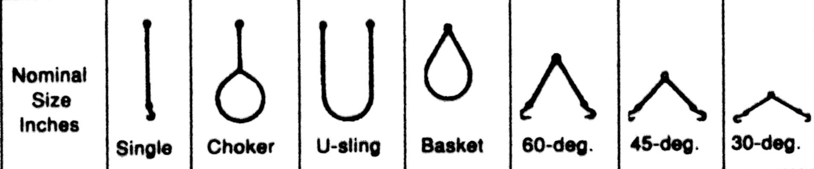
Nominal  Size | Single | Choker | U-sling | Basket | 60- deg | 45-deg | 30-deg
¼”  5/16”  3/8”  ½”  5/8”  ¾”  7/8”  1”  1 1/8” | .5  .8  1.1  2.0  2.9  4.1  5.6  7.2  9.0 | .3  .6  .8  1.4  2.1  3.0  3.8  5.0  5.6 | .7  1.1  1.5  2.7  4.2  6.0  7.7  10.0  11.2 | .6  1.0  1.4  2.4  3.8  5.4  6.8  9.3  10.5 | .57  .9  1.3  2.3  3.7  5.2  6.7  8.7  9.7 | .5  .7  1.1  1.9  3.0  4.2  5.4  7.1  7.9 | .3  .6  .8  1.3  2.1  3.0  3.8  5.0  5.6

Drop Forged Steel Shoulder-type Eyebolts
Size | 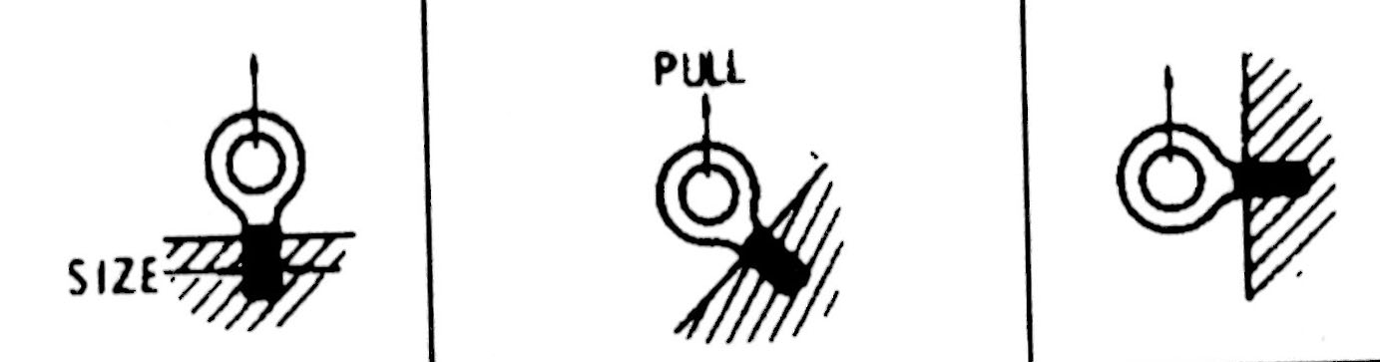
1/4"  1/2"  3/4"  1"  1 1/4"  1 1/2"  2"  2 1/2" | 300 lb  1,300 lb  3,000 lb  6,000 lb  9,000 lb  13,000 lb  23,000 lb  37,000 lb | 30 lb  140 lb  250 lb  500 lb  800 lb  1,200 lb  2,100 lb  3,800 lb | 40 lb  150 lb  300 lb  600 lb  900 lb  1,300 lb  2,300 lb  4,300 lb
Anchor Shackles
Nominal  Size | Tons Safe  Load | Dimensions
Nominal  Size | Tons Safe  Load | A | B | C  Dimensions refer to the size of the shackle.  A - Height  B - Width  C- Pin diameter
3/8”  ½”  5/8”  ¾”  7/8”  1”  1 1/8”  1 ¼”  1 ½”  2” | .8  1.4  2.2  3.2  4.3  5.6  6.7  8.2  11.8  21.1 | 1 1/2  2  2 3/8  2 7/8  3 1/4  3 5/8  4 1/4  4 3/4  5 1/2  7 3/4 | 1 1/16  7/8  1 1/16  1 1/4  1 3/8  1 11/16  1 7/8  2  2 1/4  3 1/4 | 7/16  5/8  3/4  7/8  1  1 1/8  1 1/4  1 3/8  1 5/8  2 1/4

Work Sheet
Task 1: List the three components used for hoisting and rigging.
Answer:

______________________________________________________
Task 2: Hoisting and rigging loads are measured in tons. Calculate the tons for 2489 pounds (lbs) using the formula below.
Formula: pounds ÷ 1 ton (2000 lbs) = weight in tons
Answer:

______________________________________________________
Task 3: According to the Slings - Safe Load in Tons chart, what is the nominal size for a 60-degree sling with a load of 5.2 tons.
Answer:

______________________________________________________
Task 4: Use the Drop Forged Steel Shoulder-type Eyebolts chart to locate the weight load for an eyebolt size of 1 inch at a 90-degree angle.
Answer:

______________________________________________________
Task 5: Use the Anchor Shackles chart to locate the height, width and pin diameter of a shackle with a nominal size of 7/8 inches.
Answer:

______________________________________________________
Task 6: Calculate the working load limit (WLL) for 5/8-inch diameter rope.
Answer:

______________________________________________________
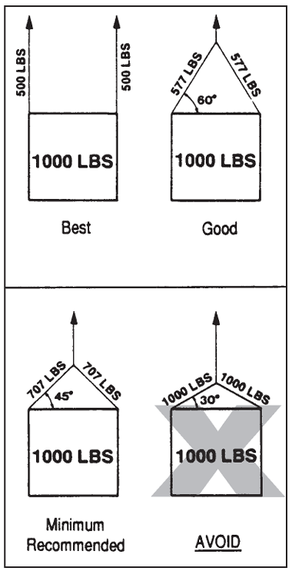
Task 7: What is the load on each sling for Minimum Recommended lift?
Answer:

______________________________________________________
Answers
Task 1: List the three components used for hoisting and rigging.
Answer: Eyebolts, shackles and slings
______________________________________________________
Task 2: Hoisting and rigging loads are measured in tons. Calculate the tons for 2489 pounds (lbs) using the formula below.
Formula (pounds ÷ 1 ton (2000) = weight in tons)
Answer: 1.2 tons
______________________________________________________
Task 3: According to the Slings - Safe Load in Tons chart, what is the nominal size for a 60-degree sling with a load of 5.2 tons.
Answer: ¾ inch
______________________________________________________
Task 4: Use the Drop Forged Steel Shoulder-type Eyebolts chart to locate the weight load for an eyebolt size of 1 inch at a 90-degree angle.
Answer: 600 lbs
______________________________________________________
Task 5: Use the Anchor Shackles chart to locate the height, width and pin diameter of a shackle with a nominal size of 7/8 inches.
Height 3 ¼, Width 1 3/8, Pin Diameter 1
______________________________________________________
Task 6: Calculate the working load limit (WLL) for 5/8-inch diameter rope.
Answer:
5/8 x 5/8 x 8 =.625 x .625 x 8 = 3.125
WLL is 3.125 tons
______________________________________________________
Task 7: What is the load on each sling for Minimum Recommended lift?
Answer: 707 lbs
______________________________________________________

Performance Descriptors
Levels | Performance Descriptors | Needs Work | Completes task with support from practitioner | Completes task independently
A1.2 | scans text to locate information
 | locates multiple pieces of information in simple texts
 | Reads more complex texts to locate a single piece of information
 | makes low-level inferences
A2.2 | performs limited searches using one or two search criteria
 | extracts information from tables and forms
 | uses layout to locate information
 | makes connections between parts of documents
 | makes low-level inferences
C3.3 | calculates using numbers expressed as whole numbers, fractions, decimals, percentages and integers
 | understands and uses properties of angles and triangles to solve problems
 | manages unfamiliar elements (e.g., context, content) to complete tasks
 | chooses and performs required operations; makes inferences to identify required operations
Levels | Performance Descriptors | Needs Work | Completes task with support from practitioner | Completes task independently
 | interprets, represents and converts measures using whole numbers, decimals, percentages, ratios and fractions
 | uses strategies to check accuracy (e.g., estimating, using a calculator, repeating a calculation, using the reverse operation)

This task: Was successfully completed Needs to be tried again

Learner Comments:

Instructor (print): Learner (print):
_______________________ _______________________

