

Task Title: Using Measuring Tapes

OALCF Cover Sheet – Practitioner Copy

Learner Name: __________________________________________
Date Started: ___________________________________________
Date Completed: _________________________________________

Goal Path: | Employment | Apprenticeship
Secondary School | Post Secondary | Independence
Successful Completion: Yes No

Task Description: The learner marks metric and Imperial measurements on a tape measure.
Main Competency/Task Group/Level Indicator:
- Understand and Use Numbers/Use measures/C3.1

Materials Required:
- Pen/pencil and paper and/or digital device

Learner Information
Construction workers and other tradespeople measure materials using either metric or Imperial measures on measuring tapes.

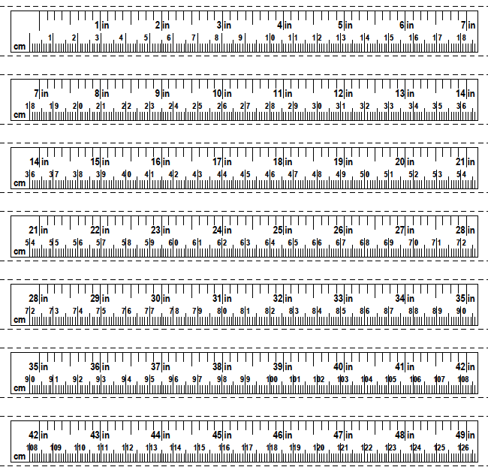
Tape Measure

Work Sheet
Task 1: On the measuring tape, mark and label:
Task 1a) 1 1/4 inches
Task 1b) 11 1/8 inches
Task 1c) 14 7/8 inches
Task 1d) 28 1/2 inches

Answer: No written response required here.

Task completed: Yes:

Task 2: On the measuring tape, mark and label:
Task 2a) 1.5 cm
Task 2b) 26.2 cm
Task 2c) 60.7 cm
Task 2d) 140.0 cm

Answer: No written response required here.

Task completed: Yes:

Answers
1a) 1 1/4 ”

2a) 1.5 cm
1b) 11 1/8 ”

1c) 14 7/8 ”
2b) 26.2 cm

1d) 28 1/2 ”
2c) 60.7 cm

2d) 104 cm

Performance Descriptors
Levels | Performance Descriptors | Needs Work | Completes task with support from practitioner | Completes task independently
C3.1 | measures distance, length, width, height, weight, liquid volume, angles and temperature
 | uses common measuring tools, such as rulers, scales and thermometers
 | chooses appropriate units (e.g. metres, inches) and non-standard units (e.g. paces, cupfuls, scoops)
 | interprets and represents measures using whole numbers, decimals and simple, common fractions (e.g. ½, ¼)
 | interprets and represents measures using symbols and abbreviations (e.g. inches as “, centimetres as cm, pounds as lbs, kilograms as kilos or kg)

This task: Was successfully completed Needs to be tried again
Learner Comments:

Instructor (print): Learner (print):
__________________ _________________

