

Task Title: Understanding Working Load Limits

OALCF Cover Sheet – Practitioner Copy

Learner Name: __________________________________________
Date Started: ___________________________________________
Date Completed: _________________________________________

Goal Path: | Employment | Apprenticeship
Secondary School | Post Secondary | Independence
Successful Completion: Yes No

Task Description: The learner will interpret information about working load limits for ropes from a chart.
Main Competency/Task Group/Level Indicator:
- Find and Use Information/Interpret documents/A2.2

Materials Required:
- Pen/pencil and paper and/or digital device

Learner Information
Industrial mechanics (millwrights) use working load limits to make sure the load they are lifting does not exceed safety limits.
Scan “Working Loads for Wire Ropes”.

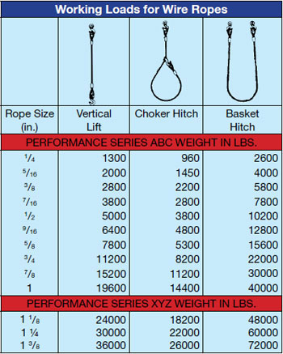

Work Sheet
Task 1: The supervisor tells his crew to use a basket hitch configuration to lift a 42,000-pound load. What size of wire rope should be used?
Answer:

_______________________________________________
Task 2: The crew is using a vertical lift configuration to lift a 5,500-pound load. What size of wire rope should be used?
Answer:

_______________________________________________
Task 3: The crew is using a vertical lift configuration to lift a 11,000-pound load. What size of wire rope should be used?
Answer:

_______________________________________________
Task 4: The crew is using a choker hitch configuration to lift a 11,250-pound load. What size of wire rope should be used?
Answer:

_______________________________________________

Answers
Task 1: The supervisor tells his crew to use a basket hitch configuration to lift a 42,000-pound load. What size of wire rope should be used?
Answer: 1 1/8-inch rope

Task 2: The crew is using a vertical lift configuration to lift a 5,500-pound load. What size of wire rope should be used?
Answer: 9/16-inch rope

Task 3: The crew is using a vertical lift configuration to lift a 11,000-pound load. What size of wire rope should be used?
Answer: ¾-inch rope

Task 4: The crew is using a choker hitch configuration to lift a 11,250-pound load. What size of wire rope should be used?
Answer: 1-inch rope

Performance Descriptors
Levels | Performance Descriptors | Needs Work | Completes task with support from practitioner | Completes task independently
A2.2 | performs limited searches using one or two search criteria
 | extracts information from tables and forms
 | uses layout to locate information
 | makes connections between parts of documents
 | makes low-level inferences
 | begins to identify sources and evaluate information

This task: Was successfully completed Needs to be tried again

Learner Comments:

Instructor (print): Learner (print):
__________________ _________________

