

Task Title: Understanding Gear Terminology

OALCF Cover Sheet – Practitioner Copy

Learner Name: __________________________________________
Date Started: ___________________________________________
Date Completed: _________________________________________

Goal Path: | Employment | Apprenticeship
Secondary School | Post Secondary | Independence
Successful Completion: Yes No

Task Description: The learner will read and interpret terminology used by millwrights and other tradespeople who repair equipment with gears.
Main Competency/Task Group/Level Indicator:
- Find and Use Information/Read continuous text/A1.2

Materials Required:
- Pen/pencil and paper and/or digital device

Learner Information
Millwrights and other skilled tradespeople may need to troubleshoot, repair and maintain gears in drive train systems and other machinery.

Read “Types of Gears” and “Idler or Intermediate Gear”.

Types of Gears
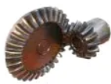  Bevel Gears | Bevel gears are usually used situations that require power to be transmitted at right angles. Bevel gears can have different angles of application but tend to be 90°.
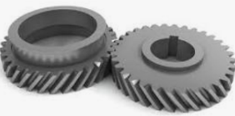  Helical Gears | Helical gears are very similar to spur gears except the teeth are not perpendicular to the face. The teeth are at an angle to the face giving helical gears more tooth contact in the same area.  Helical gears tend to run quieter and smoother than spur gears due to the increased number of teeth in constant contact at any one period of time.
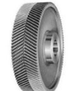  Herringbone Gears | Herringbone gears resemble two helical gears that have been placed side by side. They are often referred to as “double helicals”.  One benefit of herringbone gears is that it helps to avoid issues related to side thrust created with the use of helical gears.
Worm Gears  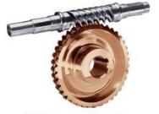 | Worm gears are used to transmit power at 90° and where high reductions are required. The worm resembles a thread that rides in helical teeth.
Spur Gears  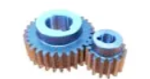 | Spur gears are the most common type of gear. Spur gears have teeth that run perpendicular to the face of the gear.
Internal Gears  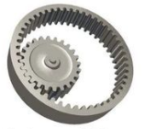 | Internal gears typically resemble inverted spur gears but are occasionally cut as helical gears.
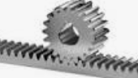  Racks | A rack is a straight gear used to transmit power and motion in a linear movement.
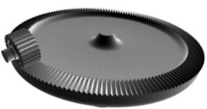  Face Gears | Face gears transmit power at (usually) right angles in a circular motion. They are not very common in industrial application.
Sprockets   | Sprockets are used to run chains or belts. They are typically used in conveyor systems.

Idler or Intermediate Gear
In a sequence of gears chained together, the ratio depends only on the number of teeth on the first and last gear. The intermediate gears, regardless of their size, do not alter the overall gear ratio of the chain. However, the addition of each intermediate gear reverses the direction of rotation of the final gear.
An intermediate gear which does not drive a shaft to perform any work is called an idler gear. Sometimes, a single idler gear is used to reverse the direction, in which case it may be referred to as a reverse idler.
Idler gears can also transmit rotation among distant shafts in situations where it would be impractical to simply make the distant gears larger to bring them together. Not only do larger gears occupy more space, the mass and rotational inertia of a gear is proportional to the square of its radius. Instead of idler gears, a toothed belt or chain can be used to transmit torque over distance.

Work Sheet
Task 1: List the type of gear that is most often used in conveyor systems.
Answer:

______________________________________________________
Task 2: List the gears that are typically used when power needs to be transmitted 90º or at a right angle.
Answer:

______________________________________________________
Task 3: Describe the difference between helical gears and spur gears.
Answer:

______________________________________________________
Task 4: List two features of intermediate gears.
Answer:

______________________________________________________

Answers
Task 1: List the type of gear that is most often used in conveyor systems.
Answer: Sprockets

Task 2: List the gears that are typically used when power needs to be transmitted 90º or at a right angle.
Answer: Bevel gears, worm gears, face gears

Task 3: Describe the difference between helical gears and spur gears.
Answer: Helical gears have teeth that do not run perpendicular to the face. The teeth are at an angle to the face giving helical gears more tooth contact in the same area. Spur gears have teeth that run perpendicular to the face of the gear.

Task 4: List two features of intermediate gears.
Any two of
- Intermediate gears do not alter the overall gear ratio
- The addition of each intermediate gear reverses the direction of rotation of the final gear
- An intermediate gear which does not drive a shaft or perform any work is called an idler gear

Performance Descriptors
Levels | Performance Descriptors | Needs Work | Completes task with support from practitioner | Completes task independently
A1.2 | scans text to locate information
 | locates multiple pieces of information in simple texts
 | makes low-level inferences
 | makes connections between sentences and between paragraphs in a single text
 | reads more complex texts to locate a single piece of information
 | follows the main events of descriptive, narrative and informational texts
 | obtains information from detailed reading
 | begins to identify sources and evaluate information

This task: Was successfully completed Needs to be tried again

Learner Comments:

Instructor (print): Learner (print):
__________________ _________________

