

Task Title: Bank Interest Rates

OALCF Cover Sheet – Practitioner Copy

Learner Name: __________________________________________
Date Started: ___________________________________________
Date Completed: _________________________________________

Goal Path: | Employment | Apprenticeship
Secondary School | Post Secondary | Independence
Successful Completion: Yes No

Task Description: Review bank interest rates for different types of accounts.
Main Competency/Task Group/Level Indicator:
- Find and Use Information/Interpret documents/A2.2
- Understand and Use Numbers/Manage money/C1.1

Materials Required:
- Pen/pencil and paper and/or digital device

Learner Information
Financial institutions post interest rates for different types of accounts.
Scan the “Interest Rates for Tangerine Bank”.

Interest Rates for Tangerine Bank

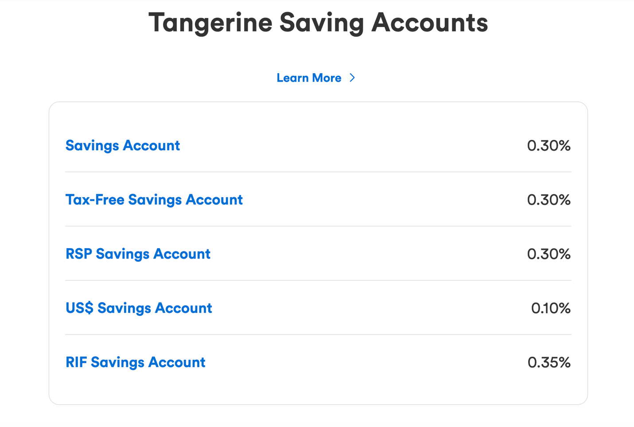

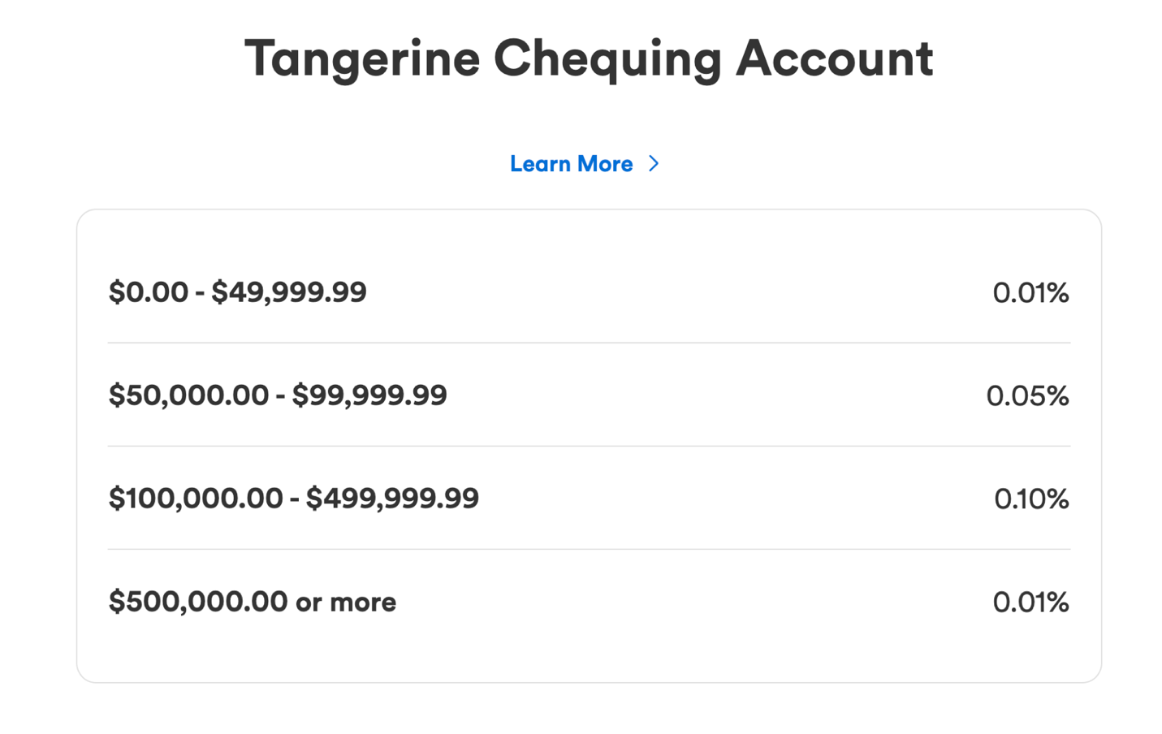

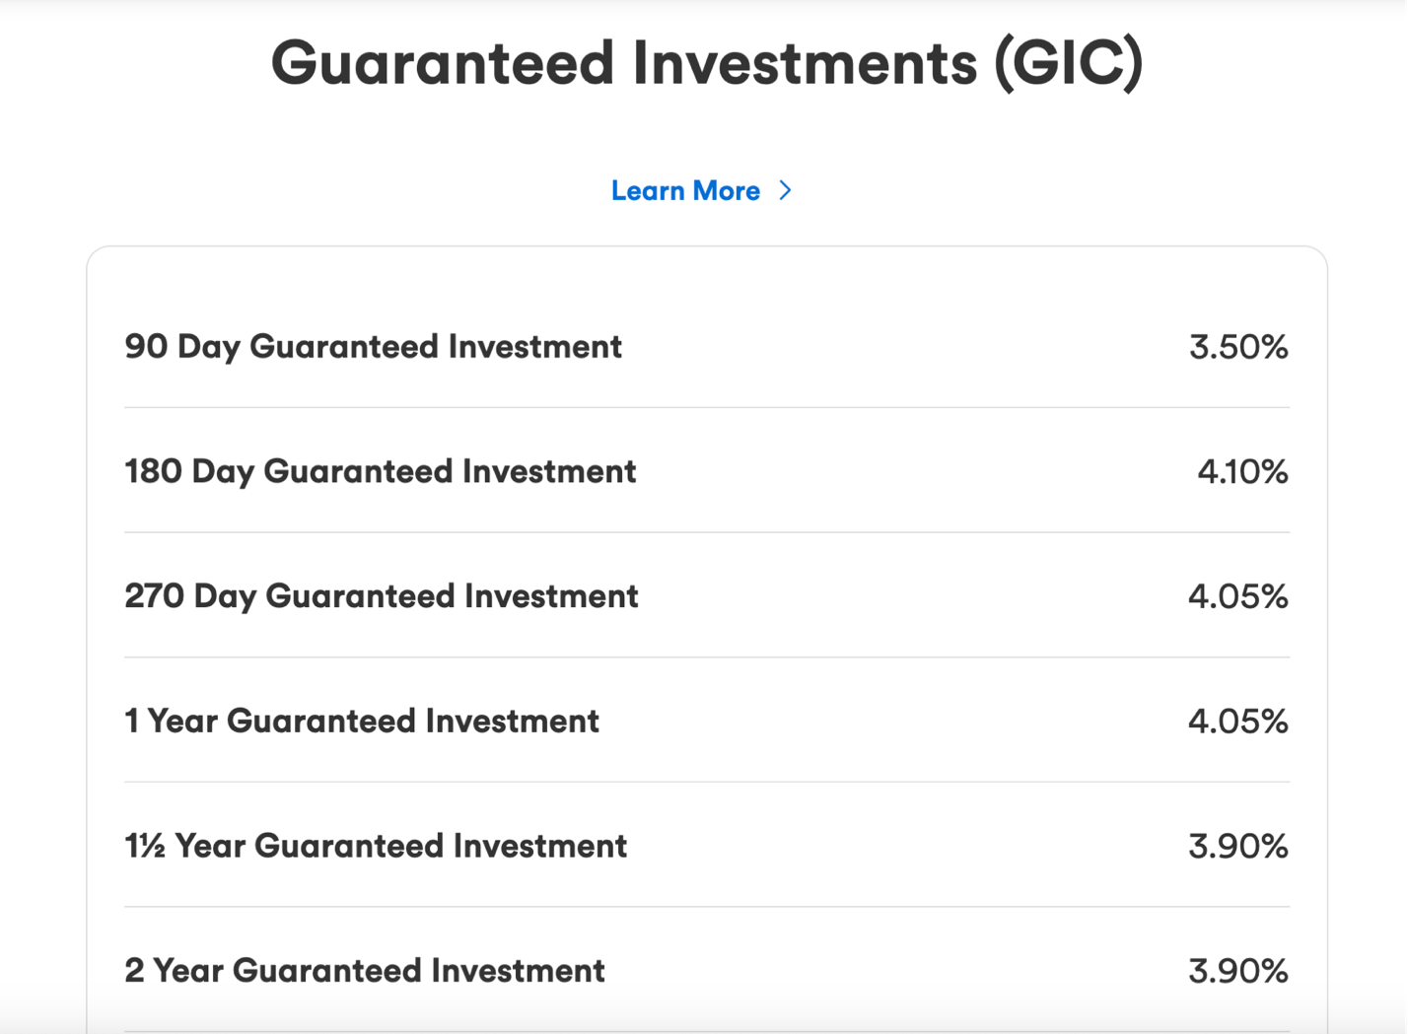

Work Sheet
Task 1: What is the interest rate for a chequing account with a balance of $75.00?
Answer:

_____________________________________________________________
Task 2: Which types of savings accounts have an interest rate of 0.30%?
Answer:

_____________________________________________________________
Task 3: How much money does a customer need to put into a chequing account to get an interest rate of 0.10%?
Answer:

______________________________________________________
Task 4: How long would a customer need to put money into a GIC (Guaranteed Investment) to get an interest rate of 4.10%?
Answer:

______________________________________________________

Answers
Task 1: What is the interest rate for a chequing account with a balance of $75.00?
Answer: 0.01%

Task 2: Which types of savings accounts have an interest rate of 0.30%?
Answer: Savings Account, Tax Free Savings Account, and RSP Savings Account

Task 3: How much money does a customer need to put into a chequing account to get an interest rate of 0.10%?
Answer: $100,000.00-$499,999.99.

Task 4: How long would a customer need to put money into a GIC (Guaranteed Investment) to get an interest rate of 4.10%?
Answer: 180 days.

Performance Descriptors
Levels | Performance Descriptors | Needs Work | Completes task with support from practitioner | Completes task independently
A2.2 | performs limited searches using one or two search criteria
 | extracts information from tables and forms
 | uses layout to locate information
 | makes low-level inferences
C1.1 | understands numerical order

This task: Was successfully completed Needs to be tried again
Learner Comments:

Instructor (print): Learner (print):
__________________ _________________

