

Task Title: Write Cheques to Pay Invoices

OALCF Cover Sheet – Practitioner Copy

Learner Name: __________________________________________
Date Started: ___________________________________________
Date Completed: _________________________________________

Goal Path: | Employment | Apprenticeship
Secondary School | Post Secondary | Independence
Successful Completion: Yes No

Task Description: Read invoices and write a cheque to pay each one.
Main Competency/Task Group/Level Indicator:
- Find and Use Information/Read continuous text/A1.2
- Communicate Ideas and Information/Complete and create documents/B3.1a
Materials Required:
- Pen/pencil and paper and/or digital device

Learner Information
In many workplaces, cheques are written to pay invoices. Many people also use cheques to pay things like monthly rent payments.
Read “How to Write a Cheque” and scan the “Cheque Template”.

How to Write a Cheque
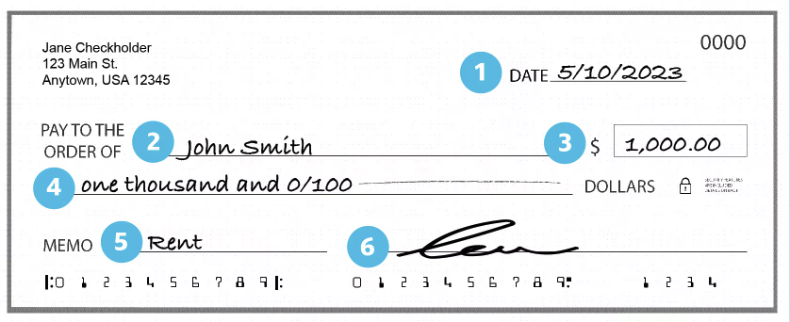

1. Date the cheque
Write the date in the top right corner of the cheque.
2. Fill in the recipient’s name
The recipient is the business or person to whom you’re writing a cheque. The field for the recipient’s name usually begins with “Pay to the order of.” Make sure this field is filled out correctly with the recipient’s full name.
3. Write the dollar amount in numbers
There are two places where you need to write the dollar amount. The first location is to the right of the recipient’s name. It’s typically a small box for numbers only and usually begins with a dollar sign.
4. Write the dollar amount in words
The second location for the dollar amount is directly below the recipient’s name. The amount should be spelled out in words. For example, if the amount of the cheque is $1,000, write “one thousand.”
To include the cents, use a fraction with “100” on the bottom. For example, if the cheque amount is $44.99, write “forty-four and 99/100.” Even if the dollar amount has no cents, it’s typically best to include a “00/100” for clarity. For example, if you’re writing a cheque for $1,500, write out “one thousand, five hundred and 00/100.”
5. Include a memo
In the memo line, write what the cheque is for. For example, an invoice number or the specific month the rent is being paid for.
6. Sign the cheque
Sign the cheque on the line in the bottom right corner.

Cheque Template
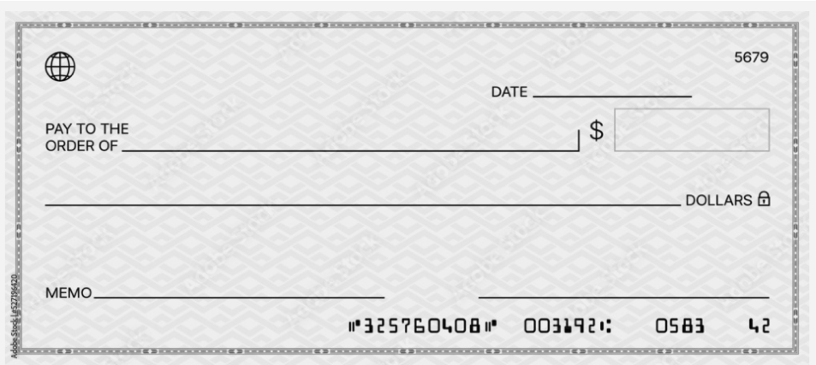

Work Sheet
Task 1: Use the cheque template to write a cheque to pay the following invoice.

Loopy Lighting Fixtures
21, Light Blvd.
Toronto, ON M4F 0A0

Invoice #3021

Sold to: J. Rowlings
A.J. Dowling Construction Co.
321, Left Lane
Innisfil, ON L9S 0O0

May 15, 2024

43 #278 light fixtures @ $14.75 each  6 cases 40watt light bulbs @ $8.55 each  400' white plastic-coated wire @ .35 a foot | 634.25  51.30  140.00
Subtotal  20% discount  HST (13%)  Total Due | 825.55  (165.11)  85.86  $746.30

Answer:

______________________________________________________

Task 2: Use the cheque template to write a cheque to pay the following invoice.

Hydro Ontario Account Number: 08975-11231

Electricity bill for: Date: September 30 2024

123 Main Street
Anytown ON
A2A 2A2

Amount of your last bill $200.12
Amount we received - $200.12
Balance forward $0.00

Your new charges $132.33

Total amount now due by October 15 2024 $132.33

A penalty will apply for accounts overdue.

Answer:

Task 3: Use the cheque template to write a cheque for your monthly rent in the amount of $1,250.00. The cheque should be dated for October 1, 2024. The rental company is “ABC Rental Inc.”.
Answer:

Answers
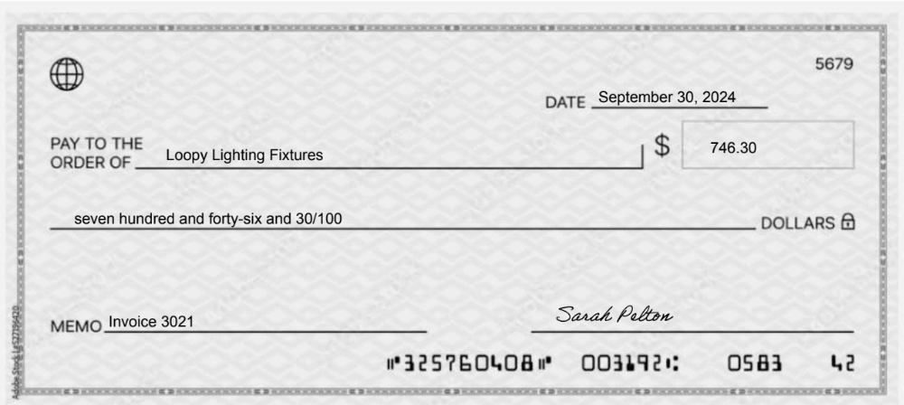
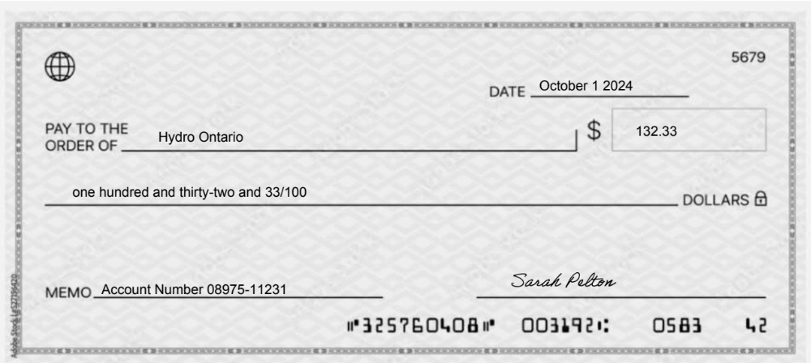
Task 1:

Task 2:
Task 3:
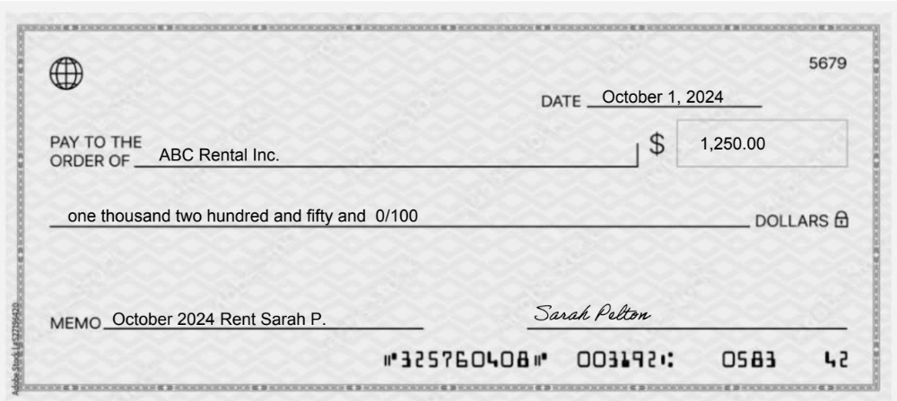

Performance Descriptors
Levels | Performance Descriptors | Needs Work | Completes task with support from practitioner | Completes task independently
A1.2 | scans text to locate information
 | locates multiple pieces of information in simple texts
 | make connections between sentences and between paragraphs in a single text
 | reads more complex texts to locate a single piece of information
 | follows the main events of descriptive, narrative and informational texts
 | obtains information from detailed reading
B3.1a | makes a direct match between what is requested and what is entered
 | makes entries using familiar vocabulary

This task: Was successfully completed Needs to be tried again

Learner Comments:

Instructor (print): Learner (print):
__________________ _________________

