

Task Title: Completing a Bank Deposit Form

OALCF Cover Sheet – Practitioner Copy

Learner Name: __________________________________________
Date Started: ___________________________________________
Date Completed: _________________________________________

Goal Path: | Employment | Apprenticeship
Secondary School | Post Secondary | Independence
Successful Completion: Yes No

Task Description: Learner will complete a bank deposit form on behalf of a workplace.
Main Competency/Task Group/Level Indicator:
- Communicate Ideas and Information/Complete and create documents/B3.2a
- Understand and Use Numbers/Manage money/C1.1

Materials Required:
- Pen/pencil and paper and/or digital device
- Calculator or digital device with calculator function

Learner Information
Many workplaces make daily or weekly deposits at a credit union or bank. A deposit form/slip needs to be carefully filled out in advance.
Review the blank “Account Deposit Slip” for Any Company.

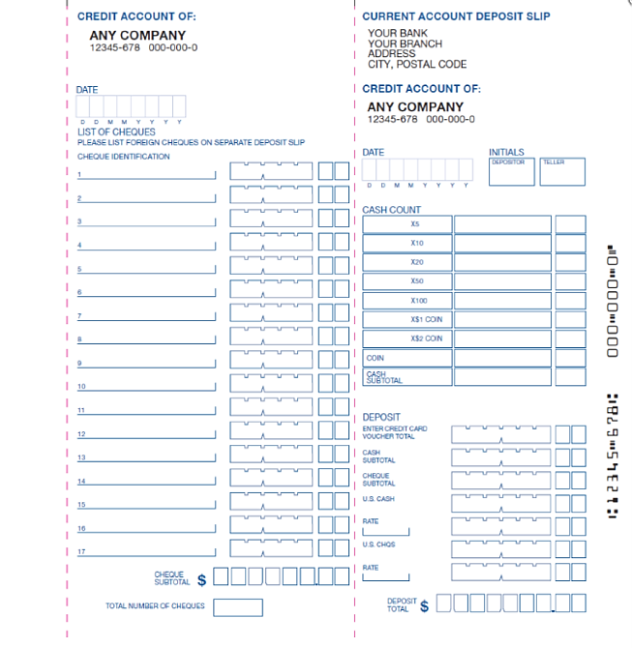
Account Deposit Slip

Work Sheet
Task 1: Complete the deposit slip using the following information:
- Date: September 22 2024
- Depositor Name: Abir Bahir
- Cheque: Joanna Smith $53.00
- Cheque: Michael Johnson $82.50
- Cash:
  - 28 Loonies
  - 61 Toonies
  - 25 - $5
  - 36 - $10
  - 121 - $20
  - 3 - $50
  - 1 - $100

Answer: No written response required here.

Task completed: Yes: No:

Task 2: Calculate the total deposited and fill in the form.
Answer: No written response required here.

Task completed: Yes: No:

Answers
Task 1: Complete the deposit slip using the following information:
- Date: September 22 2024
- Depositor Name: Abir Bahir
- Cheque: Joanna Smith $53.00
- Cheque: Michael Johnson $82.50
- Cash:
  - 28 Loonies
  - 61 Toonies
  - 25 - $5
  - 36 - $10
  - 121 - $20
  - 3 - $50
  - 1 - $100

Answer: See completed form below.

Task 2: Calculate the total deposited and fill in the form.
Answer: See completed form below.

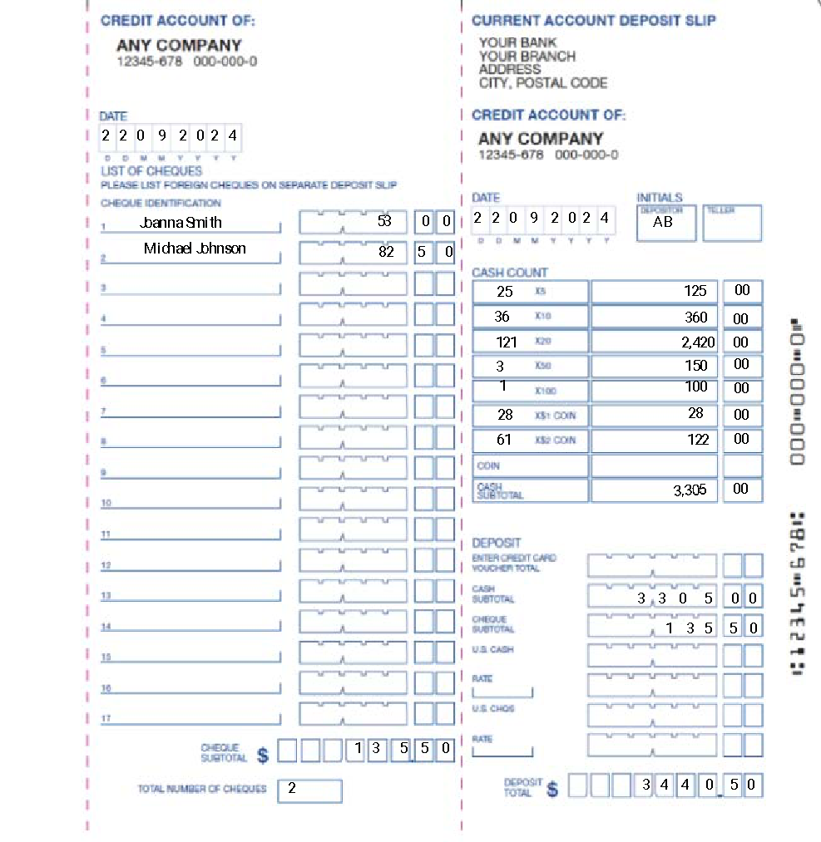

Performance Descriptors
Levels | Performance Descriptors | Needs Work | Completes task with support from practitioner | Completes task independently
B3.2a | uses layout to determine where to make entries
 | begins to make some inferences to decide what information is needed, where and how to enter the information
 | makes entries using a limited range of vocabulary
 | follows instructions on documents
C1.1 | adds, subtracts, multiplies and divides whole numbers and decimals
 | recognizes values in number and word format
 | interprets and represents costs using monetary symbols and decimals
 | uses strategies to check accuracy (e.g. estimating, using a calculator, repeating a calculation, using the reverse operation)

This task: Was successfully completed Needs to be tried again
Learner Comments:

Instructor (print): Learner (print):
__________________ _________________

