

Task Title: Using a Calendar App in the Workplace

OALCF Cover Sheet – Practitioner Copy

Learner Name: __________________________________________
Date Started: ___________________________________________
Date Completed: ________________________________________
Goal Path: | Employment | Apprenticeship
Secondary School | Post Secondary | Independence
Successful Completion: Yes No

Task Description:
The learner will read and follow written instructions to perform tasks related to using a calendar app on a computer.
Main Competency/Task Group/Level Indicator:
- Find and Use Information/Read continuous text/A1.2
- Understand and Use Numbers/Manage Time/C2.3
- Use Digital Technology/D.2
Materials Required:
- Pen/pencil and paper
- Computer with access to a Google Account

Learner Information
Employees use electronic calendars in the workplace to manage meetings and appointments. This helps them to schedule and manage time.
This calendar task will be completed on a computer. It will vary from the calendar app on a phone or tablet.
Scan the Using a Google Calendar in the Workplace.

Using a Google Calendar on the Computer

Create an Event
- Open Google Calendar
- Go to the day, week, or month where you want to add/schedule an event
- Click on “+ Create” button
- Enter the meeting title, date and time
- Choose “Add location” if known (could be physical location or phone/online, etc.)
- Save the Event

Set a Reminder
- Create an Event
- Enter the meeting title, date and time
- Choose “Add location” if known (could be physical location or phone/online, etc.)
- Select “More options”
- Select “Notification” and choose the type of notification and length of time prior to the event for a reminder to be sent
- Save the Event

Update an Event
- Open the Event
- Click “Edit Event”
- Change the date and time
- Save the Event

Add a Recurring Event
- Create a new Event
- Enter the meeting title, date and time
- Choose “Add location” if known
- Choose “Doesn’t Repeat” and select a recurring scenario
- Save the Event

Print the weekly schedule
- Click on “Settings”
- Select “Print”
- Ensure the Print Range is correct
- Print

Delete An Event
- Select the Event
- Click on the “Trash Can” icon

Work Sheet
Task 1: Schedule a team meeting for all teams Monday, March 3 from 2 pm to 3 pm in the Boardroom.
Answer: No written response required here.
Task Completed: Yes
_____________________________________________________________
Task 2: Set up a client call on Friday, March 7 at 10:30 am for 30 minutes and include a reminder notification for 15 minutes. Show your instructor your completed task.
Answer: No written response required here.
Task Completed: Yes
_____________________________________________________________
Task 3: Update the team meeting for all teams scheduled at 2 pm on March 3. The meeting has moved to March 5 at 11 am.
Answer: No written response required here.
Task Completed: Yes
_____________________________________________________________
Task 4: Set up a recurring weekly Staff Meeting for 1 hour every Tuesday at 9 am.
Answer: No written response required here.
Task Completed: Yes
_____________________________________________________________
Task 5: Schedule an all day conference for 9 am to 4 pm on March 3.
Answer: No written response required here.
Task Completed: Yes
_____________________________________________________________
Task 6: Find an open 3-hour slot on your calendar and schedule a 3-hour meeting for a conference debrief with the managers, taking into consideration the appointments already in your calendar and the information below.
- Most of the managers are tied up at a Job Fair on March 6.
- You are away for a Personal Appointment from 12 pm to 3 pm on March 4.
- You have a Lunch Meeting and Business Walkthrough planned with the CEO on March 7 from 12 noon until 2:30 pm.
Answer: No written response required here.
Task Completed: Yes
______________________________________________________
Task 7: Print a copy of the weekly schedule.
Answer: No written response required here.
Task Completed: Yes
______________________________________________________

Answers
The printed calendar should be the same or similar to the one below. Correct entries for Tasks 1-6 are shown in green. Entries shown in purple indicate the other times identified in Task 6 that are not available. The learner may choose to add them to their calendar and should not be penalized if they do.

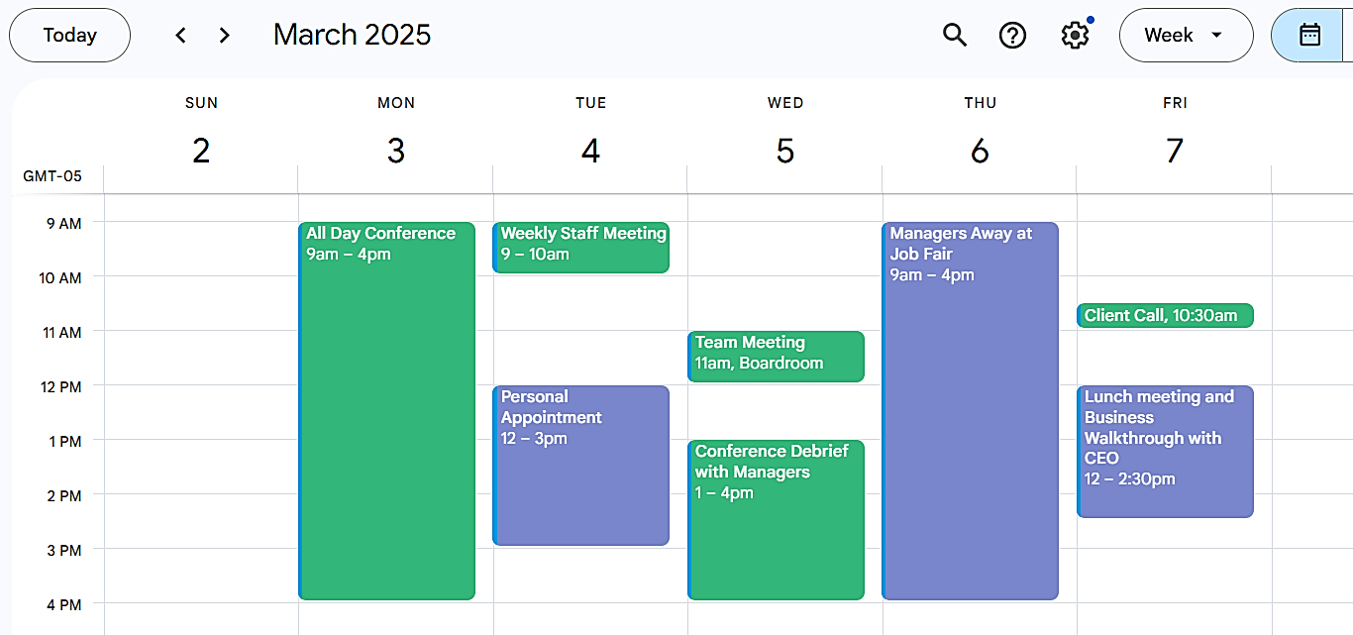

Performance Descriptors
Levels | Performance Descriptors | Needs Work | Completes task with support from practitioner | Completes task independently
A1.2 | Scans text to locate information
 | Follows the main events of descriptive, narrative, and informational texts
C2.3 | Manages unfamiliar elements (e.g. context, content) to complete tasks
 | Chooses and performs required operations; makes inferences to identify required operations
 | Organizes and displays numerical information (e.g. Gantt chart, schedules)
D.2 | Selects and follows appropriate steps to complete tasks
 | Locates and recognizes functions and commands
 | Makes low-level inferences to interpret icons and text

This task: Was successfully completed Needs to be tried again

Learner Comments:

Instructor (print): Learner (print):

_______________________ _______________________

