

Task Title: Using a Diagram of a Staircase

OALCF Cover Sheet – Practitioner Copy

Learner Name:
Date Started:
Date Completed:
Goal Path: | Employment | Apprenticeship
Secondary School | Post Secondary | Independence
Successful Completion: Yes No

Task Description:
Use measures on a diagram to perform multi-step calculations for a staircase.
Main Competency/Task Group/Level Indicator:
- Find and Use Information/Interpret documents/A2.3
- Understand and Use Numbers/Use measures/C3.3

Materials Required:
- Paper and pencil and/or digital device
- Calculator

Learner Information
Construction trades helpers and labourers often assist tradespersons such as carpenters and are asked to review diagrams for architectural installations. Scan the Stair Layout Diagram.

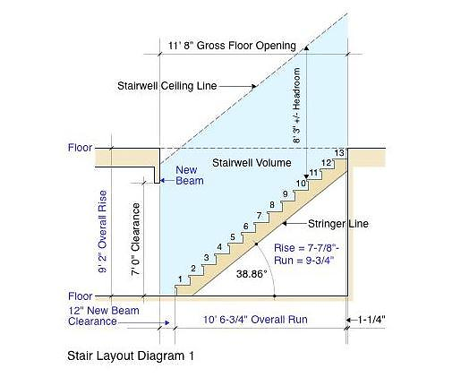
Stair Layout Diagram

Work Sheet
Task 1:
The volume of a stairwell can be calculated by multiplying the area of one step (rise x run) by the total number of steps. What is the approximate volume of the stairwell?
Answer:

Task 2:
The rise of the staircase is the sum of the individual rise measurements for all steps. What is the total rise from the bottom floor to the top of the last step?
Answer:

Task 3:
The conversion rate for inches to centimetres is 1 inch = 2.54 centimetres: What is the total rise from the bottom floor to the top of the last step in centimetres rounded to 2 decimal points?
Answer

Task 4:
The run of a stair is the horizontal distance. What is the total horizontal distance covered by all the stairs in inches?
Answer:

Answers
Task 1:
The volume of a stairwell can be calculated by multiplying the area of one step (rise x run) by the total number of steps. What is the approximate volume of the stairwell?
Answer:
Steps to answer: 7.88 x 9.75 x 13 = 998.8
The stairwell volume ​≈ 998-999 square inches
Task 2:
The rise of the staircase is the sum of the individual rise measurements for all steps. What is the total rise from the bottom floor to the top of the last step?
Answer: The total rise of the staircase is 102.375 inches [13 steps x each rise of 7 and ⅞ inches]
Or total rise area of 9’ 2” - 7.89” = 102.11”

Task 3:
The conversion rate for inches to centimetres is 1 inch = 2.54 centimetres: What is the total rise from the bottom floor to the top of the last step in centimetres rounded to 2 decimal points?
Answer: The total rise is 206.03cm (to avoid double jeopardy – answer is correct if calculation is made [and correct] using learner’s answer to Task 2)

Task 4:
The run of a stair is the horizontal distance. What is the total horizontal distance covered by all the stairs in inches?
Answer: 126.75 inches [13 steps x each run of 9 ¾ inches]
Performance Descriptors
Levels | Performance Descriptors | Needs Work | Completes task with support from practitioner | Completes task independently
A2.3 | Performs complex searches using multiple search criteria
A2.3 | Manages unfamiliar elements (e.g. vocabulary, context, topic) to complete tasks
A2.3 | Uses layout to locate information
A2.3 | Makes inferences and draws conclusions from information displays
C3.3 | Calculates using numbers expressed as whole numbers, fractions, decimals, percentages, and integers
C3.3 | Understands and uses properties of angles and triangles to solve problems
C3.3 | Makes estimates involving many factors where precision is required
C3.3 | Chooses and performs required operations; makes inferences to identify required operations
C3.3 | Identifies a variety of ways to complete tasks
C3.3 | Interprets, represents, and converts measures using whole numbers, decimals, percentages, ratios, and fractions.

This task: Was successfully completed Needs to be tried again

Learner Comments:

Instructor (print): Learner (print):

