

Task Title: Roofing Warranty Facts

OALCF Cover Sheet – Practitioner Copy

Learner Name:
Date Started:
Date Completed:
Goal Path: | Employment | Apprenticeship
Secondary School | Post Secondary | Independence
Successful Completion: Yes No

Task Description:
Read a document to learn about types of shingles and roofing warranties.

Main Competency/Task Group/Level Indicator:
- Find and Use Information/Interpret documents/A2.2-A2.3

Materials Required:
- Pen & Paper and/or digital device

Learner Information
Roofers offer a warranty to homeowners. It covers defects with the roofing materials and workmanship for a specified period. Scan the Warranty Facts document.
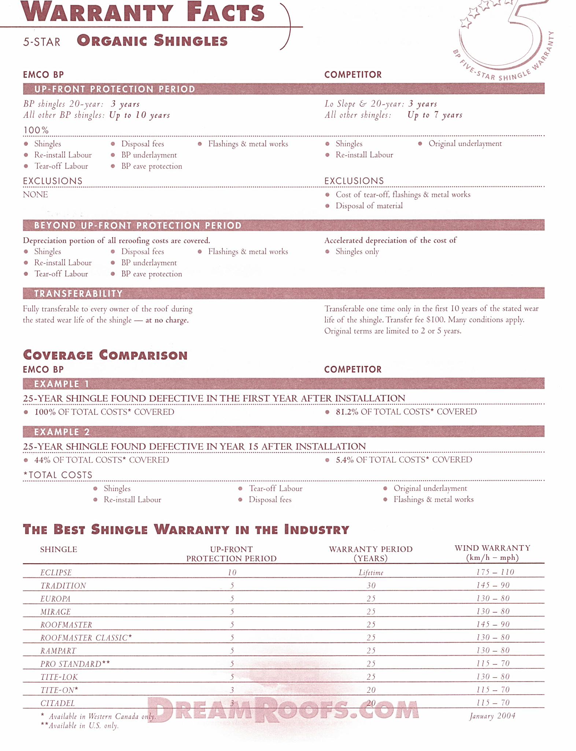
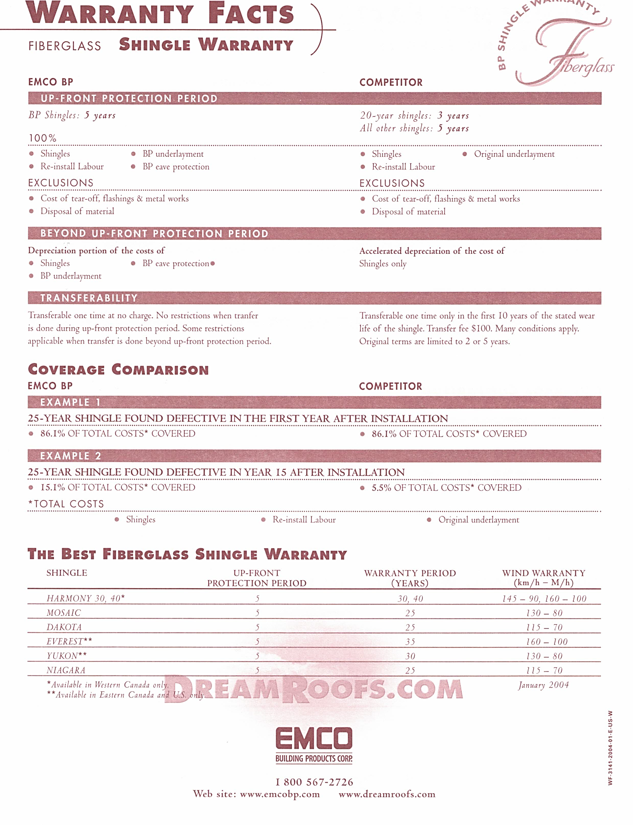

Work Sheet
Task 1: List the 2 types of fibreglass shingles that are available only in Eastern Canada and the U.S.
Answer:

Task 2: List the 3 warranty categories for each type of shingle.
Answer:

Task 3: Which kind of shingle has no exclusions in the warranty through EMCO BP?
Answer:

Task 4: Using Example 1 in the coverage comparison of the warranties offered by EMCO BP and its competitor for 25-year organic shingles, explain why EMCO BP has better coverage.
Answer:

Answers
Task 1: List the 2 types of fibreglass shingles that are available only in Eastern Canada and the U.S.
Answer: Everest and Yukon

Task 2: List the 3 warranty categories for each type of shingle.
Answer: Up-front protection period, warranty period, wind warranty

Task 3: Which kind of shingle has no exclusions in the warranty through EMCO BP?
Answer: Organic shingles

Task 4: Using Example 1 in the coverage comparison of the warranties offered by EMCO BP and its competitor for 25-year organic shingles, explain why EMCO BP has better coverage.
Answer: EMCO BP’s warranty covers a larger portion of the total costs of the roof. In Example 1, EMCO BP covers 100% of the costs compared with the competitor’s coverage of 81.2%.

Performance Descriptors
Levels | Performance Descriptors | Needs Work | Completes task with support from practitioner | Completes task independently
A2.2 | Performs limited searches using one or two search criteria
A2.2 | Uses layout to locate information
A2.2 | Extracts information from tables and forms
A2.3 | Integrates several pieces of information from documents

This task: Was successfully completed Needs to be tried again

Learner Comments:

Instructor (print): Learner (print):

