

Task Title: Use Roofing Estimator

OALCF Cover Sheet – Practitioner Copy

Learner Name:
Date Started:
Date Completed:
Goal Path: | Employment | Apprenticeship
Secondary School | Post Secondary | Independence
Successful Completion: Yes No

Task Description:
Use a roofing estimator to find information to calculate the amount of roofing supplies to order.
Main Competency/Task Group/Level Indicator:
- Find and Use Information/Interpret documents/A2.3
- Use and Understand Numbers/Use measures/C3.3
Materials Required:
- Pen & Paper and/or digital device
- Calculator (optional)

Learner Information
A Roofing Estimator can be used to calculate the amount of roofing supplies to order. Scan the BP Quick Roofing Estimator.
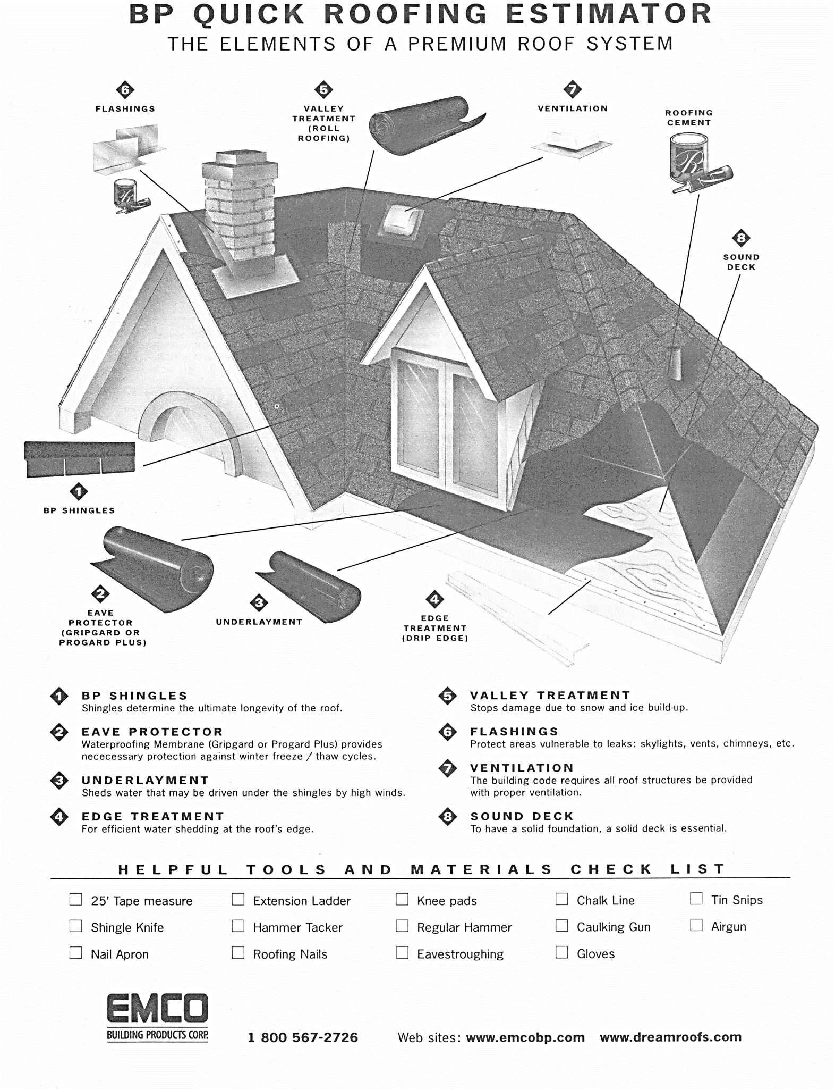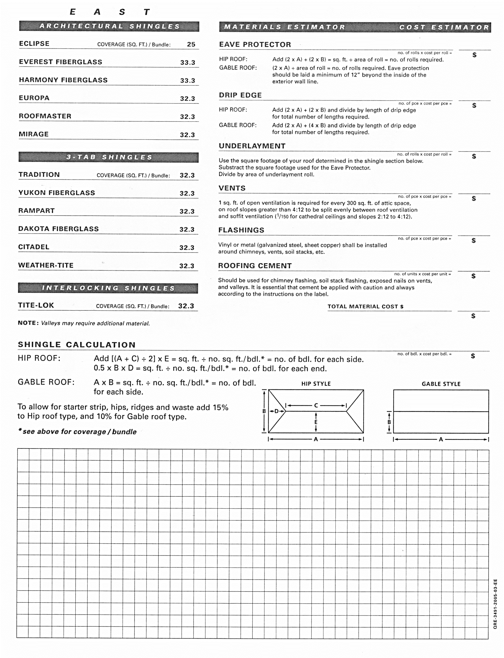

Work Sheet
Task 1: What is the purpose of Valley Treatment?
Answer:

Task 2: How many types of 3-Tab Shingles are listed?
Answer:

Task 3: Locate the Shingle Calculation section on the Estimator. Using the information in the table below, calculate the number of square feet of 1 side of the roof represented in this table.

Hip Roof/house Part A | 32 ft
Part B | 18 ft
Part C | 14 ft
Part D | 10 ft
Part E | 10 ft

Answer:

Task 4: Using your calculation in Task 3, calculate how many bundles of 3-Tab shingles will be needed.

Answer:

Task 5: If Citadel shingles cost $16.97/bundle, calculate the cost of 11 bundles.

Answer:

Answers
Task 1: What is the purpose of Valley Treatment?
Answer: to stop damage due to snow and ice buildup

Task 2: How many types of 3-Tab Shingles are listed?
Answer: 6 types of shingles

Task 3: Locate the Shingle Calculation section on the Estimator. Using the information below, calculate the number of square feet on the roof represented in this table.
Hip Roof/house A | 32 ft
B | 18 ft
C | 14 ft
D | 10 ft
E | 10 ft

Answer:
[(A + C) / 2] x E= sq. feet of roof
[(32 + 14) / 2] x 10 =
230 sq. ft.

Task 4: Using your calculation in Task 3, calculate how many bundles of shingles will be needed. If necessary, explain your answer.
Answer:
230 sq. ft. / 32.3 sq ft. per bundle = 7.12 bundles. Since bundles are sold intact, the answer is 8 bundles. *** The answer is correct if the participant used a different number of sq. ft, if they used their answer from Task 3 and did the calculation correctly in Task 4.
*** 8 bundles

Task 5: If Citadel shingles cost $16.97/bundle, calculate the cost of 11 bundles.
Answer:
$186.67

Performance Descriptors
Levels | Performance Descriptors | Needs Work | Completes task with support from practitioner | Completes task independently
A2.3 | Uses layout to locate information
A2.3 | Manages unfamiliar elements to complete tasks
C3.3 | Understands and uses formulas for finding …volume

This task: Was successfully completed Needs to be tried again

Learner Comments:

Instructor (print): Learner (print):

