

Task Title: Preventing Falls in the Workplace Infographic

OALCF Cover Sheet – Practitioner Copy

Learner Name:
Date Started:
Date Completed:

Goal Path: | Employment | Apprenticeship
Secondary School | Post Secondary | Independence
Successful Completion: Yes No

Task Description:
Use the Preventing Falls in the Workplace infographic to answer questions about trip hazards.
Main Competency/Task Group/Level Indicator:
- Find and Use information/Interpret documents/A2.2
Materials Required:
- Pen/pencil and paper and/or digital device

Learner Information
Slips and falls contribute to a lot of worker injuries and deaths. Preventing these injuries is critical to maintaining a safe workplace. Scan the Preventing Falls from Slips and Trips infographic.
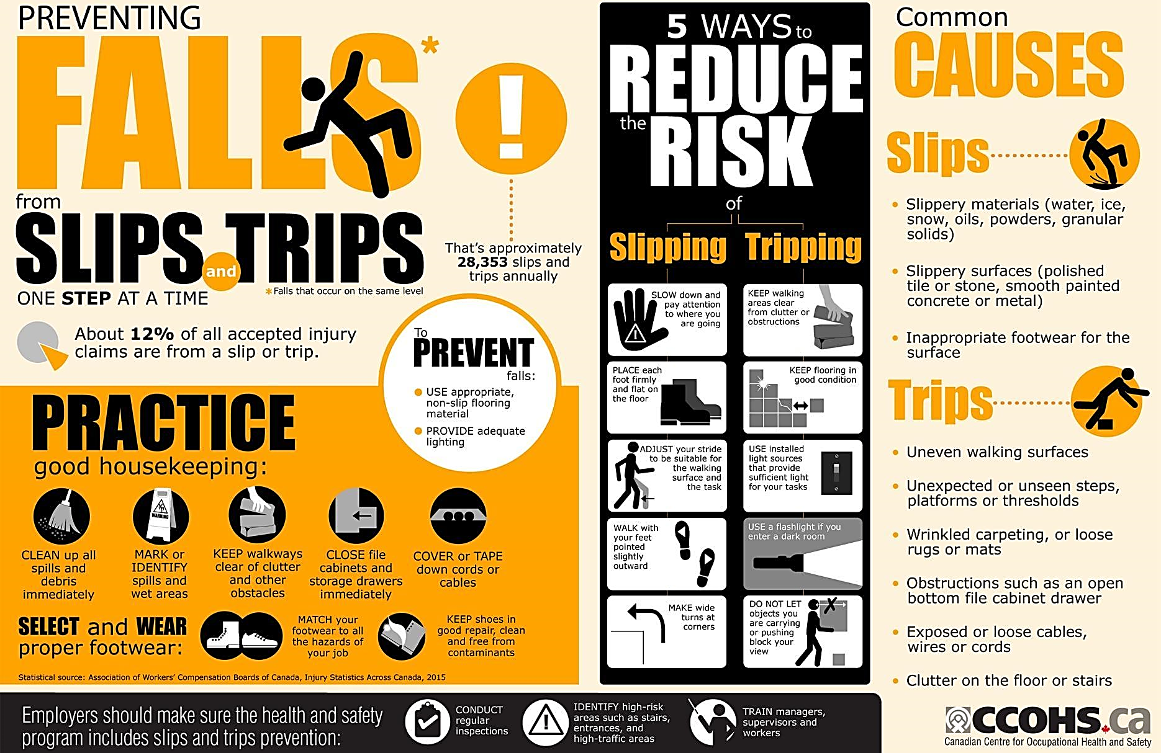

Work Sheet
Task 1: How many annual slips and trips are there in Canada?
Answer:

Task 2: List 3 good housekeeping practices to avoid trips and slips.
Answer:

Task 3: List 3 ways to reduce the risk of slipping.
Answer:

Task 4: List 3 ways to reduce the risk of tripping.
Answer:

Task 5: What are the common causes of slips?
Answer:

Task 6: What are the common causes of trips?
Answer:

Answers
Task 1: How many annual slips and trips are there in Canada?
Answer: 28,353
Task 2: List 3 good housekeeping practices to avoid trips and slips.
Answer: Any 3 of the following:
- Clean up spills and debris immediately
- Mark or identify spills and wet areas
- Keep walkways clear of clutter and other obstacles
- Close file cabinets and storage drawers immediately
- Cover or tape down cords of cables
- Select and wear proper footwear – match your footwear to all hazards of your job and keep shoes I good pair, clean free from contaminants
Task 3: List 3 ways to reduce the risk of slipping.
Answer: Any 3 of the following:
- Slow down and pay attention to where you are going
- Place each foot firmly and flat on the floor
- Adjust your stride to be suitable for the walking surface and the task
- Make wide turns at corners
- Walk with your feet pointed slightly outward

Task 4: List 3 ways to reduce the risk of tripping.
Answer: Any 3 of the following:
- Keep walking areas clear from clutter or obstructions
- Keep flooring in good condition
- Use installed light sources that provide sufficient light for your tasks
- Use a flashlight if you enter a dark room
- Do not let objects you are carrying or pushing block your view

Task 5: What are the common causes of slips?
Answer:
- Slippery materials (water, ice, snow, oils, powders, granular solids)
- Slippery surfaces (polished tile or stone, smooth painted concrete or metal)
- Inappropriate footwear for the surface
Task 6: What are the common causes of trips?
Answer:
- Uneven walking surfaces
- ﻿﻿Unexpected or unseen steps, platforms or thresholds
- ﻿﻿Wrinkled carpeting, or loose rugs or mats
- ﻿﻿Obstructions such as an open bottom file cabinet drawer
- ﻿﻿Exposed or loose cables, wires or cords
- Clutter on the floor or stairs

Performance Descriptors
Levels | Performance Descriptors | Needs Work | Completes task with support from practitioner | Completes task independently
A2.2 | Performs limited searches using one or two search criteria
A2.2 | Uses layout to locate information
A2.2 | Makes low-level inferences
A2.2 | Makes connections between parts of documents

This task: Was successfully completed Needs to be tried again
Learner Comments:

Instructor (print): Learner (print):

