

Task Title: Mining Safety Part 2

OALCF Cover Sheet – Practitioner Copy

Learner Name:
Date Started:
Date Completed:
Goal Path: | Employment | Apprenticeship
Secondary School | Post Secondary | Independence
Successful Completion: Yes No

Task Description:
Read a health and safety poster to understand Mining safety in workplace operations.
Main Competency/Task Group/Level Indicator:
- Find and Use Information/Interpret documents/A2.2
- Understand and Use Numbers/Manage data/C4.1
Materials Required:
- Pen/pencil and/or digital device

Learner Information
The mining industry is made up of various occupations which include driving different pieces of equipment on and off the jobsite. In all occupations there is a focus on safety on the job. Scan the Workplace Health and Safety Snapshot for Ontario Mining Sector in 2022.

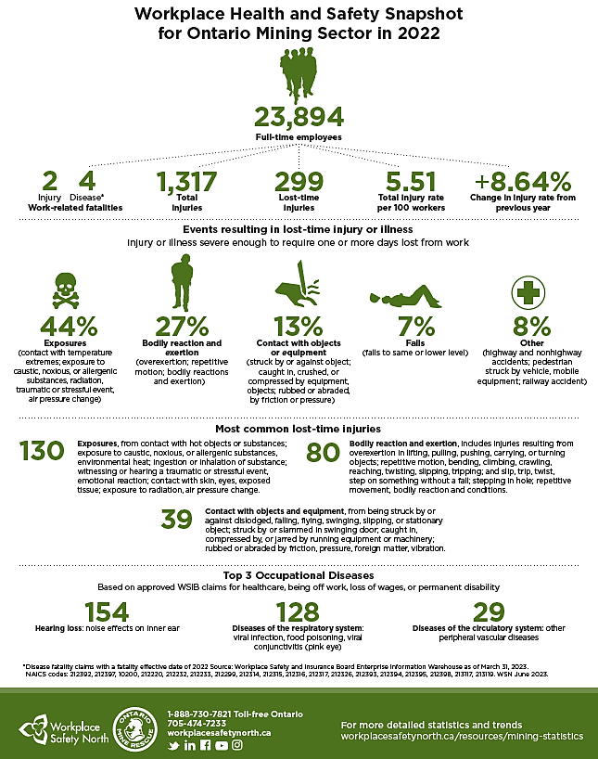

Work Sheet
Task 1: How many full-time employees are there in the Ontario Mining Sector?
Answer:

Task 2: What are the 3 most common lost time injuries?
Answer:

Task 3: What is considered a lost time injury?
Answer:

Task 4: List two ways an exposure injury can occur.

Task 5: Calculate the total number of Top 3 Occupational Diseases.

Task 6: What is the change in injury rate from the previous year?

Answer Sheet
Task 1: How many Full-time employees are there in the Ontario Mining Sector?
Answer: 23,894
Task 2: What are the 3 most common lost time injuries?
Answer
- Exposures
- Bodily reaction and exertion
- Contact with objects or equipment

Task 3: What is considered a lost time injury?
Answer: Injury or illness severe enough to require one or more days lost from work

Task 4: List two ways an exposure injury can occur.
Answer: Any two of the following:
- Contact with temperature extremes
- Exposure to caustic, noxious or allergenic substances
- Radiation
- Traumatic or stressful event
- Air pressure change

Task 5: Calculate the total number of Top 3 Occupational Diseases.
Answer: 154 + 128 + 29 = 311

Task 6: What is the change in injury rate from the previous year?
Answer: +8.64%
Performance Descriptors
Levels | Performance Descriptors | Needs Work | Completes task with support from practitioner | Completes task independently
A2.2 | Performs limited searches using or two search criteria
A2.2 | Extracts information from tables and forms
A2.2 | Uses layout to locate information
C4.1 | Adds, subtracts, multiplies and divides whole numbers and decimals
C4.1 | Begins to interpret integers

This task: Was successfully completed Needs to be tried again

Learner Comments:

Instructor (print): Learner (print):

