

Task Title: Mining Safety Part 1

OALCF Cover Sheet – Practitioner Copy

Learner Name:___________________________________________
Date Started:____________________________________________
Date Completed: _________________________________________
Goal Path: | Employment | Apprenticeship
Secondary School | Post Secondary | Independence
Successful Completion: Yes No

Task Description:
Read a certification and training bulletin to understand mining safety in workplace operations.

Main Competency/Task Group/Level Indicator:
- Find and Use Information/Read continuous text/A1.2
- Find and Use Information/Interpret documents/A2.1

Materials Required:
- Pen/pencil and/or digital device

Learner Information
The mining industry is made up of various occupations which include driving different pieces of equipment on and off the jobsite. In all occupations there is a focus on safety on the job.
Scan the Overview of Joint Health and Safety Committee certification and mining safety training bulletin.

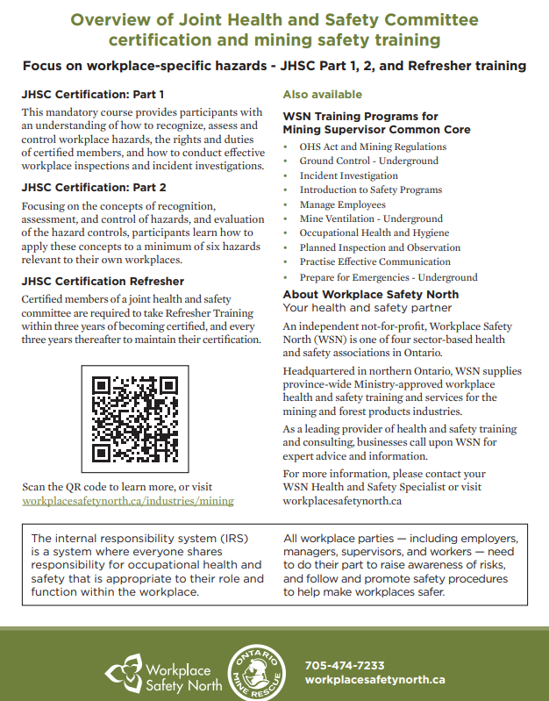

Work Sheet
Task 1: What is the focus of this bulletin?
Answer:

Task 2: How many Joint Health and Safety Committee certifications are there?
Answer:

Task 3: List the two things that participants must understand in the JHSC Certification: Part 1.
Answer:

Task 4: What are two ways to learn more?
Answer:

Task 5: What is the internal responsibility system (IRS)?
Answer:

Answers
Task 1: What is the focus of this bulletin?
Answer: Workplace-specific hazards

Task 2: How many Joint Health and Safety Committee certifications are there?
Answer: Three

Task 3: List the two things that participants must understand in the JHSC Certification: Part 1.
Answer: Any two of the following:
- Recognize, assess and control workplace hazards
- The rights and duties of certified members
- How to conduct effective workplace inspections
- Incident investigations

Task 4: What are two ways to learn more?
Answer: Scan the QR code or visit workplacesafetynorth.ca/industries/mining

Task 5: What is the internal responsibility system (IRS)?
Answer: Where everyone shares responsibility for occupational health and safety that is appropriate to their role and function within the workplace.

Performance Descriptors
Levels | Performance Descriptors | Needs Work | Completes task with support from practitioner | Completes task independently
A1.2 | Scans text to locate information
 | Locates multiple pieces of information in simple texts
 | Reads more complex texts to locate a single piece of information
A2.1 | Locates specific details in simple document, such as labels and signs

This task: Was successfully completed Needs to be tried again
Learner Comments:

Instructor (print): Learner (print):

