

Task Title: Material Handling, Hoisting and Moving Heavy Objects

OALCF Cover Sheet – Practitioner Copy

Learner Name: __________________________________________
Date Started: ___________________________________________
Date Completed:_________________________________________
Goal Path: | Employment | Apprenticeship
Secondary School | Post Secondary | Independence
Successful Completion: Yes No

Task Description:
Read document to learn safe Material Handling practices for hoisting and moving heavy objects to prevent injuries in the workplace.

Main Competency/Task Group/Level Indicator:
- Find and Use Information/Interpret documents/A2.2

Materials Required:
- Pen and paper and/or digital device

Learner Information
Knowing how to safely hoist and move heavy objects is an important part of preventing injuries and staying safe when working as a Material Handler. Scan the Manual Materials Handling (MMH) - Hoisting and Moving Heavy Objects.

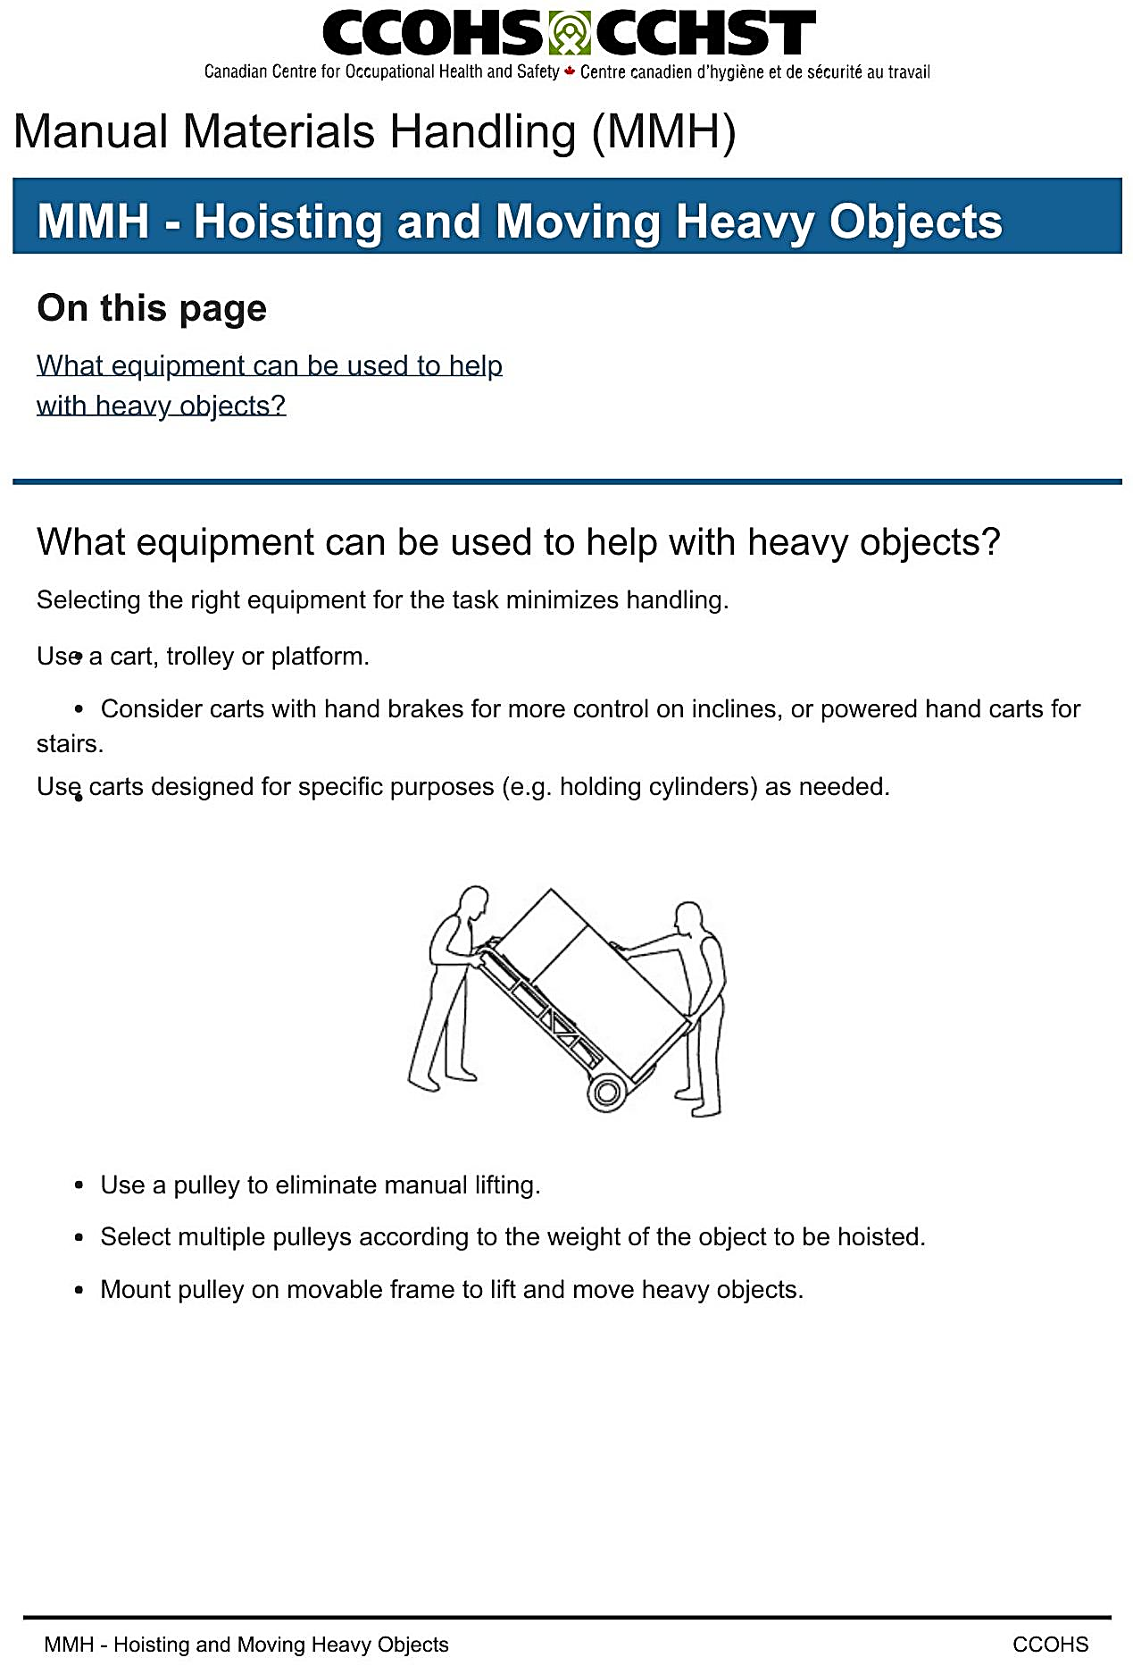

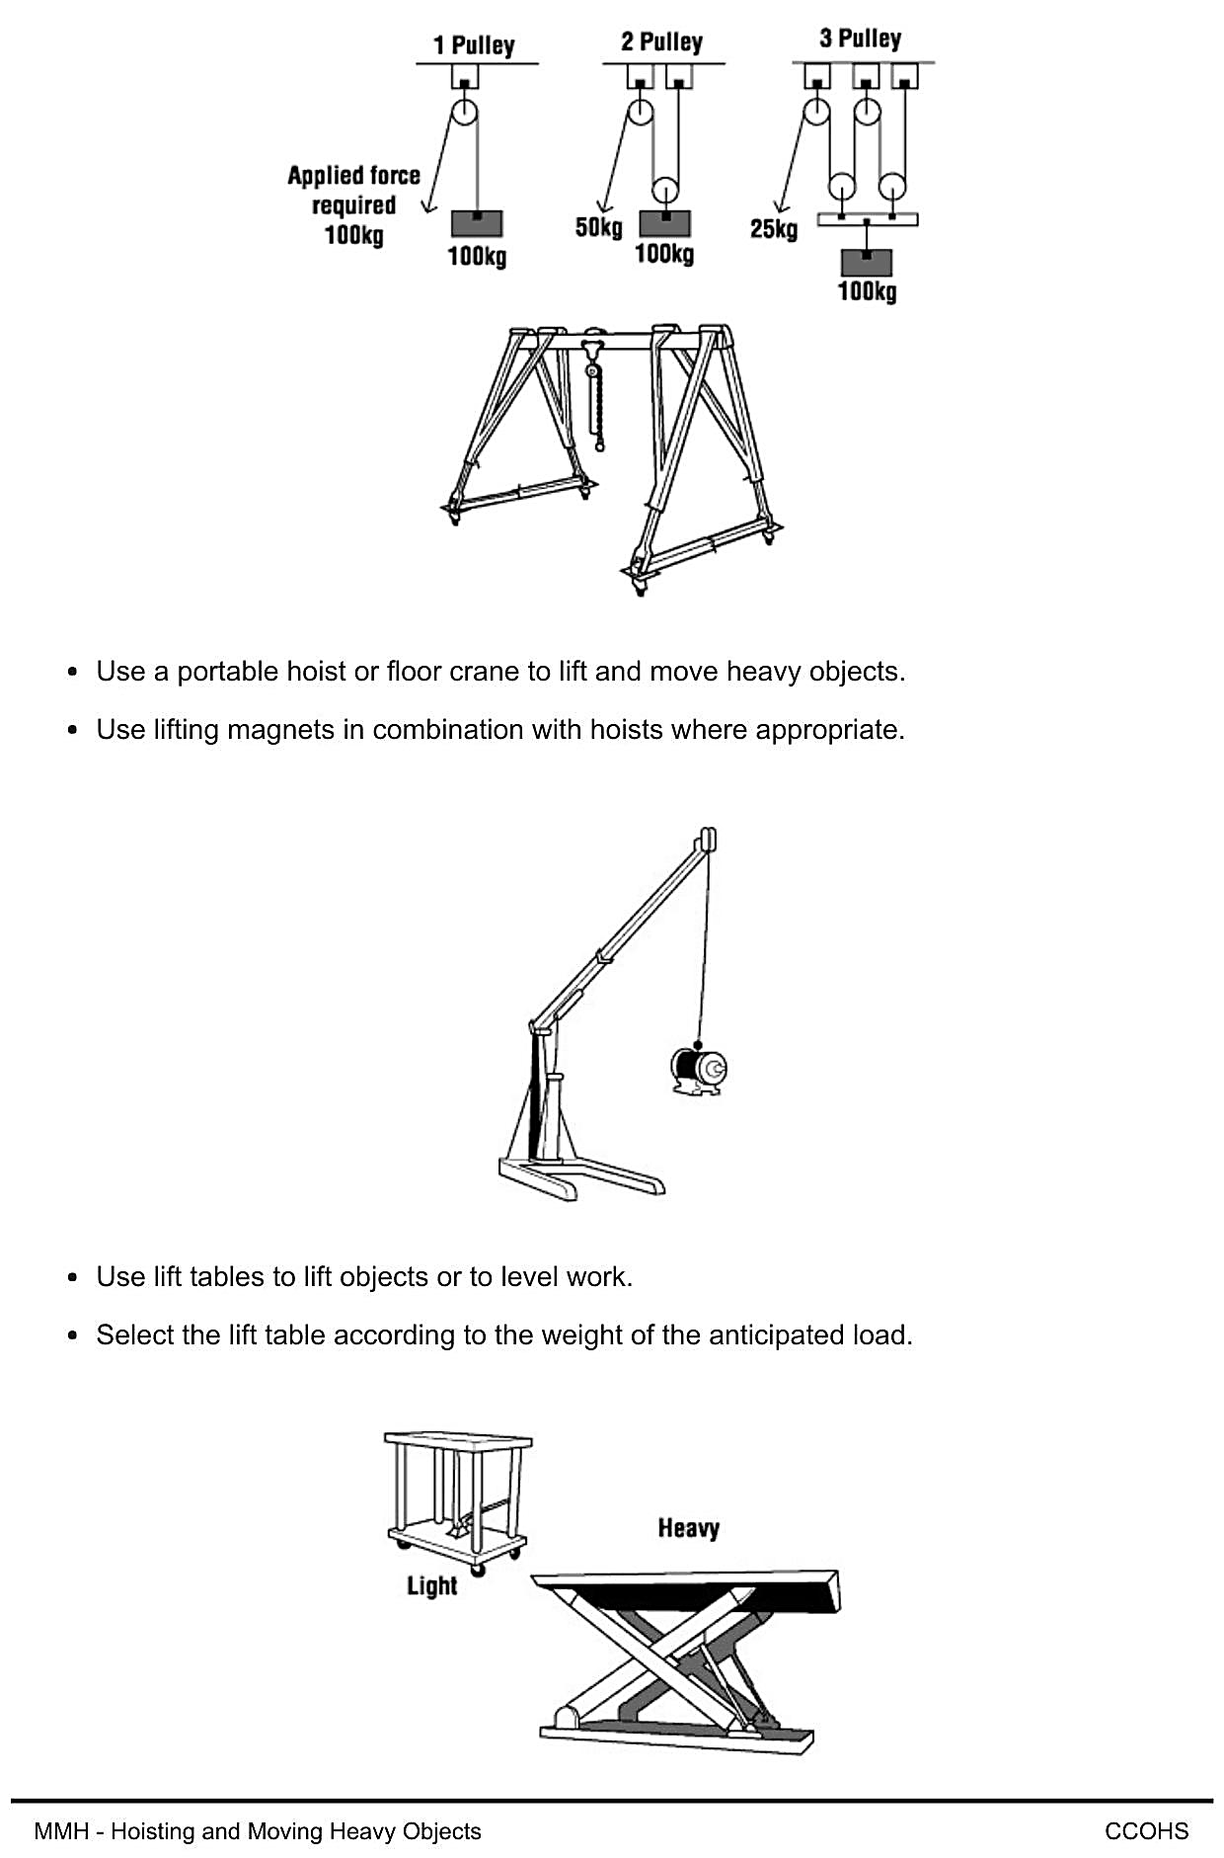

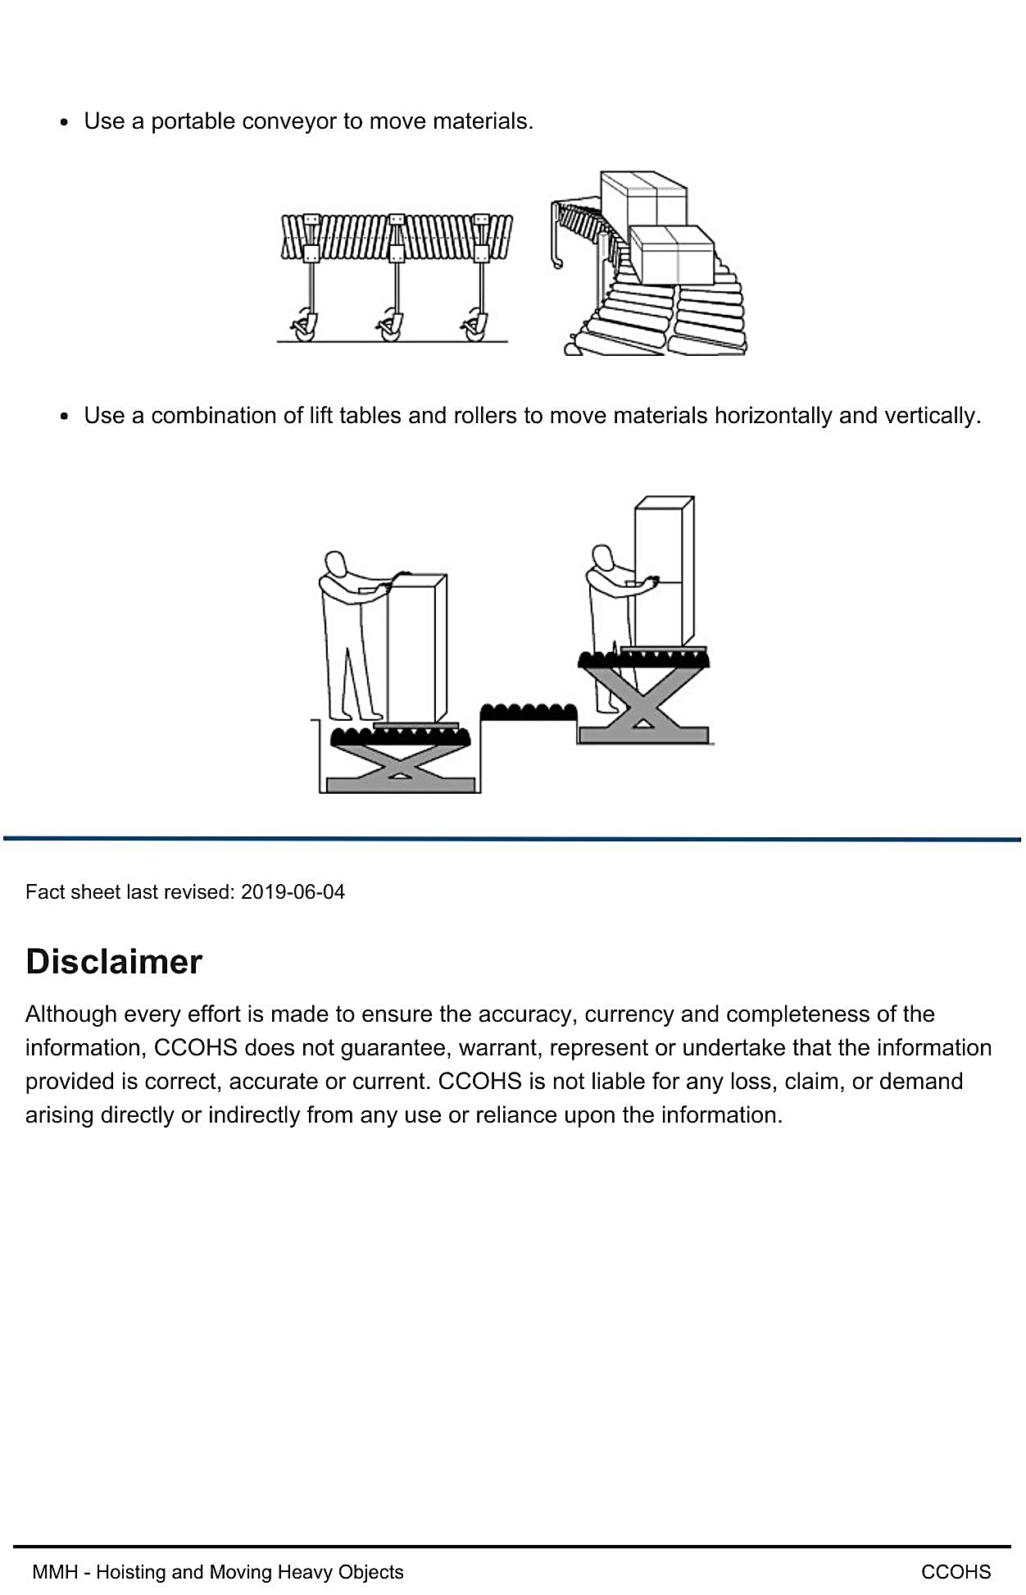
Link to document online: https://www.ccohs.ca/oshanswers/ergonomics/mmh/hoisting.html

Work Sheet
Task 1: Why is it important to select the right equipment to move heavy objects?
Answer:
_____________________________________________________________
Task 2: What can you use instead of manual lifting?
Answer:
_____________________________________________________________
Task 3: How much applied force is needed when using 3 pulleys to lift 100kg?
Answer:
_____________________________________________________________
Task 4: When should you use a combination of lift tables and rollers?
Answer:
______________________________________________________
Task 5: How do you select which lift table to use?
Answer:

_____________________________________________________________
Task 6: Which type of cart gives you more control on inclines?
Answer:
_____________________________________________________________
Answers
Task 1: Why is it important to select the right equipment to move heavy objects?
Answer: “Selecting the right equipment for the task minimizes handling.”

Task 2: What can you use instead of manual lifting?
Answer: a pulley

Task 3: How much applied force is needed when using 3 pulleys to lift 100kg?
Answer: 25kg

Task 4: When should you use a combination of lift tables and rollers?
Answer: When “moving materials horizontally and vertically”

Task 5: How do you select which lift table to use?
Answer: “Select the lift table according to the weight of the anticipated load”

Task 6: Which type of cart gives you more control on inclines?
Answer: “carts with hand brakes”

Performance Descriptors
Levels | Performance Descriptors | Needs Work | Completes task with support from practitioner | Completes task independently
A2.2 | Perform limited searches using one or two search criteria
A2.2 | Uses layout to locate information
A2.2 | Interpret documents to locate and connect information

This task: Was successfully completed Needs to be tried again

Learner Comments:

Instructor (print): Learner (print):

_______________________ _______________________

