

Task Title: Understanding Manual Material Handling practices in the workplace

OALCF Cover Sheet – Practitioner Copy

Learner Name:
Date Started:
Date Completed:
Goal Path: | Employment | Apprenticeship
Secondary School | Post Secondary | Independence
Successful Completion: Yes No

Task Description:
Read a document on Manual Material Handling practices and answer questions about general practices to prevent injuries and stay safe in the workplace.
Main Competency/Task Group/Level Indicator:
- Find and Use Information/Interpret Documents/A2.2
Materials Required:
- Pen and paper and/or digital device

Learner Information
Every workplace includes tasks that involve manual materials handling: lifting, lowering, carrying, pushing, pulling, holding or restraining. It is important to understand general materials handling practices to prevent injuries and stay safe at your workplace. Scan Manual Materials Handling (MMH) - General Practice.

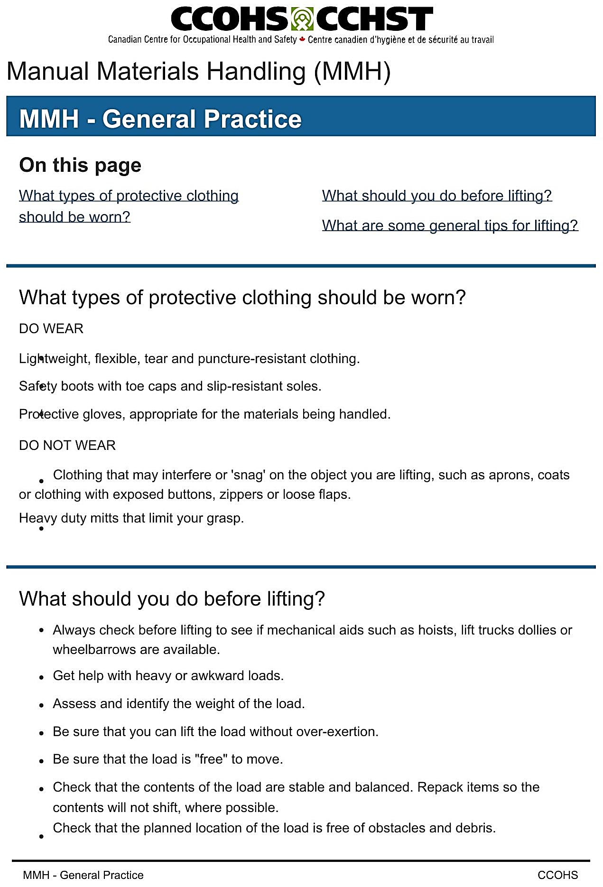

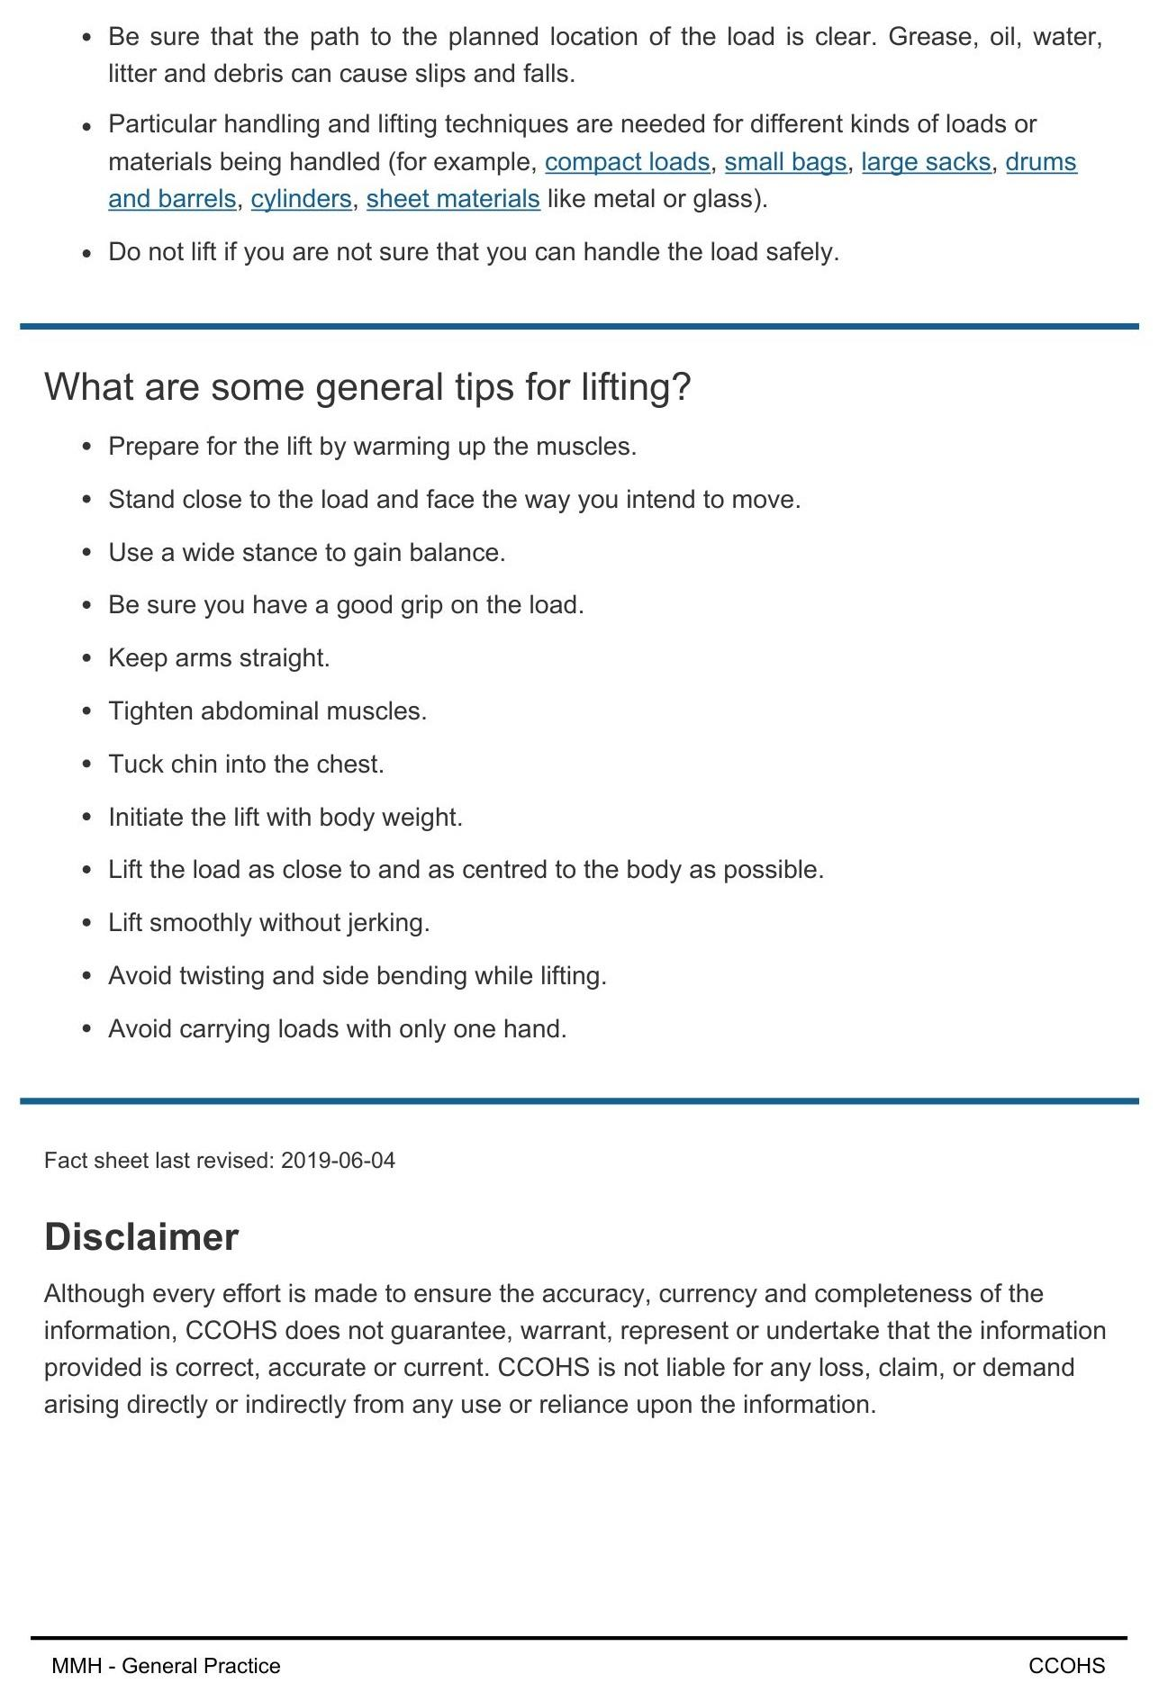

Work Sheet
Task 1: List two pieces of protective clothing you should wear when material handling.
Answer:

Task 2: Why shouldn’t you wear clothing with exposed buttons or zippers?
Answer:

Task 3: What should you always check before lifting?
Answer:

Task 4: When should you repack items before moving them?
Answer:

Task 5: What should you do if you are not sure you can safely handle the load?
Answer:

Task 6: List three things you can do to lift safely.
Answer:

Answers
Task 1: List two pieces of protective clothing you should wear when material handling.
Answer: Any two of the following are correct.
- Lightweight, flexible, tear and puncture-resistant clothing
- Safety boots with toes caps and slip-resistant soles
- Protective gloves, appropriate for the materials being handled
Task 2: Why shouldn’t you wear clothing with exposed buttons or zippers?
Answer: They “may interfere or ‘snag’ on the object you are lifting”
Task 3: What should you always check before lifting?
Answer: “Always check before lifting to see if mechanical aids such as hoists, lift trucks, dollies or wheelbarrows are available."
Task 4: When should you repack items before moving them?
Answer: Repack items when the contents of the load are not stable and balanced.
Task 5: What should you do if you are not sure you can safely handle the load?
Answer: Do not lift.
Task 6: List three things you can do to lift safely.
Answer: Any three of the following are correct
- Prepare for the lift by warming up the muscles.
- Stand close to the load and face the way you intend to move.
- Use a wide stance to gain balance
- Keep your arms straight
- Tighten abdominal muscles.
- Tuck chin into the chest.
- Initiate the lift with body weight.
- Lift the load as close to and as centred to the body as possible.
- Lift smoothly without jerking.
- Avoid twisting and side bending while lifting.
- Avoid carrying loads with only one hand.

Performance Descriptors
Levels | Performance Descriptors | Needs Work | Completes task with support from practitioner | Completes task independently
A2.2 | Perform limited searches using one or two search criteria
A2.2 | Uses layout to locate information
A2.2 | Interpret documents to locate and connect information

This task: Was successfully completed Needs to be tried again

Learner Comments:

Instructor (print): Learner (print):

URLs
Link to document online: https://www.ccohs.ca/oshanswers/ergonomics/mmh/generalpractice.html

