

Task Title: Forestry Safety Part 2

OALCF Cover Sheet – Practitioner Copy

Learner Name:___________________________________________
Date Started:____________________________________________
Date Completed: _________________________________________
Goal Path: | Employment | Apprenticeship
Secondary School | Post Secondary | Independence
Successful Completion: Yes No

Task Description:
Read a chart to understand causes of distracted driving in Ontario logging operations.
Main Competency/Task Group/Level Indicator:
- Find and Use Information/Interpret documents/A2.2
Materials Required:
- Pen/pencil and/or digital device

Learner Information
Forestry safety is important in the logging industry in Ontario. Research has found the use of smartphones and two-way radios have made distracted driving the top health and safety risk for logging workers. Scan the Distracted Driving Causes chart.

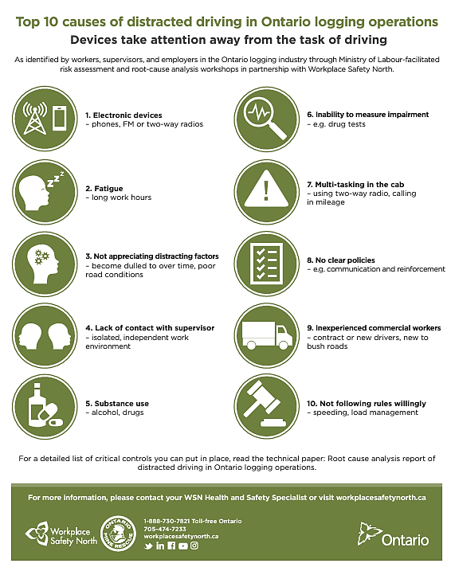
Distracted Driving Causes

Work Sheet
Task 1: Who identified the top 10 causes of distracted driving in Ontario logging operations?
Answer:

Task 2: List three causes of distracted driving.
Answer:

Task 3: What are the two reasons given for multi-tasking in the cab?
Answer:

Task 4: Who do you contact to get more information?
Answer:

Task 5: Where can you locate a detailed list of critical controls?
Answer:

Answers
Task 1: Who identified the top 10 causes of distracted driving in Ontario logging operations?
Answer: Workers, Supervisors, Employers

Task 2: List three causes of distracted driving.
Answer: Any 3 of the following:
- Electronic devices (phones, FM or two-way radios)
- Fatigue
- Not appreciating distracting factors (become dulled over time, poor road conditions)
- Lack of contact with supervisor (isolated)
- Substance abuse (alcohol, drugs)
- Inability to measure impairment
- Multitasking in the cab
- No clear policies
- Inexperienced commercial workers (contract or new drivers, new to bush roads)
- Not following rules willingly (speeding, load management)
Task 3: What are the two reasons given for multi-tasking in the cab?
Answer: Using two-way radio and calling in mileage
Task 4: Who do you contact to get more information?
Answer: Your WSN Health and Safety Specialist
Task 5: Where can you locate a detailed list of critical controls?
Answer: the technical paper: Root cause analysis report of distracted driving in Ontario logging operations

Performance Descriptors
Levels | Performance Descriptors | Needs Work | Completes task with support from practitioner | Completes task independently
A2.2 | Performs limited searches using one or two search criteria
A2.2 | Extracts information from tables and forms
A2.2 | Uses layout to locate information
A2.2 | Makes connections between parts of documents

This task: Was successfully completed Needs to be tried again

Learner Comments:

Instructor (print): Learner (print):

