

Task Title: Ductwork Installation Guide

OALCF Cover Sheet – Practitioner Copy

Learner Name:
Date Started:
Date Completed:
Goal Path: | Employment | Apprenticeship
Secondary School | Post Secondary | Independence
Successful Completion: Yes No

Task Description:
Read a Ductwork Installation Guide to answer questions about home installation.
Main Competency/Task Group/Level Indicator:
- Find and Use Information/Interpret documents/A2.2
Materials Required:
- Pen and Paper and/or digital device

Learner Information

Installation guides give homeowners tips on how to complete simple construction projects at home. Scan the Ductwork Installation Guide.

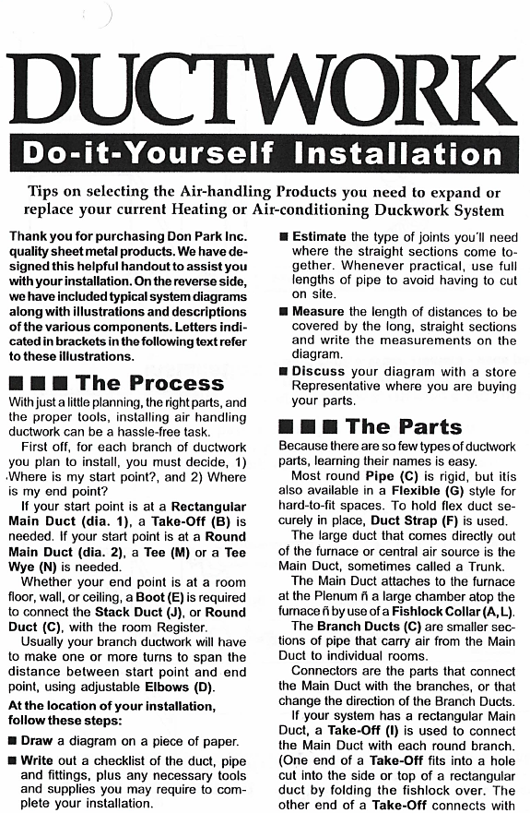
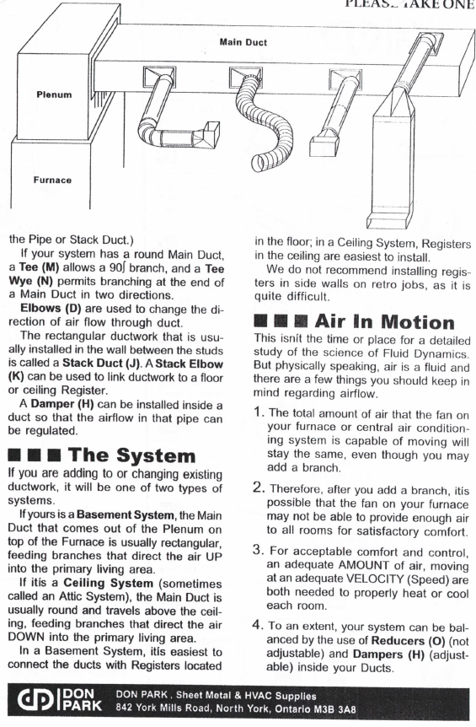
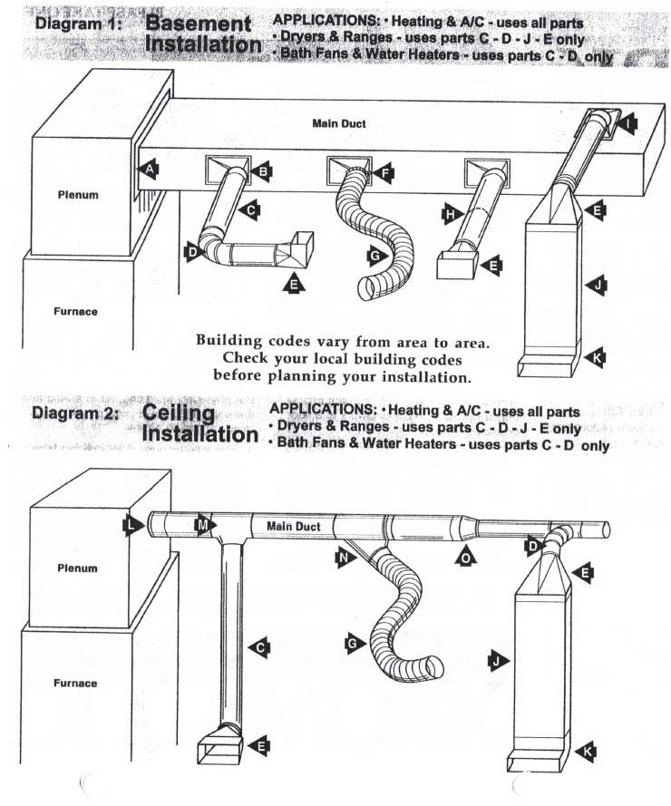
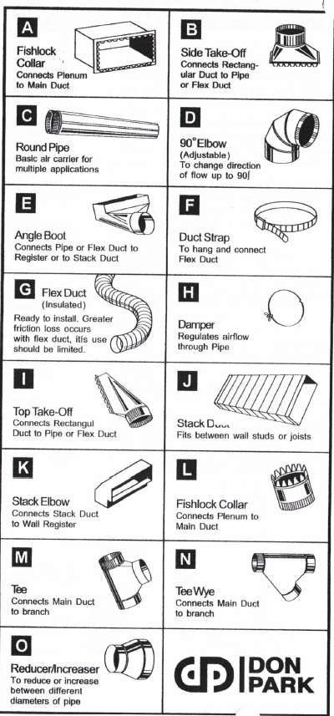

Work Sheet:
Task 1: Which 2 types of installations are found in the instructions?
Answer:

Task 2: Which code must the installer check before planning the installation?
Answer:
Task 3: List the 5 steps that are part of the Process.

Task 4: How does someone know this installation does not need to be done by an expert?

Task# 5: Where does an installer use a “reducer/increaser”?

Answers
Task 1: Which 2 types of installations are found in the instructions?
Answer: Basement, ceiling

Task 2: Which code must the installer check before planning the installation? (answer is difficult to find)
Answer: (Local) building codes

Task 3: Locate where the Process is explained. List the 5 steps that are part of the Process. (distractors: another list is numbered while this list is not)
Answer:
- Draw a diagram.
- Write a checklist of the ducts, fittings, pipes, and tools and supplies needed
- Estimate the type of pipes needed.
- Measure the lengths of distances and write down these measurements.
- Discuss the diagram with a store representative to be sure you have everything needed.

Task 4: How does someone know this installation does not need to be done by an expert? (low-level inference required)
Answer: This is a “Do It Yourself” instruction sheet so the process does not need to be done by an expert.

Task 5: Where does an installer use a “reducer/increaser”?
Answer: To reduce or increase between diameters of pipe

Performance Descriptors
Levels | Performance Descriptors | Needs Work | Completes task with support from practitioner | Completes task independently
A2.1 | Scans to locate specific details
A2.1 | Locates specific details in simple documents
A2.2 | Makes low-level inferences
A2.2 | Uses layout to locate information

This task: Was successfully completed Needs to be tried again

Learner Comments:

Instructor (print): Learner (print):

