

Task Title: Completing a Bill of Lading Form

OALCF Cover Sheet – Practitioner Copy

Learner Name:
Date Started:
Date Completed:
Goal Path: | Employment | Apprenticeship
Secondary School | Post Secondary | Independence
Successful Completion: Yes No

Task Description:
Read a Bill of Lading form to understand the requirements for filling it out as a Material Handler in the workplace.
Main Competency/Task Group/Level Indicator:
- Find and Use Information/Interpret documents/A2.3
Materials Required:
- Pen and paper and/or digital device

Note to Instructor/Facilitator
The Bill of Lading form is best viewed online in magnifying format.

Learner Information
Completing a Bill of Lading for items being shipped is a common part of many Material Handling jobs. It is important to understand and fill in this document with correct shipping information for your employer.
Scan the FedEX Bill of Lading.

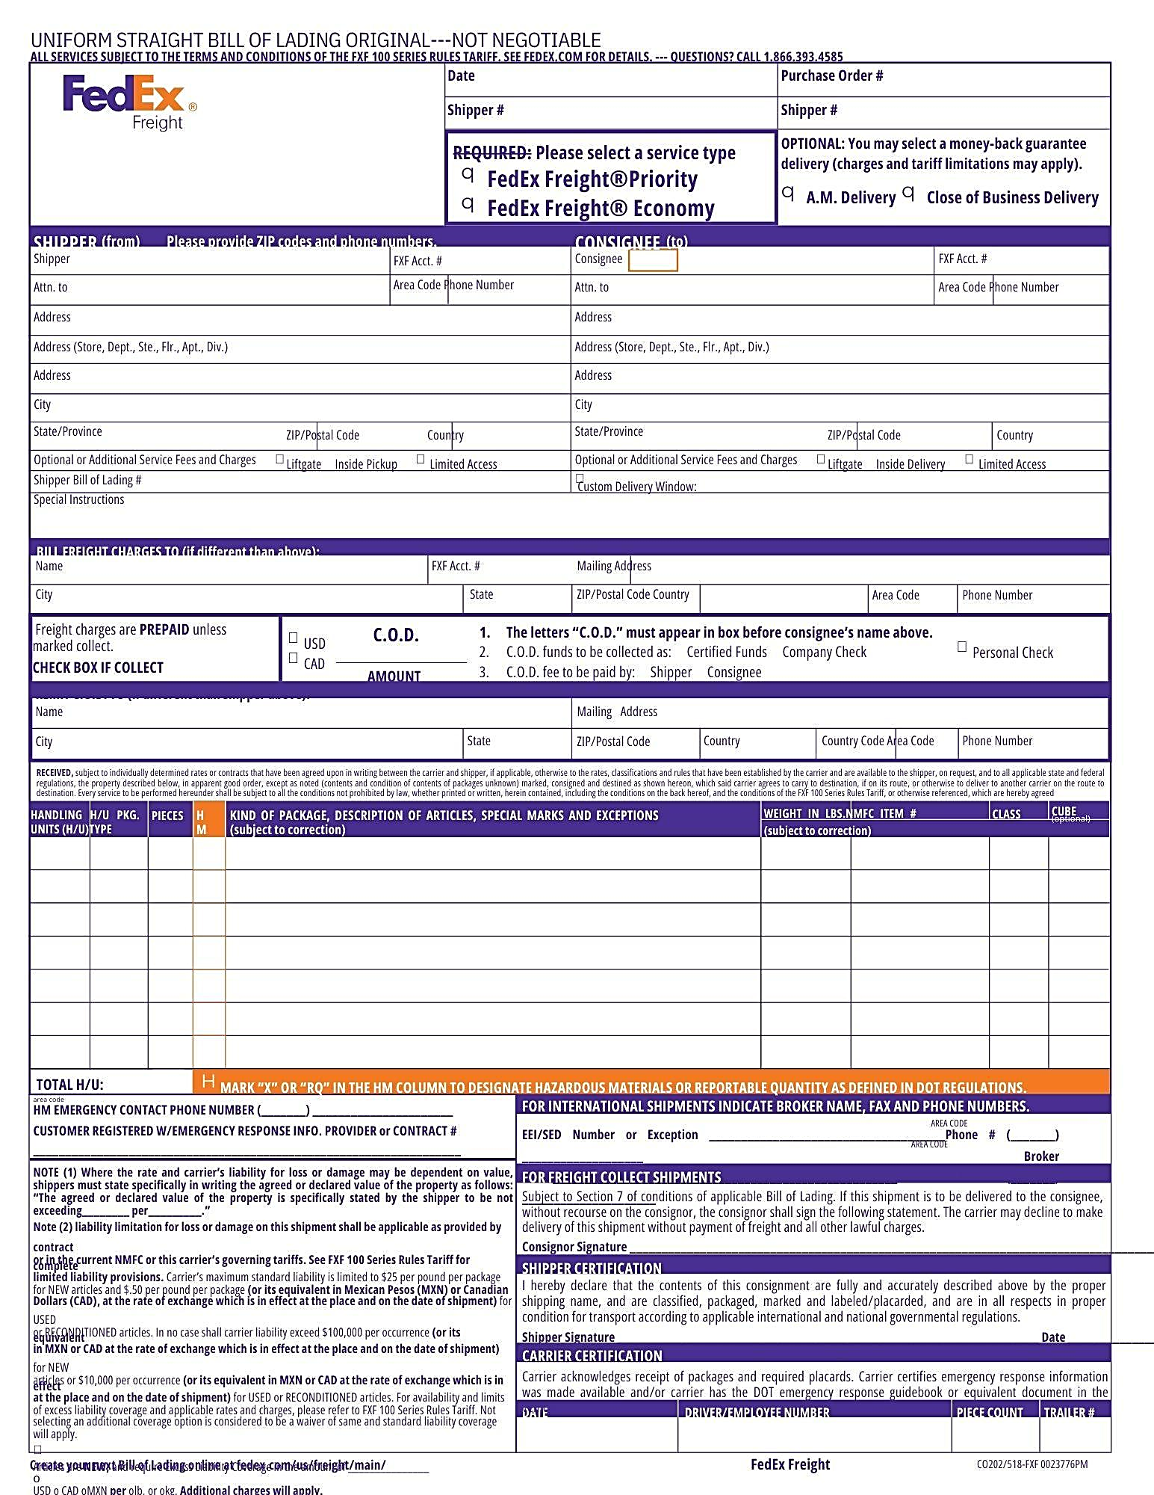

Work Sheet
Task 1: Which two service types does Fedex offer?
Answer:
Task 2: List 5 pieces of information about the Shipper that are needed to complete the form.
Answer:

Task 3: Where must the letters “C.O.D.” appear for a collect shipment?
Answer:

Task 4: How do you designate an item you are shipping as a Hazardous material?
Answer:

Task 5: List 3 pieces of information you need to fill in about the items you are shipping.
Answer:

Task 6: When do you need to provide an emergency contact number?
Answer:

Task 7: What information must you provide for international shipments?
Answer:

Answers
Task 1: Which two service types does FedEx offer?
Answer: FedEx Freight Priority and FedEx Freight Economy
Task 2: List 5 pieces of information about the Shipper that are needed to complete the form
Answer: Any 5 of the following:

- name
- FXF Acct #
- Attn to:
- address
- Phone number
- city
- state/province
- postal code
- Country
- Shipper Bill of Lading #

Task 3: Where must the letters “C.O.D.” appear for a collect shipment?
Answer: The letters “C.O.D.” must appear in the box before the consignee's name at the top of the form.
Task 4: How do you designate an item you are shipping as a Hazardous material?
Answer: Mark “X” or “RQ” in the HM Column
Task 5: List 3 pieces of information you need to fill in about the items you are shipping
Answer: Any 3 of the following:

- Handling units
- H/U Pkg. type
- Pieces
- HM
- Kind of package
- description of articles
- special marks
- exceptions
- Weight in lbs.
- NMFC Item#
- Class
- Cube (optional)

Task 6: When do you need to provide an emergency contact number?
Answer: When shipping Hazardous Materials
Task 7: What information must you provide for international shipments?
Answer: Broker Name, Fax and Phone numbers

Performance Descriptors
Levels | Performance Descriptors | Needs Work | Completes task with support from practitioner | Completes task independently
A2.3 | Interpret somewhat complex documents to connect, evaluate and integrate information

This task: Was successfully completed Needs to be tried again

Learner Comments:

Instructor (print): Learner (print):

URLs
Link to printable FedEx Bill of Lading:
www.fedex.com/content/dam/fedex/us-united-states/freight/images/2019/Q3/fxfbol_1932893323.pdf

