

Task Title: Classification of Trades

OALCF Cover Sheet – Practitioner Copy

Learner Name:___________________________________________
Date Started:____________________________________________
Date Completed: _________________________________________
Goal Path: | Employment | Apprenticeship
Secondary School | Post Secondary | Independence
Successful Completion: Yes No

Task Description:
Read definitions and interpret information in a table to answer questions about trades classifications.

Main Competency/Task Group/Level Indicator:
- Find and Use Information/Read continuous text/A1.2
- Find and Use Information/ Interpret documents/A2.2

Materials Required:
- Pen and paper and/or digital device

Learner Information
Skilled Trades Ontario provides information about the classification of Trades in Ontario. Scan the definitions document and table.
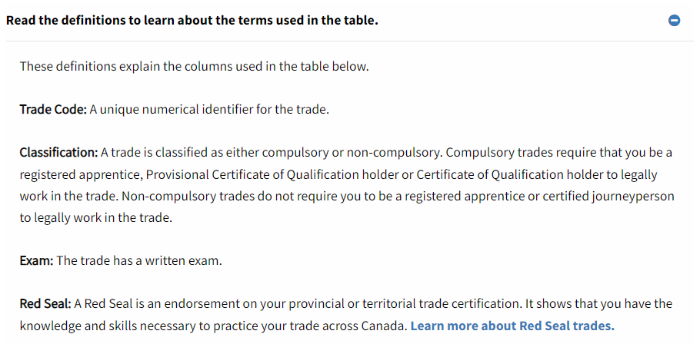
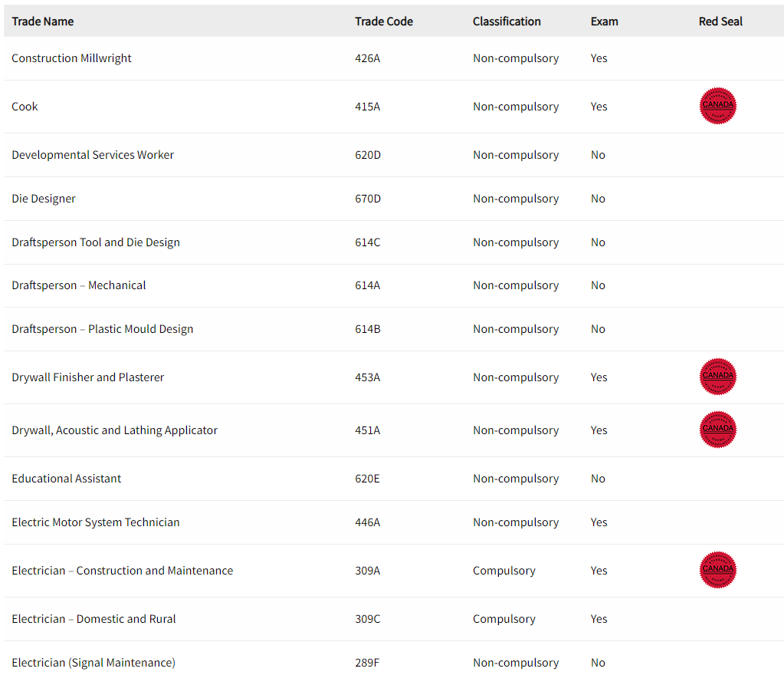

Work Sheet
Task 1: List the two (2) trades classifications in the Province of Ontario.
Answer:

_____________________________________________________________
Task 2: What is the definition of a Compulsory trade?
Answer:

_____________________________________________________________
Task 3: Where can you practise your trade if you have a Red Seal?
Answer:

_____________________________________________________________
Task 4: What is a trade that is both Compulsory and Red Seal?
Answer:
_____________________________________________________________

Answers
Task 1: List the two (2) trades classifications in the Province of Ontario.
Answer:
Compulsory and Non-compulsory

Task 2: What is the definition of a Compulsory trade?
Answer:
A Compulsory trade requires an apprenticeship – must be a registered apprentice, Provisional Certificate of Qualification holder, or Certificate of Qualification holder to legally work in the trade.

Task 3: Where can you practise your trade if you have a Red Seal?
Answer:
Across Canada/Any Province or Territory in Canada

Task 4: What is a trade that is both Compulsory and Red Seal?
Answer:
Electrician – Construction and Maintenance [Trade code 309A]
Performance Descriptors
Levels | Performance Descriptors | Needs Work | Completes task with support from practitioner | Completes task independently
A1.2 | Scans text to locate information
 | Locates multiple pieces of information in simple texts
A2.2 | Performs limited searches using one or two search criteria
 | Extracts information from tables and forms
 | Uses layout to locate information
 | Makes connections between parts of documents

This task: Was successfully completed Needs to be tried again

Learner Comments:

Instructor (print): Learner (print):
_______________________ _______________________

