

Task Title: Calculating Costs on a Material Handling Order Form

OALCF Cover Sheet – Practitioner Copy

Learner Name:
Date Started:
Date Completed:
Goal Path: | Employment | Apprenticeship
Secondary School | Post Secondary | Independence
Successful Completion: Yes No

Task Description:
Using information provided on a Material Handling Order Form to calculate material handling costs for an employer attending a trade show.
Main Competency/Task Group/Level Indicator:
- Understand and Use Numbers/Manage money/C1.3
Materials Required:
- Pen and paper and/or digital device
- Calculator (optional)

Learner Information
Terra Greenhouses will be attending a trade show and needs its greenhouse workers to order advanced material handling services.
Scan the Advance Material Handling Order Form.

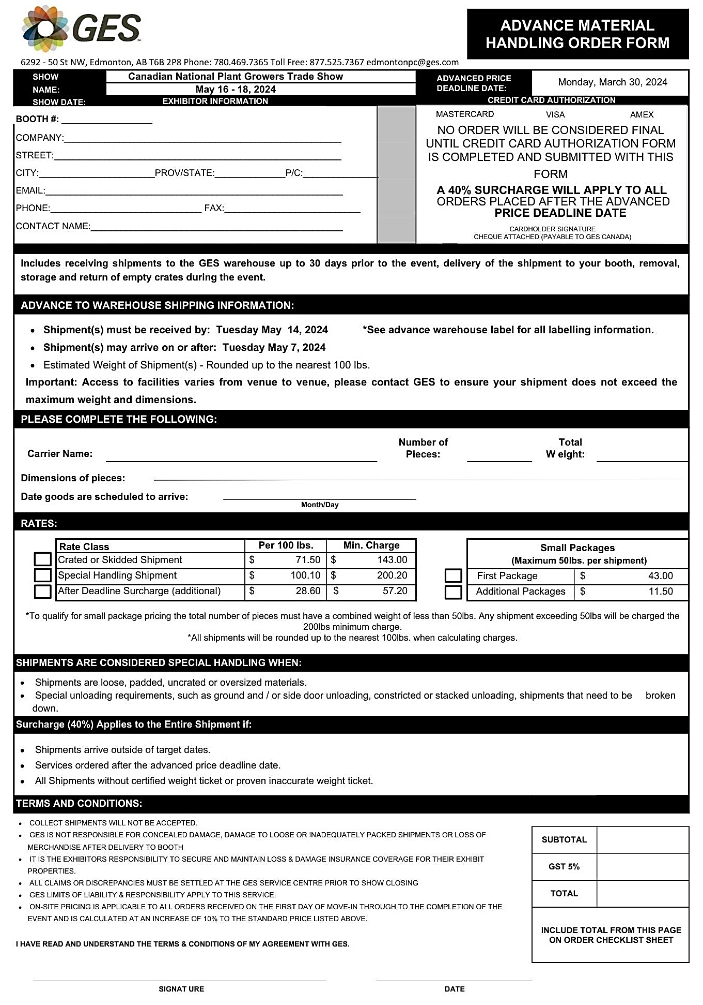

Work Sheet
Task 1: Calculate the cost to order material handling services for 2 crates of decorative plant pots that weigh 100 lbs each?
Answer:

Task 2: Calculate the cost to order material handling services for 3 skids of live plants that weigh 150 lbs each?
Answer:

Task 3: Calculate the subtotal to order material handling services for 2 skids weighing 100 lbs each and 2 crates weighing 200 lbs each.
Answer:

Task 4: Calculate the GST for the material handling service order if the subtotal is $429.00.
Answer:

Task 5: Calculate the total cost to order these material handling services including GST for 4 skids weighing 100 lbs each and 2 crates weighing 200 lbs each.
Answer:

Task 6: Terra Greenhouses wants to order material handling services that subtotal $572.00 but they missed the Advanced Price Deadline. Calculate the new subtotal.
Answer:

Answers
Task 1: Calculate the cost to order material handling services for 2 crates of decorative plant pots that weigh 100 lbs each?
Answer: $ 71.50 x 2 = $ 143.00

Task 2: Calculate the cost to order material handling services for 3 skids of live plants that weigh 150 lbs each?
Answer:
Step 1: 50lbs = 50/100 = 0.5
Step 2: $71.50 x 1.5 = $ 107.25 cost per skid ($71.50/100lb)
Step 3: $107.25 x 3 = $321.75 is the answer

Task 3: Calculate the subtotal to order material handling services for 2 skids weighing 100 lbs each and 2 crates weighing 200 lbs each.
Answer: $143.00 + $286.00 = $429.00

Task 4: Calculate the GST for the material handling service order if the subtotal is $429.00.
Answer: $429.00 x 0.05 = $21.45

Task 5: Calculate the total cost to order these material handling services including GST for 4 skids weighing 100 lbs each and 2 crates weighing 200 lbs each.
Answer:
Step 1: 4 x $71.50 = $286 (cost 4 - 100 lb skids)
Step 2: 2 x $143.00 = $286 (cost 2 - 200lb crates)
Step 3: $286.00 + $286.00 = $572.00 (or $286.00 x 2)
Step 4: $572.00 x .05 (or 5%) GST = $28.60
Step 5: $572.00 + $28.60 = $600.60
Task 6: Terra Greenhouses wants to order material handling services that subtotal $572.00 but they missed the Advanced Price Deadline. Calculate the new subtotal.
Answer:
$572.00 x 1.40 = $800.80 is the answer
or
Step 1: $572.00 x .40 = $228.80
Step 2: $572.00 + $228.80 = $800.80 is the answer

Performance Descriptors
Levels | Performance Descriptors | Needs Work | Completes task with support from practitioner | Completes task independently
C1.3 | Make low level inferences to calculate costs and expenses that may include rates such as taxes and discounts
A2.2 | Interpret simple documents to locate and connect information

This task: Was successfully completed Needs to be tried again

Learner Comments:

Instructor (print): Learner (print):

