

Task Title: Understanding an Application for Miscellaneous Leave

OALCF Cover Sheet – Practitioner Copy

Learner Name:
Date Started:
Date Completed:
Goal Path: | Employment | Apprenticeship
Secondary School | Post Secondary | Independence
Successful Completion: Yes No

Task Description:
Read and understand an Application for Miscellaneous Leave.
Main Competency/Task Group/Level Indicator:
- Find and Use Information/Read continuous text/A1.2
- Find and Use Information/Interpret documents/A2.2

Materials Required:
- Access to a computer or other digital device (if preferred)
- Pen and paper (if preferred)

Learner Information
There are many reasons why an employee might need to take time off from work other than sick days or vacation days. Some employers have policies in place for miscellaneous leave. Scan the Application for Miscellaneous Leave Form.

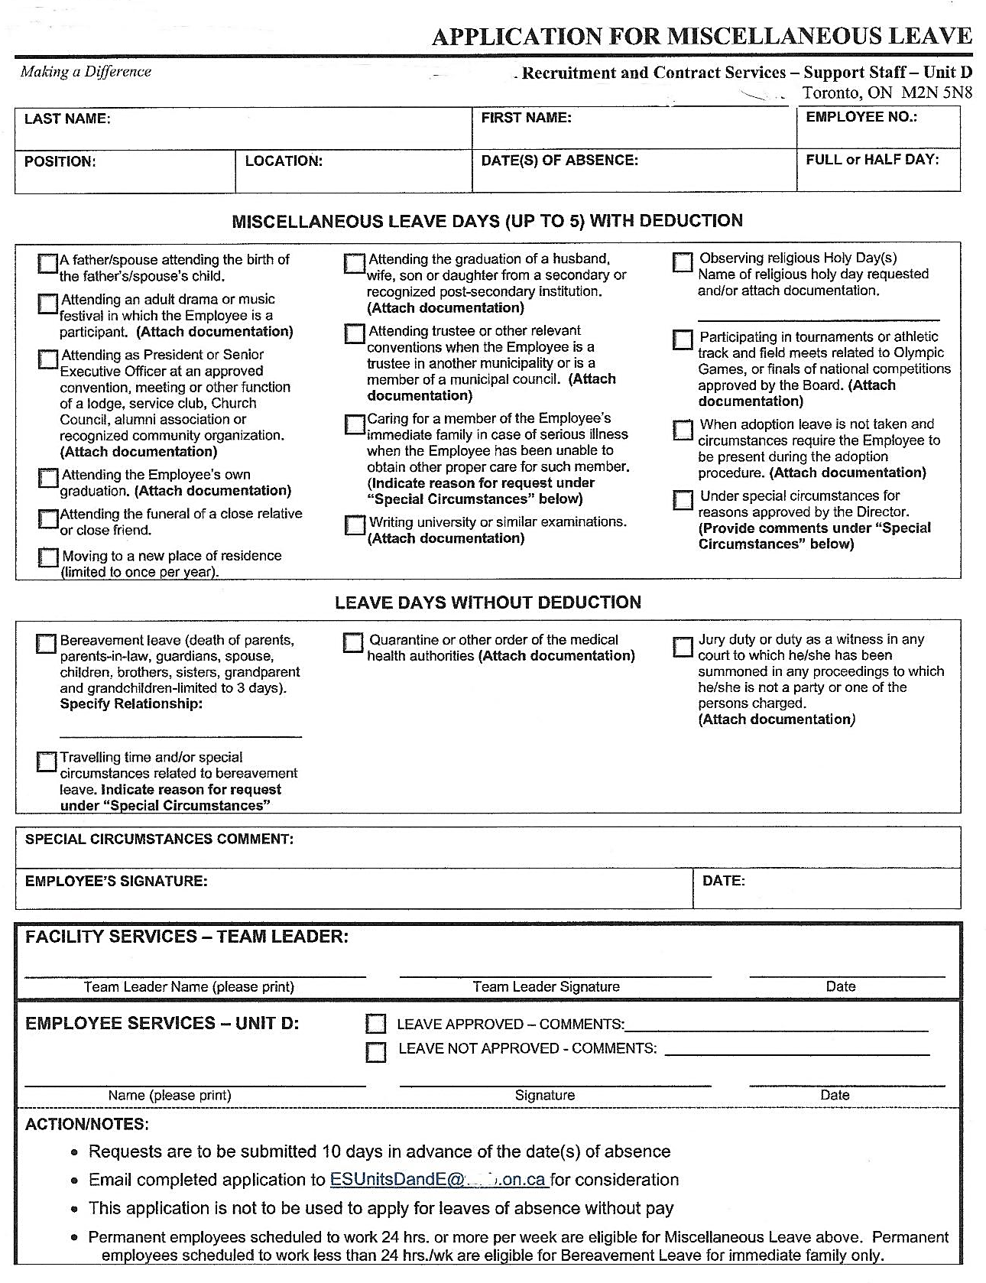

Work Sheet
Task 1: How many miscellaneous leave days can be taken with a deduction in pay?
Answer:

Task 2: If an employee is requesting travel time and/or special circumstances related to bereavement leave, what do they need to do when completing this form?
Answer:

Task 3: List the two leaves related to graduations.
Answer:

Task 4: What is the difference in leave between permanent employees scheduled to work 24 hours or more per week and permanent employees scheduled to work less than 24 hours per week?
Answer:

Task 5: Which type of school examinations can an employee request a leave to take?
Answer:

Answers
Task 1: How many miscellaneous leave days can be taken with a deduction in pay?
Answer: Up to 5
Task 2: If an employee is requesting travel time and/or special circumstances related to bereavement leave, what do they need to do when completing this form?
Answer: Indicate reason for request under “Special Circumstances”.
Task 3: List the two leaves related to graduations.
Answer:
- Attending the Employee’s own graduation
- Attending the graduation of a husband, wife, son or daughter from a secondary or recognized post-secondary institution.
Task 4: What is the difference in leave between permanent employees scheduled to work 24 hours or more per week and permanent employees scheduled to work less than 24 hours per week?
Answer:
Permanent employees scheduled to work 24 hours or more per week are eligible for Miscellaneous Leave and permanent employees scheduled to work less than 24 hours per week are eligible for Bereavement Leave for immediate family only.
Task 5: Which type of school examinations can an employee request a leave to take?
Answer: University or Similar

Performance Descriptors
Levels | Performance Descriptors | Needs Work | Completes task with support from practitioner | Completes task independently
A1.2 | Scans text to locate information
A1.2 | Locates multiple pieces of information in simple texts
A2.2 | Extracts information from tables and forms

This task: Was successfully completed Needs to be tried again

Learner Comments:

Instructor (print): Learner (print):

