

Task Title: 10 Reasons to be Libro

OALCF Cover Sheet – Practitioner Copy

Learner Name: __________________________________________
Date Started: ___________________________________________
Date Completed: _________________________________________

Goal Path: | Employment | Apprenticeship
Secondary School | Post Secondary | Independence
Successful Completion: Yes No

Task Description: Learners will read about Libro Credit Union to understand the services they provide.
Main Competency/Task Group/Level Indicator:
- Find and Use Information/Interpret documents/A2.1
Materials Required:
- Pen/pencil and paper and/or digital device

Learner Information
Credit Unions and banks are financial institutions that offer different benefits to customers. Credit Unions are different from banks because customers at Credit Unions are owners.

Scan “10 Reasons to be Libro”.

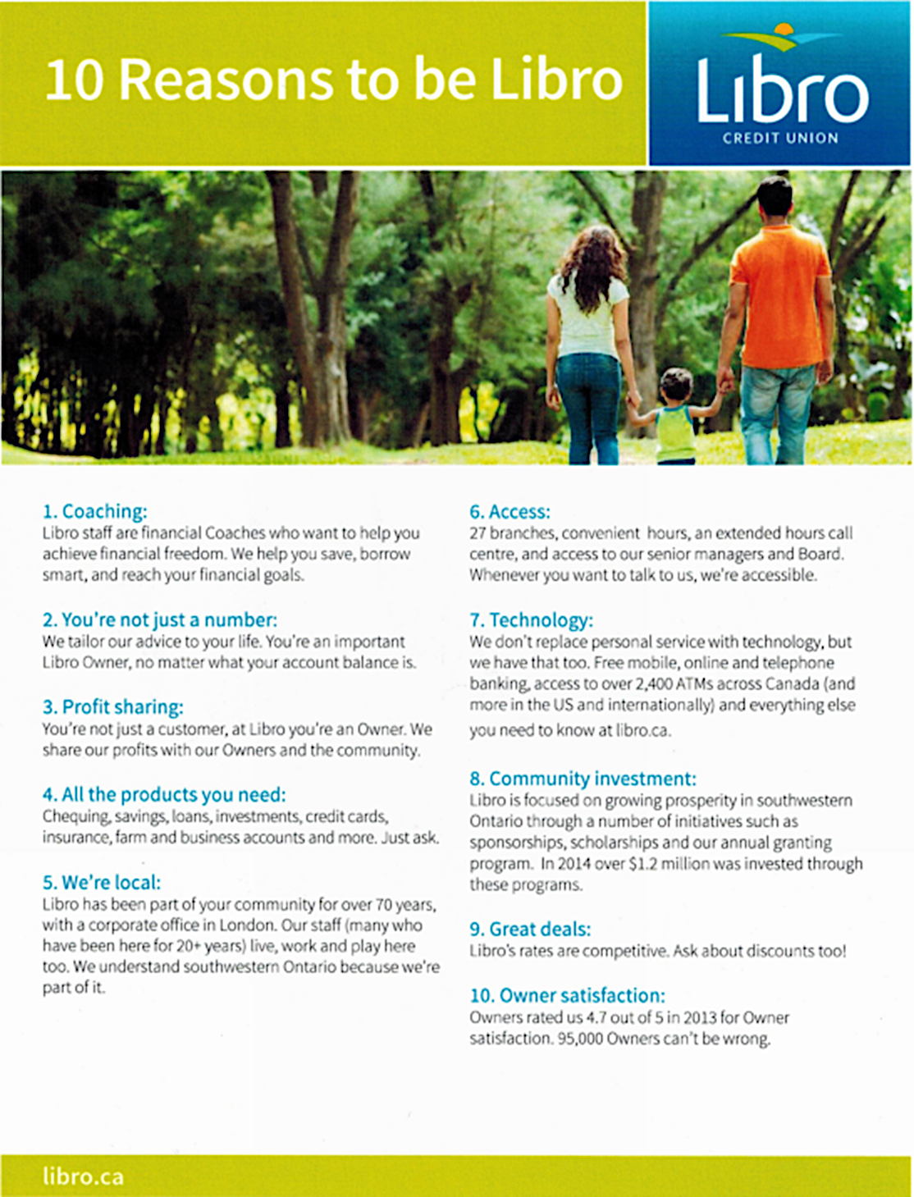

Work Sheet
Task 1: Who does Libro share their profits with?
Answer:

______________________________________________________
Task 2: Who are financial coaches?
Answer:

______________________________________________________
Task 3: How long has Libro been a part of the community of southwestern Ontario?
Answer:

______________________________________________________
Task 4: How much money did Libro invest in the community in 2014?
Answer:

______________________________________________________

Task 5: What is the owner satisfaction rating for Libro?
Answer:

______________________________________________________

Answers
Task 1: Who does Libro share their profits with?
Answer: Owners and the community

Task 2: Who are financial coaches?
Answer: Libro staff

Task 3: How long has Libro been a part of the community of southwestern Ontario?
Answer: Over 70 years

Task 4: How much money did Libro invest in the community in 2014?
Answer: Over 1.2 million dollars

Task 5: What is the owner satisfaction rating for Libro?
Answer: 4.7 out of 5

Performance Descriptors
Levels | Performance Descriptors | Needs Work | Completes task with support from practitioner | Completes task independently
A2.1 | scans to locate specific details
 | interprets brief text and common symbols

This task: Was successfully completed Needs to be tried again
Learner Comments:

Instructor (print): Learner (print):
__________________ _________________

