

Task Title: Tracking Height and Weight Percentiles

OALCF Cover Sheet – Practitioner Copy

Learner Name: __________________________________________
Date Started: ___________________________________________
Date Completed: _________________________________________

Goal Path: | Employment | Apprenticeship
Secondary School | Post Secondary | Independence
Successful Completion: Yes No

Task Description: The learner will use height and weight percentile charts to monitor a child’s growth over time.
Main Competency/Task Group/Level Indicator:
- Understand and Use Numbers/Manage Data/C4.3
Materials Required:
- Pen/pencil and paper and/or digital device

Learner Information
Some health care professionals use height and weight percentile charts as one of their guidelines to monitor a child’s growth.
Scan the “Birth to 36 months: Boys” and the “Weight-for-age percentiles: Girls, birth to 36 months” growth charts.

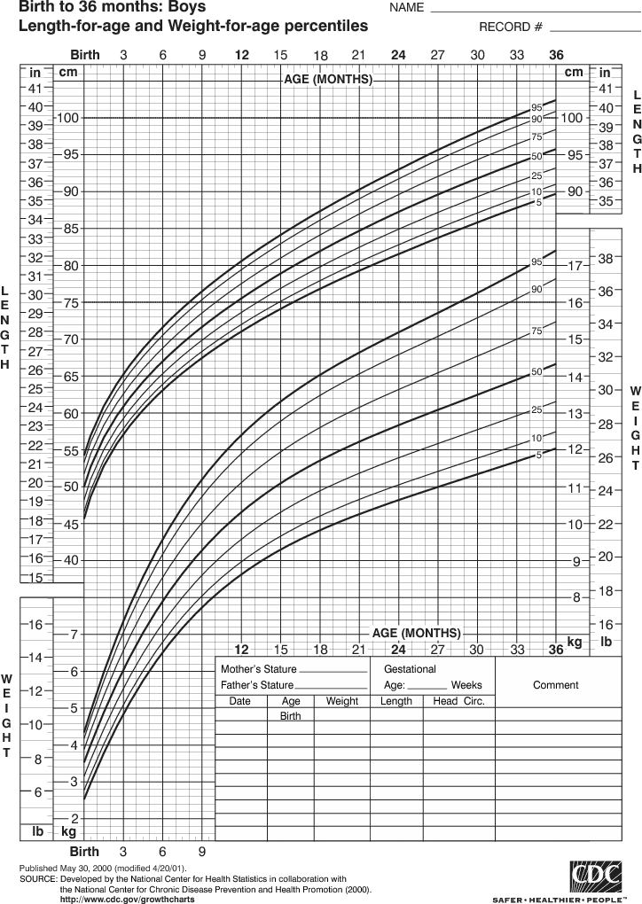

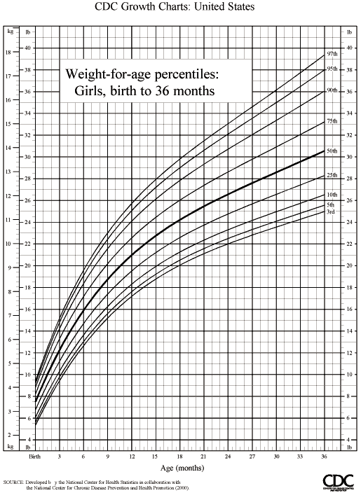

Work Sheet
Task 1a) Plot the following weight information on the “Birth to 36 months: Boys” percentiles chart.
Birth | 8 lb 3 oz |  | 21 months | 26 lb 7 oz
3 months | 12 lb 8 oz |  | 24 months | 27 lb 6 oz
6 months | 16 lb |  | 27 months | 28 lb 4 oz
9 months | 20 lb 15 oz |  | 30 months | 29 lb 1 oz
12 months | 22 lb 1 oz |  | 33 months | 30 lb 4 oz
15 months | 24 lb |  | 36 months | 31 lb 8 oz
18 months | 25 lb 14 oz

Answer: No written response required here.

Task completed: Yes: No:

Task 1b) Plot the same weights on the “Weight-for-age percentiles: Girls birth-36 months” chart.
Answer: No written response required here.

Task completed: Yes: No:

Task 1c) What difference do you notice between the lines you have created on the two charts?
Answer:

______________________________________________________
Task 2a) Plot the following height information on the “Birth to 36 months: Boys” percentiles chart:
Birth | 21 ½” |  | 21 months | 33 ¾”
3 months | 24 ¾” |  | 24 months | 34 ½”
6 months | 27” |  | 27 months | 36 ¼”
9 months | 29” |  | 30 months | 37”
12 months | 30 ½” |  | 33 months | 38 ½”
15 months | 31 ½” |  | 36 months | 39 ½”
18 months | 32”

Answer: No written response required here.

Task completed: Yes: No:

Task 2b: What percentile would this child fall into?
Answer:

______________________________________________________

Answers
Task 1a) Plot the following weight information on the “Birth to 36 months: Boys” percentiles chart:
Answer. See first chart below.

Task 1b) Plot the same weights on the “Weight-for-age percentiles: Girls birth-36 months” chart.
Answer: See second chart below.

Task 1c) What difference do you notice between the lines you have created on the two charts?
Answers will vary but the learner should observe that a girl will be in a higher percentile than a boy of the same age and weight.

Task 2a) Plot the following height information on the “Birth to 36 months: Boys” percentiles chart:
Answer: See first chart below.

Task 2b) What percentile would this child fall into?
Answer: This child would fall into the 91st percentile (90 to 93 is acceptable)
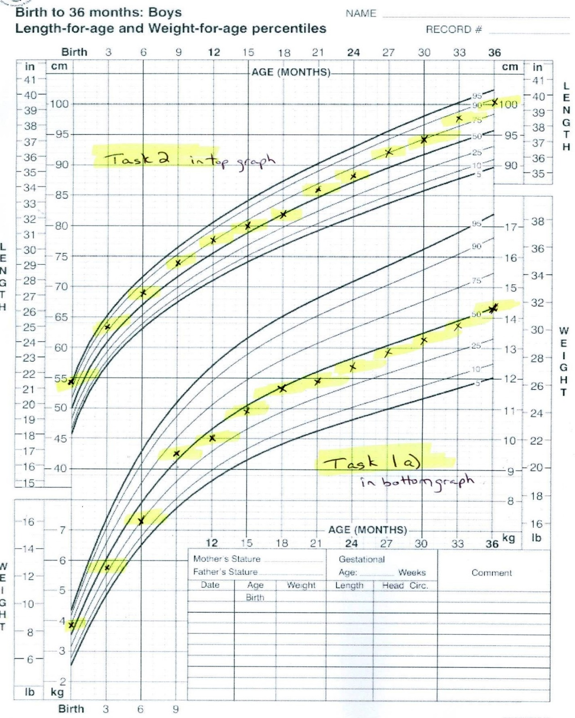

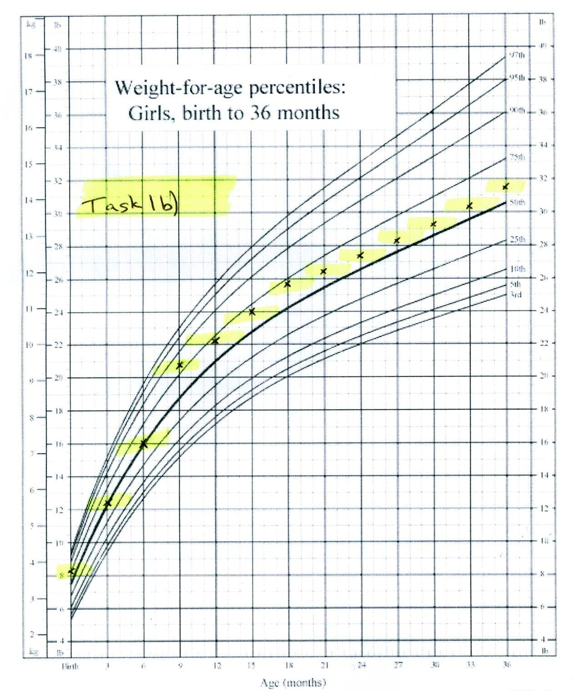

Performance Descriptors
Levels | Performance Descriptors | Needs Work | Completes task with support from practitioner | Completes task independently
C4.3 | manages unfamiliar elements (e.g. context, content) to complete tasks
 | makes estimates involving many factors where precision is required
 | begins to recognize bias in data and in displays, such as graphs
 | selects appropriate steps to solutions from among options
 | interprets, represents and converts values using whole numbers, decimals, percentages, ratios and fractions
 | finds integrates and analyzes data
 | organizes and represents numerical information (e.g. tables, graphs)
 | makes predictions using data; identifies trends

This task: Was successfully completed Needs to be tried again
Learner Comments:

Instructor (print): Learner (print):
__________________ _________________

