

Task Title: Create a Table to Compare Supplies

OALCF Cover Sheet – Practitioner Copy

Learner Name: __________________________________________
Date Started: ___________________________________________
Date Completed: _________________________________________

Goal Path: | Employment | Apprenticeship
Secondary School | Post Secondary | Independence
Successful Completion: Yes No

Task Description: Create a table to compare supplies to be ordered.
Main Competency/Task Group/Level Indicator:
- Communicate Ideas and Information/Complete and create documents/B3.2b
Materials Required:
- Pen/pencil and paper
- Computer with word processing program (e.g. Microsoft Word or Google Docs)

Learner Information
People often create tables to help make choices about which product to purchase. An employee may be asked to create a table comparing supplies before making a purchasing decision.

Scan the information for 6 Utility buckets.
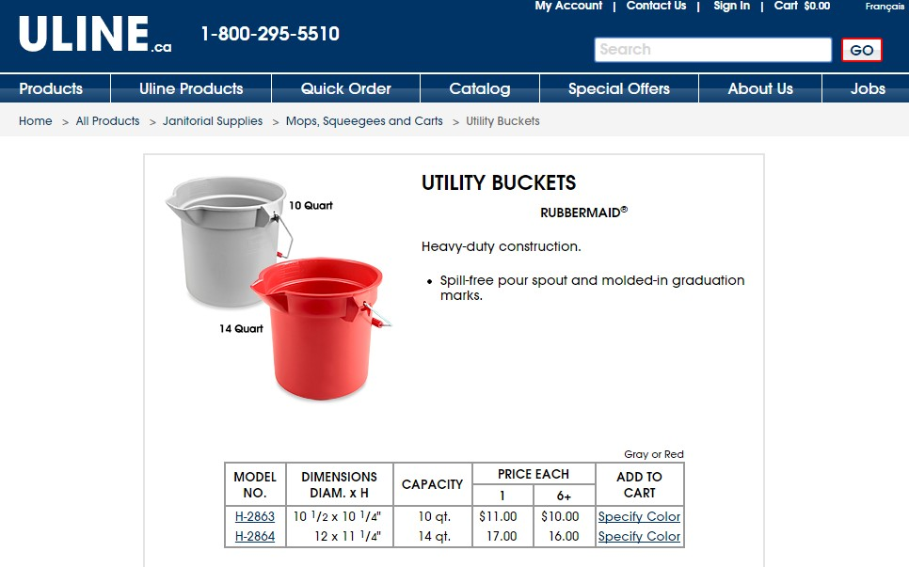
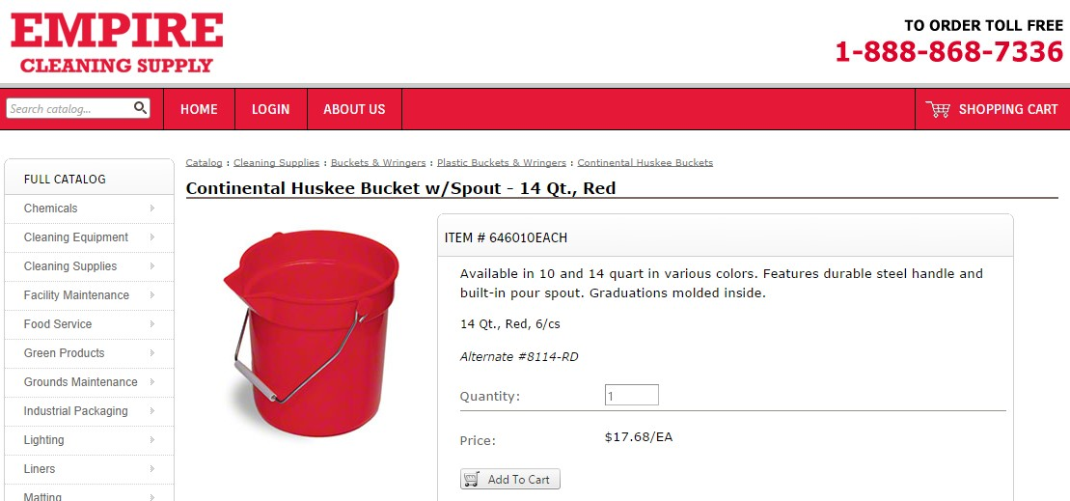

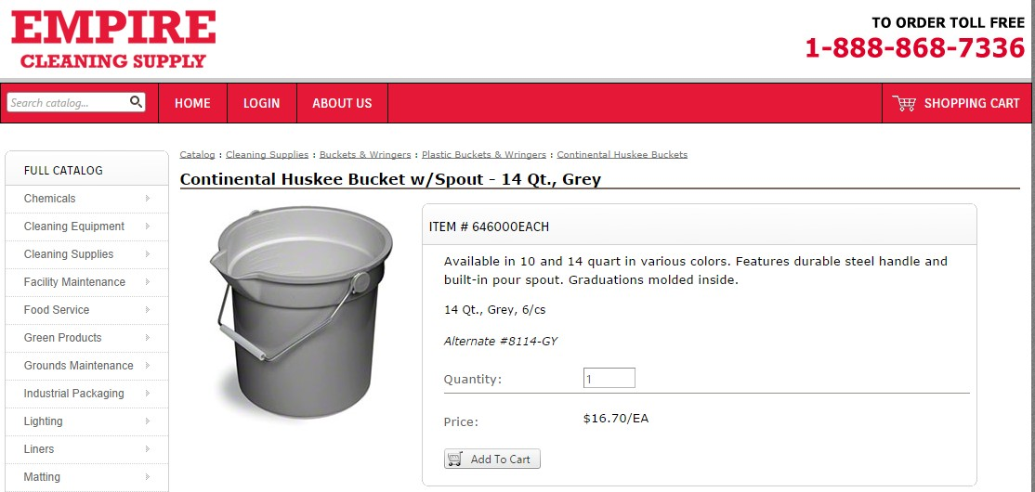

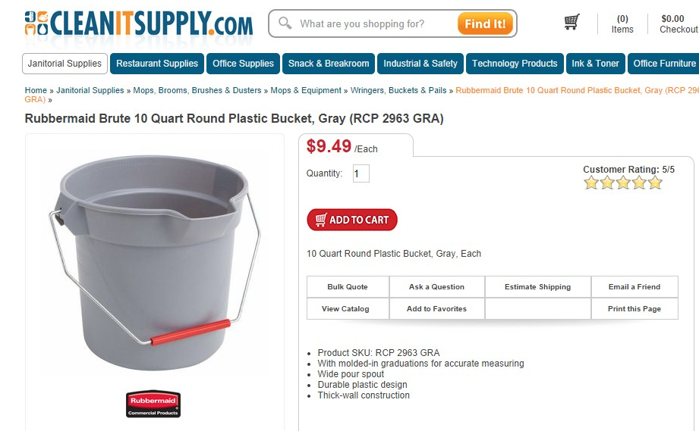

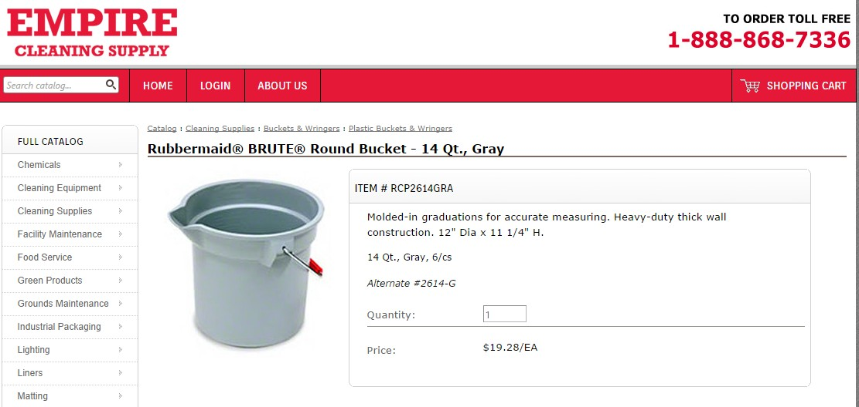

Work Sheet
Task 1: Create a table to compare the features and prices of the
six (6) utility buckets. Give your table a title. Use the
following column headings:

- Distributor
- Brand
- Model Name
- Model #
- Capacity
- Price
- Discount for multiple orders

Answer:

Task completed: Yes: No:

Task 2: Use the product information for the six buckets to fill in your table.

Answers
An example of a completed comparison table is here:

Utility Bucket Feature and Price Comparison
Distributor | Brand | Model name | Model # | Capacity | Price | Discount for multiple orders
ULINE.com | Rubbermaid | N/A | H-2863 | 10qt. | $11.00 each | $10.00 each for 6 +
ULINE.com | Rubbermaid | N/A | H-2864 | 14qt | $17.00 each | $16.00 each for 6+
Empire Cleaning Supply | Continental | Huskee | 646010-red | 14qt | $17.68 each | N/A
Empire Cleaning Supply | Continental | Huskee | 646000-grey | 14qt | $16.70 each | N/A
CLEANITSUPPLY.com | Rubbermaid | Brute | RCP 2963 | 10qt | $9.49 each | N/A
Empire Cleaning Supply | Rubbermaid | Brute | RCP2614 | 14qt | $19.28 each | N/A

Performance Descriptors
Levels | Performance Descriptors | Needs Work | Completes task with support from practitioner | Completes task independently
B3.2b | follows conventions to display information in simple documents (e.g. use of font, colour, shading, bulleted lists)
 | sorts entries into categories
 | displays one or two categories of information organized according to content to be presented
 | identifies parts of documents using titles, row and column headings and labels
This task: Was successfully completed Needs to be tried again

Learner Comments:

Instructor (print): Learner (print):
__________________ _________________
Skill Building Activities

Links to Online Resources:
GCF LearnFree:
- Google Docs – Working with Tables: https://edu.gcfglobal.org/en/googledocuments/working-with-tables/1/

- Word – Creating Tables: https://edu.gcfglobal.org/en/word/tables/1/

LearningHUB Digital Courses including Microsoft Word and Google Docs: https://www.learninghub.ca/apps/pages/index.jsp?uREC_ID=1118749&type=d&pREC_ID=1380779
LearningHUB Course Catalogue: https://www.learninghub.ca/apps/pages/coursecatalogue

