

Task Title: Calculate the Area of an Irregular Room

OALCF Cover Sheet – Practitioner Copy

Learner Name: __________________________________________
Date Started: ___________________________________________
Date Completed: _________________________________________

Goal Path: | Employment | Apprenticeship
Secondary School | Post Secondary | Independence
Successful Completion: Yes No

Task Description: The learner will use a floor plan of an irregular room to determine if specific pieces of furniture will fit.
Main Competency/Task Group/Level Indicator:
- Understand and Use Numbers/Use measures/C3.3

Materials Required:
- Pen/pencil and paper and/or digital device
- Calculator or digital device with calculator function
- Ruler

Learner Information
Floor plans are often used to determine where to place furniture in a room.
Scan the “Bedroom Floor Plan”. In the floor plan each small square represents 1 foot squared (1 foot x 1 foot x 1 foot x 1 foot).

Bedroom Floor Plan
WINDOW
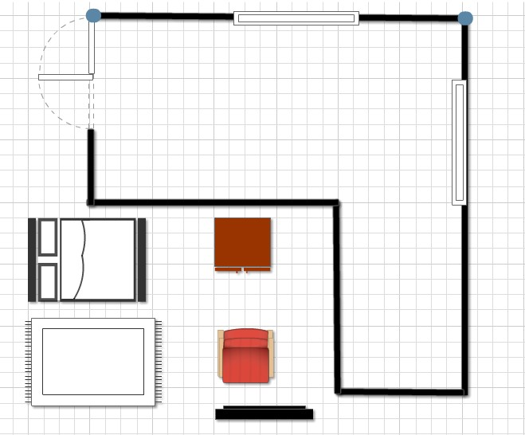

WINDOW
DOOR

DRESSER
BED plans are often used to determine where to place furniture in a room.

CHAIR
RUG

T.V.

Work Sheet
Task 1: Calculate in feet the perimeter of the bedroom.
Answer:

______________________________________________________
Task 2: Calculate in feet the total area of the bedroom.
Answer:

______________________________________________________
Task 3: Calculate in feet the total approximate amount of the room taken up by windows.
Answer:

______________________________________________________
Task 4: Use the floor plan to record the placement you’ve decided on for each piece of furniture shown.
Answer: No written response required here.

Task completed: Yes:

_____________________________________________________________

Answers
Task 1: Calculate the perimeter of the bedroom in feet.
Answer: 24 + 24 + 8 + 12 + 16 + 12 = 96 feet

Task 2: Calculate the total area (in feet) of the bedroom.
Answer:
12 x 24 = 288
12 x 8 = 96
288 + 96 = 384 square feet

Task 3: Calculate the total approximate amount of the room (in feet) taken up by windows.
Answer: 8 + 8 = 16 feet

Task 4: Use the floor plan to record the placement you’ve decided on for each piece of furniture shown.
Answers will vary but will reflect that the learner understands that the size of the furniture is represented by the floor plan grid.

Performance Descriptors
Levels | Performance Descriptors | Needs Work | Completes task with support from practitioner | Completes task independently
C3.3 | calculates using numbers expressed as whole numbers, fractions, decimals, percentages and integers
 | understands and uses formulas for finding the perimeter, area and volume of non-rectangular, composite shapes
 | manages unfamiliar elements (e.g. context, content) to complete tasks
 | makes estimates involving many factors where precision is required
 | chooses and performs required operations; makes inferences to identify required operations
 | selects appropriate steps to solutions from among options
 | identifies a variety of ways to complete tasks
C.3 | represents measures using whole numbers
 | uses strategies to check accuracy (e.g. estimating, using a calculator, repeating a calculation, using the reverse operation)

This task: Was successfully completed Needs to be tried again
Learner Comments:

Instructor (print): Learner (print):
__________________ _________________

