

Task Title: Adjust a Project Schedule

OALCF Cover Sheet – Practitioner Copy

Learner Name:___________________________________________
Date Started:____________________________________________
Date Completed: _________________________________________

Goal Path: | Employment | Apprenticeship
Secondary School | Post Secondary | Independence
Successful Completion: Yes No

Task Description: The learner will adjust a project schedule to accommodate delays.
Main Competency/Task Group/Level Indicator:
- Understand and Use Numbers/Manage time/C2.3
Materials Required:
- Pen/pencil and paper and/or digital device

Learner Information
When coordinating a project that involves many steps and many people, delays often happen. A Gantt chart or Bar chart is often used to plan a multi-stage project.
Scan the Denkor Dental Gantt Chart and Construction Schedule Bar Chart.

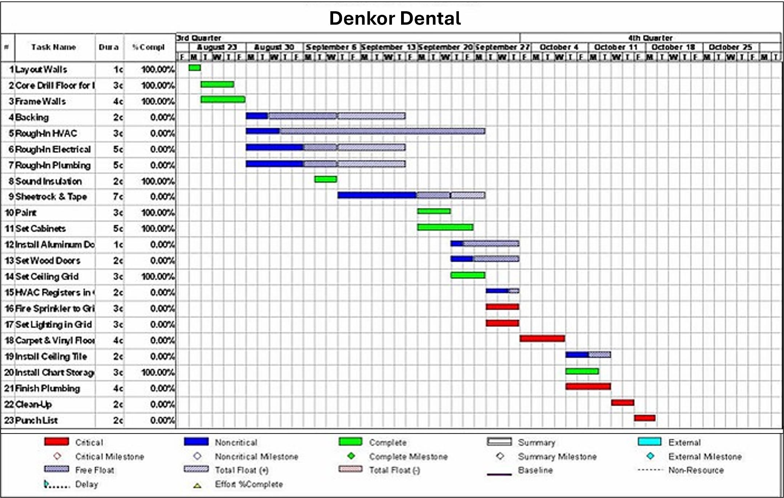
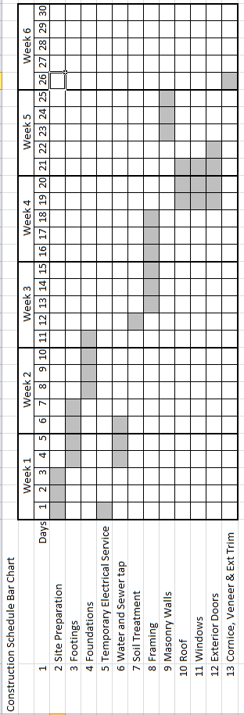

Work Sheet
Task 1: Look at the Denkor Dental Gantt chart. The general contractor has just been told that the wood doors will be two weeks late arriving due to supply problems at the factory. Use a highlighter to indicate on the chart what the new time frame is for setting them.
Answer: No written response required here.

Task completed: Yes:
______________________________________________________
Task 2: Look at the Construction Schedule Bar Chart. Extreme amounts of rain have caused the site to flood, delaying installation of the foundations for three days. That means that everything after that is delayed as well. What day should the windows and exterior doors now be delivered?
Answer:

______________________________________________________

Answers
Task 1: Look at the Denkor Dental Gantt chart. The general contractor has just been told that the wood doors will be two weeks late arriving due to supply problems at the factory. Use a highlighter to indicate on the chart what the new time frame is for setting them.
Answer: Highlighted area should be week of October 4, the Thursday and Friday (T F), on line 13 – Set Wood Doors

Task 2: Look at the Construction Schedule Bar Chart. Extreme amounts of rain have caused the site to flood, delaying installation of the foundations for three days. That means that everything after that is delayed as well. What day should the windows and exterior doors now be delivered?
Answer: Installation of the windows and doors is now scheduled for Day 22 (three days after original start date of Day 19).

Performance Descriptors
Levels | Performance Descriptors | Needs Work | Completes task with support from practitioner | Completes task independently
C2.3 | calculates using numbers expressed as whole numbers, fractions, decimals and percentages
 | manages unfamiliar elements (e.g. context, content to complete tasks
 | chooses and performs required operations; makes inferences to identify required operations
 | selects appropriate steps to reach solutions from amongst options
 | finds, integrates and analyzes numerical information
 | organizes and displays numerical information (e.g. Gantt chart schedules)
 | uses strategies to check accuracy (e.g. estimating, using a calculator, repeating a calculation, using the reverse operation)

This task: Was successfully completed Needs to be tried again
Learner Comments:

Instructor (print): Learner (print):
__________________ _________________

