

Task Title: Table of Contents

OALCF Cover Sheet – Practitioner Copy

Learner Name: __________________________________________
Date Started: ___________________________________________
Date Completed: _________________________________________

Goal Path: | Employment | Apprenticeship
Secondary School | Post Secondary | Independence
Successful Completion: Yes No

Task Description: Learner will read a table of contents to locate specific sections.
Main Competency/Task Group/Level Indicator:
- Find and Use Information/Interpret documents/A2.2
Materials Required:
- Pen/pencil and paper and/or digital device

Learner Information

Employees often need to review the User Guide or Manual for a product in order to identify and solve problems. Look at the “Table of Contents” for the photocopier.

Scan the “Table of Contents” for Apex Alpha Photocopier WC 341.

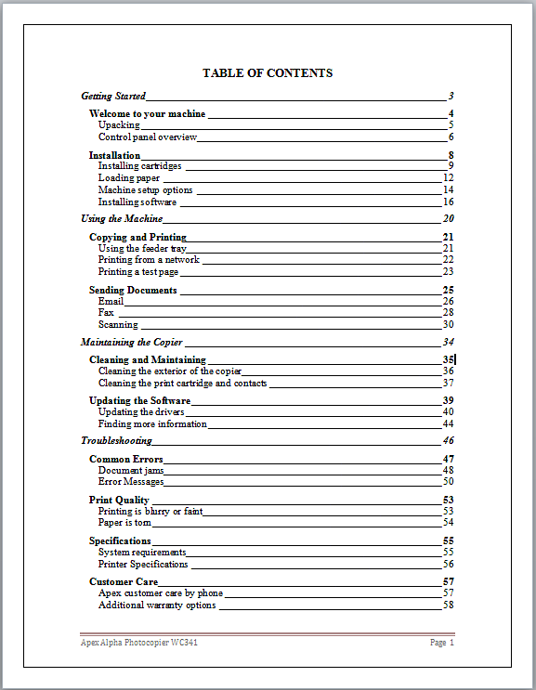

Work Sheet
Task 1: List the four section headings in the User’s Guide.
Answer:

______________________________________________________
Task 2: Which section contains information that will help fix an error with the photocopier?
Answer:

______________________________________________________
Task 3: List the two common errors that happen with this photocopier.
Answer:

______________________________________________________
Task 4: If this manual does not contain the specific information needed to solve the problem with the photocopier, who can be called for help?
Answer:

______________________________________________________

Answers
Task 1: List the four section headings in the User’s Guide.
Answer:
- Getting Started
- Using the Machine
- Maintaining the Copier
- Troubleshooting

Task 2: Which section contains information that will help fix an error with the photocopier?
Answer: Troubleshooting

Task 3: List the two common errors that happen with this photocopier.
Answer: Document jams, error messages.

Task 4: If this manual does not contain the specific information needed to solve the problem with the photocopier, who can be called for help?
Answer: Call (phone) Apex customer care.

Performance Descriptors
Levels | Performance Descriptors | Needs Work | Completes task with support from practitioner | Completes task independently
A2.2 | performs limited searches using one or two search criteria
 | extracts information from tables and forms
 | uses layout to locate information
 | makes connections between parts of documents
 | makes low-level inferences

This task: Was successfully completed Needs to be tried again
Learner Comments:

Instructor (print): Learner (print):
__________________ _________________

