

Task Title: Review Information on a Job Application

OALCF Cover Sheet – Practitioner Copy

Learner Name:___________________________________________
Date Started:____________________________________________
Date Completed: _________________________________________
Goal Path: | Employment | Apprenticeship
Secondary School | Post Secondary | Independence
Successful Completion: Yes No

Task Description: Review a Job Application to locate information.
Main Competency/Task Group/Level Indicator
- Find and Use Information/Interpret documents/A2.2

Materials Required:
- Pen/pencil and paper and/or digital device

Learner Information

When applying for jobs, it is usually necessary to complete an application form.

Scan “Diversified Transportation Ltd. Application for Employment”.

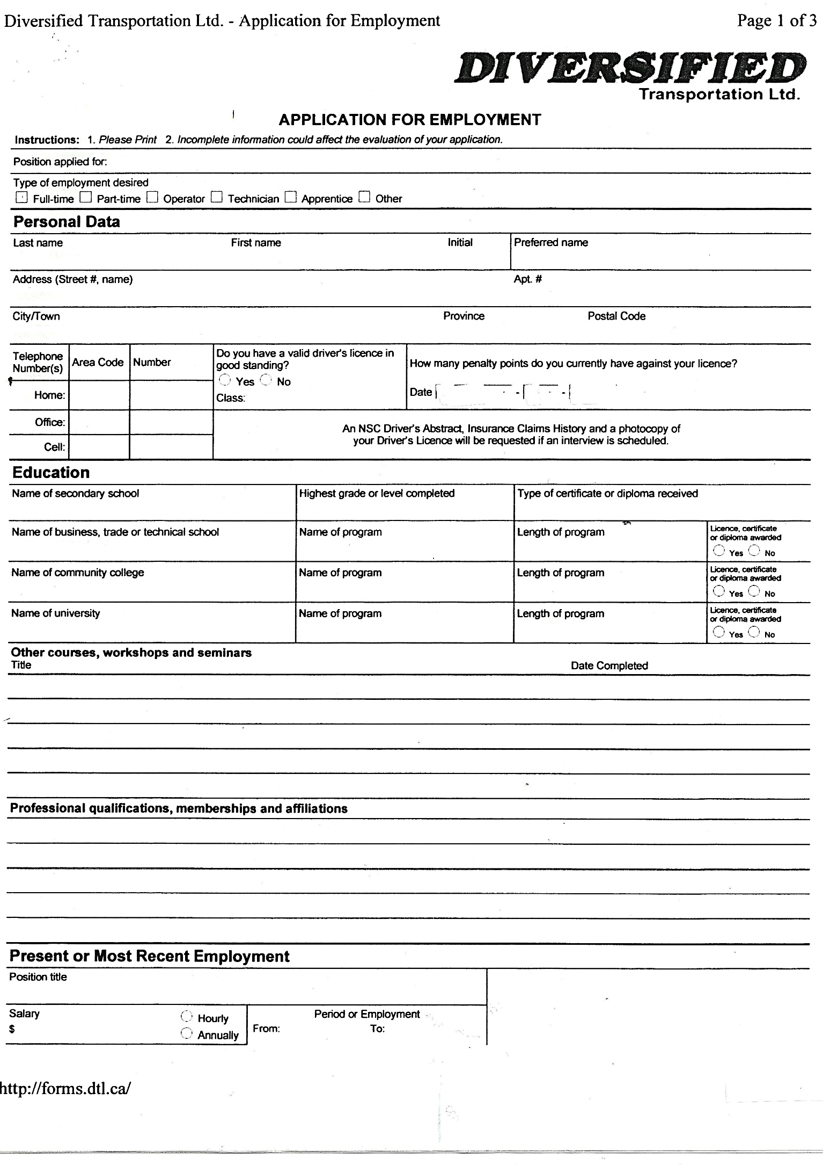
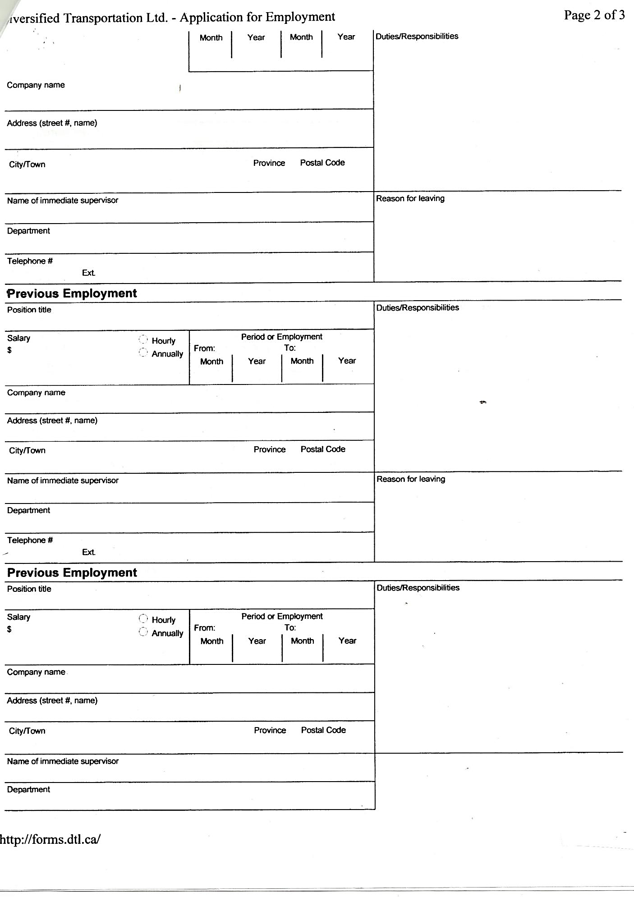
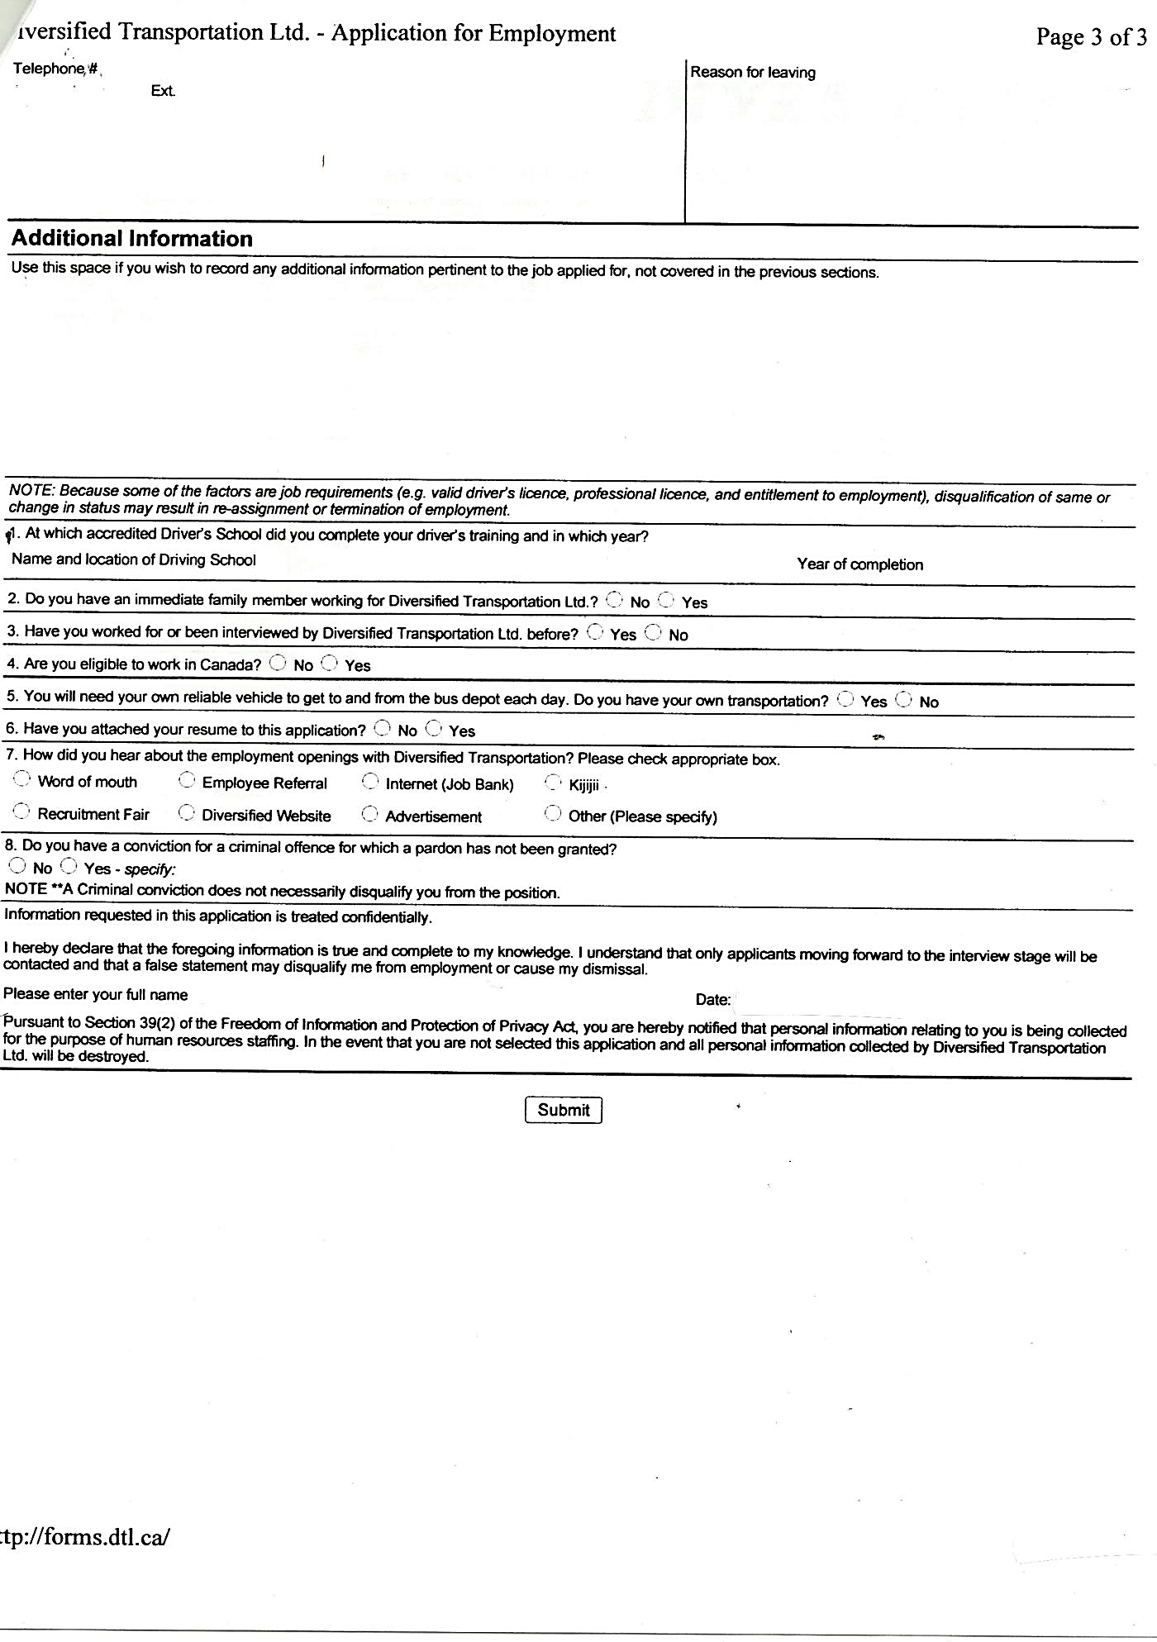

Work Sheet
Task 1: What are the two (2) instructions the applicant needs to follow?
Answer:

______________________________________________________
Task 2: If the applicant has a criminal conviction, what does that mean to the application?
Answer:

______________________________________________________
Task 3: What three (3) factors are job requirements?
Answer:

______________________________________________________
Task 4: What three (3) items will the applicant be requested to provide if they are given an interview?
Answer:

______________________________________________________

Answers
Task 1: What are the two (2) instructions the applicant needs to follow?
Answer: Please print and incomplete information could affect the evaluation of your application.

Task 2: If the applicant has a criminal conviction, what does that mean to the application?
Answer: A criminal conviction does not necessarily disqualify the applicant from the position.

Task 3: What three (3) factors are job requirements?
Answer: Under the “NOTE” on page 3 – valid driver’s license, professional license, entitlement to employment.

Task 4: What three (3) items will the applicant be requested to provide if they are given an interview?
Answer: NSC Driver’s Abstract, Insurance Claims History, photocopy of Driver’s License.

Performance Descriptors
Levels | Performance Descriptors | Needs Work | Completes task with support from practitioner | Completes task independently
A2.2 | performs limited searches using one or two search criteria
 | extracts information from tables and forms
 | uses layout to locate information
 | makes connections between parts of documents
 | makes low-level inferences
 | begins to identify sources and evaluate information

This task: Was successfully completed Needs to be tried again

Learner Comments:

Instructor (print): Learner (print):
_________________ _____________________

