

Task Title: Diluting a Cleaning Product Using a Ratio

OALCF Cover Sheet – Practitioner Copy

Learner Name: __________________________________________
Date Started: ___________________________________________
Date Completed: _________________________________________

Goal Path: | Employment | Apprenticeship
Secondary School | Post Secondary | Independence
Successful Completion: Yes No

Task Description: The learner will use ratio and proportion to calculate mixtures and final products.
Main Competency/Task Group/Level Indicator:
- Understand and Use Numbers/Use measures/C3.2

Materials Required:
- Pen/pencil and paper and/or digital device
- Calculator or digital device with calculator function

Learner Information
Cleaners use products that need to be mixed using ratio and proportion.
Scan the “AllChem Glass Cleaner Concentrate” label.

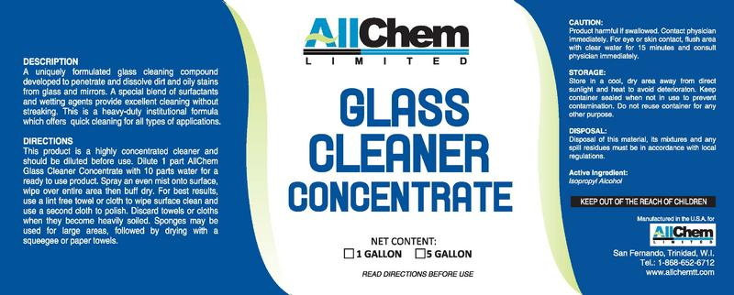
DESCRIPTION
A uniquely formulated glass cleaning compound developed to penetrate and dissolve dirt and oily stains from glass and mirrors. A special blend of surfactants and wetting agents provide excellent cleaning without streaking. This is a heavy-duty institutional formula which offers quick cleaning for all types of applications.

DIRECTIONS
This product is a highly concentrated cleaner and should be diluted before use. Dilute 1-part AllChem Glass Cleaner Concentrate with 10 parts water for a ready to use product. Spray an even mist onto surface, wipe over entire area then buff dry. For best results, use a lint free towel or cloth to wipe surface clean and use a second cloth to polish. Discard towels or cloths when they become heavily soiled. Sponges may be used for large areas, followed by drying with a squeegee or paper towels.
CAUTION
Product harmful if swallowed. Contact physician immediately. For eye or skin contact, flush area with clear water for 15 minutes and consult physician immediately.

STORAGE
Store in a cool, dry area away from direct sunlight and heat to avoid deterioration. Keep container sealed when not in use to prevent contamination. Do not reuse container for any other purpose.

DISPOSAL
Disposal of this material, its mixtures and any spill residues must be in accordance with local regulations.

ACTIVE INGREDIENT
Isopropyl Alcohol

KEEP OUT OF REACH OF CHILDREN

Work Sheet
Task 1: Calculate how much water is required to dilute 250mL of AllChem Glass Cleaner concentrate.
Answer:

______________________________________________________
Task 2: Calculate how much AllChem Glass Cleaner concentrate is required if 1.45L of water is used.
Answer:

______________________________________________________
Task 3: Calculate how much undiluted AllChem Glass Cleaner is needed to fill a 500mL spray bottle with mixed solution.
Answer:

______________________________________________________
Task 4: If 1000mL of AllChem Glass Cleaner concentrate is used, calculate how much solution (water and cleaner) is made.
Answer:

______________________________________________________

Answers
Task 1: Calculate how much water is required to dilute 250mL of AllChem Glass Cleaner concentrate.
Answer:
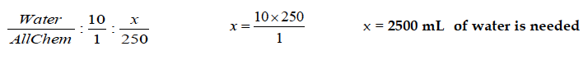

Task 2: Calculate how much AllChem Glass Cleaner concentrate is required if 1.45L of water is used.
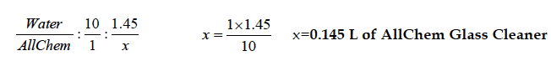
Answer:

Task 3: Calculate how much undiluted AllChem Glass Cleaner is needed to fill a 500mL spray bottle with mixed solution.
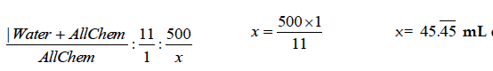
Answer:

Task 4: If 1000mL of AllChem Glass Cleaner concentrate is used, calculate how much solution (water and cleaner) is made.
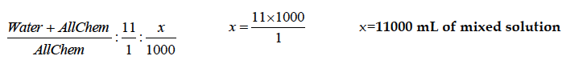
Answer:

Performance Descriptors
Levels | Performance Descriptors | Needs Work | Completes task with support from practitioner | Completes task independently
C3.2 | calculates using numbers expressed as whole numbers, fractions, decimals, percentages and integers
 | understands and uses ratio and proportion
 | interprets and applies rates (e.g. km/hr) and ratios (e.g. map scales)

This task: Was successfully completed Needs to be tried again
Learner Comments:

Instructor (print): Learner (print):
__________________ _________________

Skill Building Activities

Links to Online Resources:
Khan Academy Ratio Word Problems: https://www.khanacademy.org/math/cc-sixth-grade-math/cc-6th-ratios-prop-topic/cc-6th-equivalent-ratios/e/ratio_word_problems
Khan Academy Ratios and Rates: https://www.khanacademy.org/math/pre-algebra/pre-algebra-ratios-rates

What Does Dilutions Mean?: https://www.housekeepingchannel.com/hcp_365-Dilution

