

Task Title: Departure Time 24-Hour Conversion

OALCF Cover Sheet – Practitioner Copy

Learner Name: __________________________________________
Date Started: ___________________________________________
Date Completed: _________________________________________

Goal Path: | Employment | Apprenticeship
Secondary School | Post Secondary | Independence
Successful Completion: Yes No

Task Description: The learner will convert a departure time from the 24-hour to 12-hour clock.
Main Competency/Task Group/Level Indicator:
- Understand and Use Numbers/Manage time/C2.2

Materials Required:
- Pen/pencil and paper and/or digital device

Learner Information
People use train or bus timetables for getting to an interview, going to an appointment, getting to work, volunteering or taking their family to an event. Timetables may appear in 12-hour or 24-hour formats.
Scan the “Richmond Hill Train & Bus” timetable.

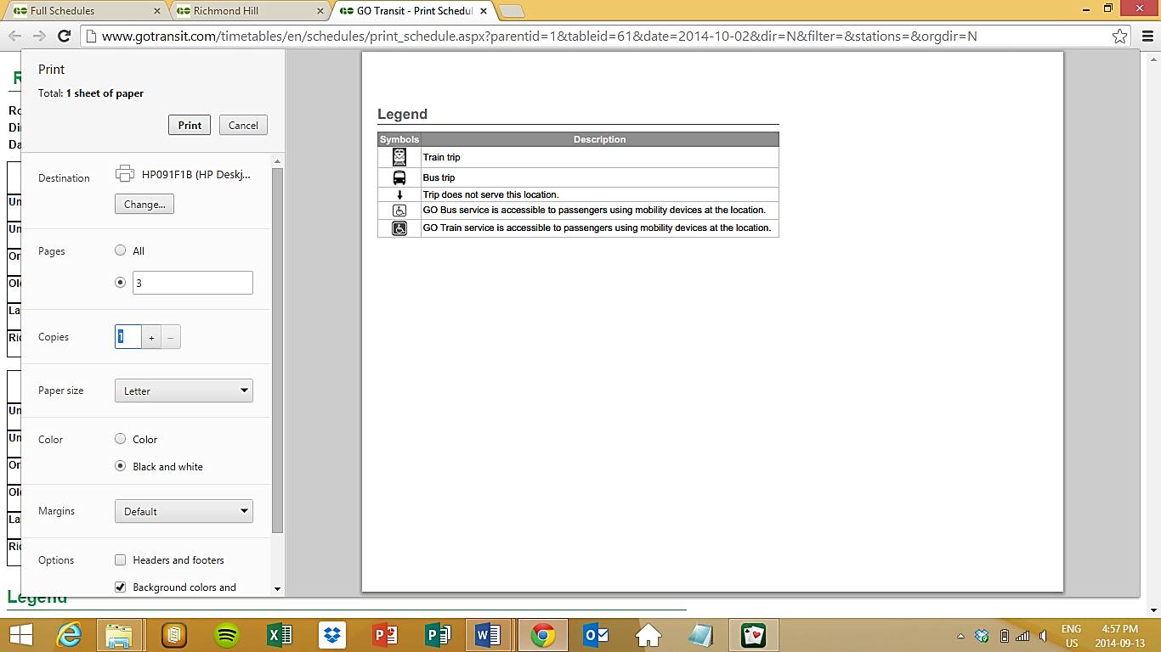
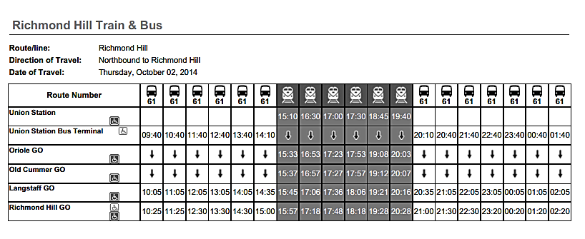

Work Sheet
Task 1: What is the earliest time in a 12-hour format that the train departs from Union Station?
Answer:

______________________________________________________
Task 2: What time in a 12-hour format does the last train leave Union Station?
Answer:

______________________________________________________
Task 3: How often do the buses run out of Union Station Bus Terminal after 9:00 p.m.?
Answer:

______________________________________________________
Task 4: If you are departing from Old Cummer GO after 5:00 p.m., how many trains will be running between 5:00 p.m. and 7:00 p.m.?
Answer:

______________________________________________________
Task 5: If you are leaving Langstaff GO between 10:00 pm and midnight, what are times of the buses in a 12-hour format?
Answer:

______________________________________________________

Answers
Task 1: What is the earliest time in a 12-hour format that the train departs from Union Station?
Answer: 3:10 p.m. (15:10 was converted)

Task 2: What time in a 12-hour format does the last train leave Union Station?
Answer: 7:40 p.m. (19:40 was converted)

Task 3: How often do the buses run out of Union Station Bus Terminal after 9:00 p.m.?
Answer: Every hour

Task 4: If you are departing from Old Cummer GO after 5:00 p.m., how many trains will be running between 5:00 p.m. and 7:00 p.m.?
Answer: 2 trains- 5:27 p.m. (17:27) and 5:57 p.m. (17:57)

Task 5: If you are leaving Langstaff GO between 10:00 pm and midnight, what are times of the buses in a 12-hour format?
Answer: 10:05 p.m. (22:05) and 11:05 p.m. (23:05)

Performance Descriptors
Levels | Performance Descriptors | Needs Work | Completes task with support from practitioner | Completes task independently
C2.2 | converts between units of time (e.g. millennia, centuries, decades, years, months, weeks, days, hours, minutes, seconds)
 | makes simple estimates
 | selects appropriate steps to reach solutions
 | understands and converts time between 12- and 24-hour clocks
 | chooses and performs required operation(s); may make inferences to identify required operation(s)
 | interprets, represents and converts time using whole numbers, decimals, percentages, ratios and simple, common fractions (e.g. ½, ¼)

This task: Was successfully completed Needs to be tried again
Learner Comments:

Instructor (print): Learner (print):
__________________ _________________

Skills Building Activities
Links to Online Resources:

Short Videos:
How to Read a Bus Schedule: https://www.youtube.com/watch?v=Gho_vu5PZTY
Calculating Time: https://www.youtube.com/watch?v=ByP1IWg1PPY
12 vs 24-hour clock: https://www.youtube.com/watch?v=fHAt7lDjVGA

