

Task Title: Convert Fractions to Decimals on a Timesheet

OALCF Cover Sheet – Practitioner Copy

Learner Name: __________________________________________
Date Started: ___________________________________________
Date Completed: _________________________________________

Goal Path: | Employment | Apprenticeship
Secondary School | Post Secondary | Independence
Successful Completion: Yes No

Task Description: The learner will convert fractions of hours to decimals on a timesheet.
Main Competency/Task Group/Level Indicator:
- Understand and Use Numbers/Manage time/C2.2
Materials Required:
- Pen/pencil and paper and/or digital device
- Calculator or digital device with calculator function

Learner Information
Employees often have to complete their own timesheets. Often the time worked needs to be recorded in decimal format rather than in fractions so this can be entered into a computer program by the payroll clerk.
Scan the “Howie’s Restaurant Employee Time Sheet”.
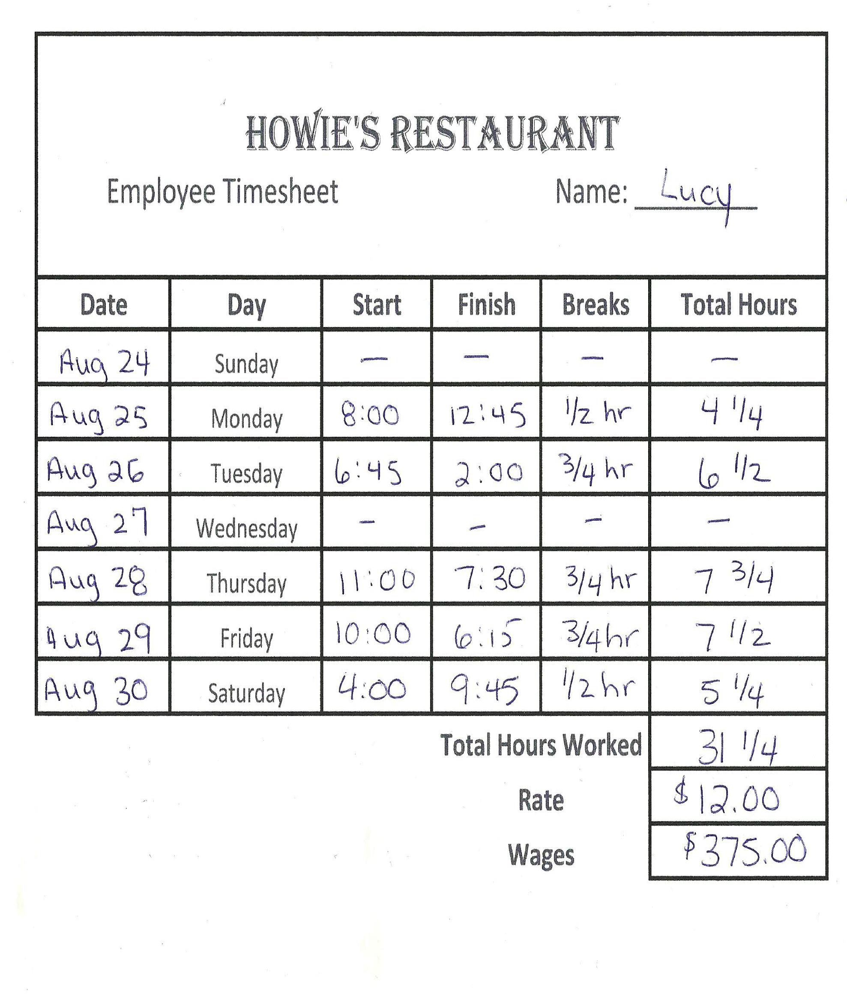

Work Sheet
Task 1: Convert the hours spent on breaks on Monday, August 25th to a decimal.
Answer:

______________________________________________________
Task 2: Convert the total hours worked on Thursday, August 28th to a decimal.
Answer:

______________________________________________________
Task 3: Convert the total hours worked on Friday, August 29th to a decimal.
Answer:

______________________________________________________
Task 4: Lucy made a mistake and on Tuesday, August 26th worked until 2:15. Calculate her total hours worked less time spent on breaks and convert your final number to a decimal.

Answer:

______________________________________________________

Answers
Task 1: Convert the hours spent on breaks on Monday, August 25th to a decimal.
Answer: 0.5 hours (1/2 = 1 divided by 2 = 0.5 hours)

Task 2: Convert the total hours worked on Thursday, August 28th to a decimal.
Answer: 7.75 hours (7 ¾ = 7 + (3 divided by 4) = 7 + .75 = 7.75 hours)

Task 3: Convert the total hours worked on Friday, August 29th to a decimal.
Answer: 7.5 hours (1/2 = 1 divided by 2 = .5 hours so 7 ½ = 7.5 hours)

Task 4: Lucy made a mistake and on Tuesday, August 26th worked until 2:15. Calculate her total hours worked less time spent on breaks and convert your final number to a decimal.
Answer: 6:45 am to 2:15 pm = 7 ½ hrs – ¾ hr = 7.5 - .75 = 6.75 hr

Performance Descriptors
Levels | Performance Descriptors | Needs Work | Completes task with support from practitioner | Completes task independently
C2.2 | calculates using numbers expressed as whole numbers, fractions, decimals and percentages
 | interprets, represents and converts time using whole numbers, decimals, percentages, ratios and simple, common fractions (e.g. ½, ¼)
 | chooses and performs required operation(s); may make inferences to identify required operation(s)
 | uses strategies to check accuracy (e.g. estimating, using a calculator, repeating a calculation, using the reverse operation)

This task: Was successfully completed Needs to be tried again

Learner Comments:

Instructor (print): Learner (print):
__________________ _________________

Skill Building Activities

Links to Online Resources:
LearningHUB math courses including:
- Everyday Life Math Courses
- Math Foundations 1: Decimals and Fractions
- Math Foundations 2: More Fractions
https://www.learninghub.ca/apps/pages/index.jsp?uREC_ID=1118749&type=d&pREC_ID=1380783
LeaningHUB Course Catalogue: https://www.learninghub.ca/apps/pages/coursecatalogue

Khan Academy: Converting Between Fractions and Decimals:
https://www.khanacademy.org/math/cc-seventh-grade-math/cc-7th-fractions-decimals/cc-7th-fracs-to-decimals/v/converting-fractions-to-decimals-ex2

