

Task Title: Comparing Quantities of Granola Bars

OALCF Cover Sheet – Practitioner Copy

Learner Name: __________________________________________
Date Started: ___________________________________________
Date Completed: _________________________________________

Goal Path: | Employment | Apprenticeship
Secondary School | Post Secondary | Independence
Successful Completion: Yes No

Task Description: The learner will compare quantities in boxes of granola bars.
Main Competency/Task Group/Level Indicator:
- Understand and Use Numbers/Manage data/C4.1

Materials Required:
- Pen/pencil and paper and/or digital device
- Calculator or digital device with calculator function (optional)

Learner Information

When buying groceries, it’s helpful to compare quantities or amounts to see which item is the best value.

Scan the various granola bar product boxes shown below.

Granola Products

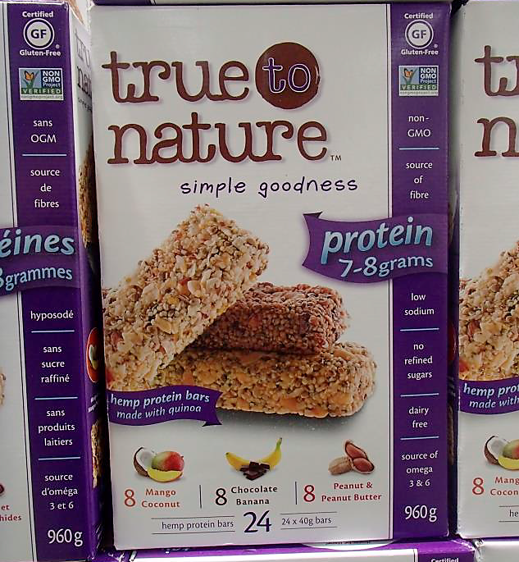
Box 1 Box 2
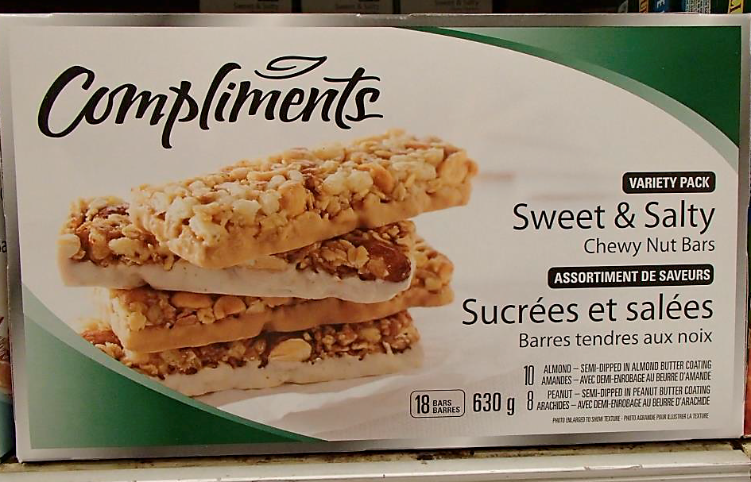

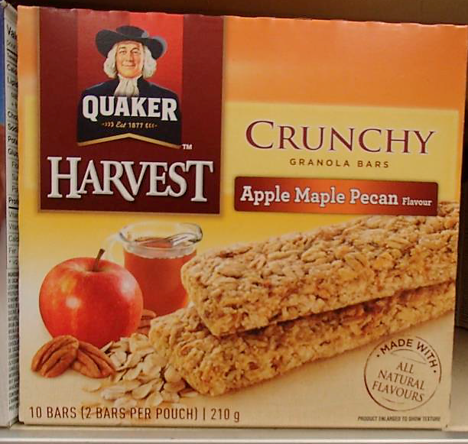
Box 3 Box 4
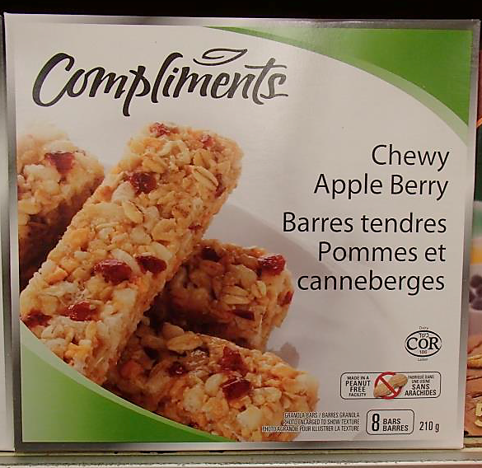

Work Sheet
Task 1: Compare boxes 1 and 2. Which box has more granola bars?
Answer:
______________________________________________________
Task 2: Compare boxes 1 and 2. Which box has more kinds of granola bars in it?
Answer:
______________________________________________________
Task 3: Compare boxes 3 and 4. If both boxes of granola bars are the same price, which box is the better deal?
Answer:
______________________________________________________
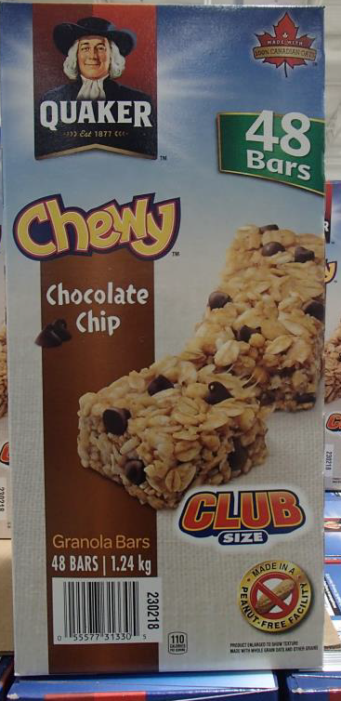
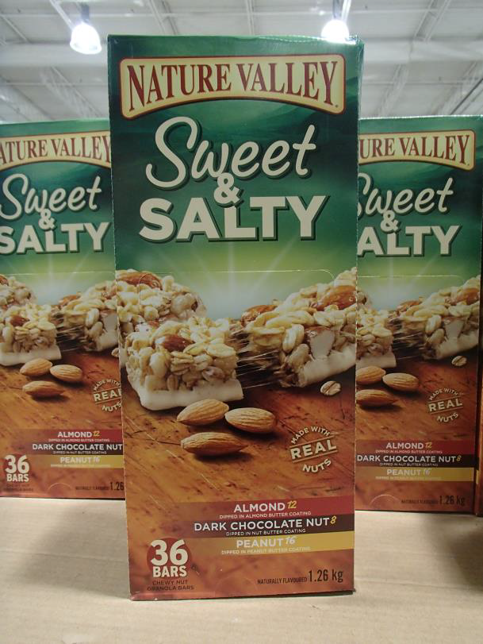
Many factories have a lunch room where employees can purchase a snack while they are at work. Usually the snack bar is run by a canteen manager. In this scenario, the canteen sells two types of granola bars:

Task 4: The canteen manager usually sells about 175 of the Quaker Chewy Chocolate Chip granola bars each week. How many of these boxes should they buy to stock the shelves for one week?
Answer:

______________________________________________________
Task 5: The canteen manager usually sells about 60 of the Nature Valley Sweet & Salty granola bars each week. How many of these boxes should they buy to stock the shelves for one week?
Answer:

______________________________________________________

Answers
Task 1: Compare boxes 1 and 2. Which box has more granola bars?
Answer: Box 1, True to Nature (24 compared to 18)

Task 2: Compare boxes 1 and 2. Which box has more kinds of granola bars in it?
Answer: Box 1, True to Nature (3 compared to 2)

Task 3: Compare boxes 3 and 4. If both boxes of granola bars are the same price, which box is the better deal?
Answer: Box 3, Quaker Harvest (10 bars compared to 8)

Many factories have a lunch room where employees can purchase a snack while they are at work. Usually the snack bar is run by a canteen manager. In this scenario, the canteen sells two types of granola bars.
Task 4: The canteen manager usually sells about 175 of the Quaker Chewy Chocolate Chip granola bars each week. How many of these boxes should they buy to stock the shelves for one week?
Answer:
175 ÷ 48 = 3.65
They would need to buy 4 boxes.

Task 5: The canteen manager usually sells about 60 of the Nature Valley Sweet & Salty granola bars each week. How many of these boxes should they buy to stock the shelves for one week?
Answer:
60 ÷ 36 = 1.67
They would need to buy 2 boxes.

Performance Descriptors
Levels | Performance Descriptors | Needs Work | Completes task with support from practitioner | Completes task independently
C4.1 | adds, subtracts, multiplies and divides whole numbers and decimals
 | identifies and compares quantities of items
 | identifies and performs required operation
 | makes simple estimates
 | interprets and represents values using whole numbers, decimals, percentages and simple, common fractions (e.g. ½, ¼)
 | follows apparent steps to reach solutions
 | uses strategies to check accuracy (e.g. estimating, using a calculator, repeating a calculation, using the reverse operation)

This task: Was successfully completed Needs to be tried again

Learner Comments:

Instructor (print): Learner (print):
__________________ _________________

